---------------------------------------------------------------------------------------------------------------------
---------------------------------------------------------------------------------------------------------------------

THE CURSE OF ER’MAH’GERD
A GOOD COMPANY QUEST

Explore the farcical fantasy realm of Mezzo-Earth in this playful adventure for first-time tabletop gamers and experienced players alike.

ONEMILLIONWORDS DAVID MICHAEL WILLIAMS [5E Compatible]

---------------------------------------------------------------------------------------------------------------------
---------------------------------------------------------------------------------------------------------------------

---------------------------------------------------------------------------------------------------------------------
---------------------------------------------------------------------------------------------------------------------

The Curse of Er’Mah’Gerd

Writer: David Michael Williams
Editors: Bill Fischer, William Fischer, Dusty Krikau
Cover Artist: Mary Christopherson
Interior Artists: Carley Knoll & Gwendolyn Williams
Cartographer: David Michael Williams

ONEMILLIONWORDS
one-million-words.com

Use the following coupon code for this title at www.rpgnow.com to receive a digital copy of this adventure and any updated editions as they are published:
[insert coupon code]

---------------------------------------------------------------------------------------------------------------------

---------------------------------------------------------------------------------------------------------------------

THE CURSE OF ER’MAH’GERD is a work of fiction. Names, characters, places, and incidents either are products of the author’s imagination or are used fictitiously. Any resemblance to actual persons, living or dead, business establishments, events, or locales is entirely coincidental.
ONEMILLIONWORDS
Copyright © 2022 by One Million Words, LLC
First publication by One Million Words, LLC, Wisconsin, USA
First printing, June 2022
ISBN 978-1-7370096-1-0

The publication of THE CURSE OF ER’MAH’GERD is done under version 1.0a of the Open Gaming License and the System Reference Document by permission from Wizards of the Coast, Inc.
Designation of Product Identity
The following items are hereby designated as Product Identity in accordance with Section 1(e) of the Open Game License, version 1.0a: The Curse of Er’Mah’Gerd, A Good Company Quest, all proper nouns, capitalized terms, italicized terms, artwork, maps, symbols, depictions, and illustrations, except such elements that already appear in the System Reference Document or have been released as Open Content.
Designation of Open Content
Subject to the Product Identity designation above, such sections of creatures and NPC statistics as derived from the SRD are designed as Open Gaming Content. Some of the portions of this book which are delineated OGC originate from the System Reference Document and are copyright © 1999, 2000 Wizards of the Coast, Inc. The remainder of these OGC portions of this book are hereby added to the Open Game Content and, if so used, should bear the copyright notice “THE CURSE OF ER’MAH’GERD, copyright © 2022 One Million Words, all rights reserved, visit david-michael-williams.com or contact info@david-michael-williams.com.”
THE CURSE OF ER’MAH’GERD is copyright © 2022 One Million Words. Open game content may only be used under and in the terms of the Open Game License. One Million Words is not affiliated with Wizards of the Coast™. One Million Words makes no claim to or challenge to any trademarks held by Wizards of the Coast™.
OPEN GAME LICENSE V1.0a
The following text is the property of Wizards of the Coast, Inc. and is Copyright 2000 Wizards of the Coast, Inc. (“Wizards”). All Rights Reserved.
1. Definitions: (a) “Contributors” means the copyright and/or trademark owners who have contributed Open Game Content; (b) “Derivative Material” means copyrighted material including derivative works and translations (including into other computer languages), potation, modification, correction, addition, extension, upgrade, improvement, compilation, abridgment or other form in which an existing work may be recast, transformed or adapted; (c) “Distribute” means to reproduce, license, rent, lease, sell, broadcast, publicly display, transmit or otherwise distribute; (d) “Open Game Content” means the game mechanic and includes the methods, procedures, processes and routines to the extent such content does not embody the Product Identity and is an enhancement over the prior art and any additional content clearly identified as Open Game Content by the Contributor, and means any work covered by this License, including translations and derivative works under copyright law, but specifically excludes Product Identity. (e) “Product Identity” means product and product line names, logos and identifying marks including trade dress; artifacts; creatures characters; stories, storylines, plots, thematic elements, dialogue, incidents, language, artwork, symbols, designs, depictions, likenesses, formats, poses, concepts, themes and graphic, photographic and other visual or audio representations; names and descriptions of characters, spells, enchantments, personalities, teams, personas, likenesses and special abilities; places, locations, environments, creatures, equipment, magical or supernatural abilities or effects, logos, symbols, or graphic designs; and any other trademark or registered trademark clearly identified as Product identity by the owner of the Product Identity, and which specifically excludes the Open Game Content; (f) “Trademark” means the logos, names, mark, sign, motto, designs that are used by a Contributor to identify itself or its products or the associated products contributed to the Open Game License by the Contributor (g) “Use”, “Used” or “Using” means to use, Distribute, copy, edit, format, modify, translate and otherwise create Derivative Material of Open Game Content. (h) “You” or “Your” means the licensee in terms of this agreement.
2. The License: This License applies to any Open Game Content that contains a notice indicating that the Open Game Content may only be Used under and in terms of this License. You must affix such a notice to any Open Game Content that you Use. No terms may be added to or subtracted from this License except as described by the License itself. No other terms or conditions may be applied to any Open Game Content distributed using this License.
3.Offer and Acceptance: By Using the Open Game Content You indicate Your acceptance of the terms of this License.
4. Grant and Consideration: In consideration for agreeing to use this License, the Contributors grant You a perpetual, worldwide, royalty-free, non-exclusive license with the exact terms of this License to Use, the Open Game Content.
5.Representation of Authority to Contribute: If You are contributing original material as Open Game Content, You represent that Your Contributions are Your original creation and/or You have sufficient rights to grant the rights conveyed by this License.
6.Notice of License Copyright: You must update the COPYRIGHT NOTICE portion of this License to include the exact text of the COPYRIGHT NOTICE of any Open Game Content You are copying, modifying or distributing, and You must add the title, the copyright date, and the copyright holder’s name to the COPYRIGHT NOTICE of any original Open Game Content you Distribute.
7. Use of Product Identity: You agree not to Use any Product Identity, including as an indication as to compatibility, except as expressly licensed in another, independent Agreement with the owner of each element of that Product Identity. You agree not to indicate compatibility or co-adaptability with any Trademark or Registered Trademark in conjunction with a work containing Open Game Content except as expressly licensed in another, independent Agreement with the owner of such Trademark or Registered Trademark. The use of any Product Identity in Open Game Content does not constitute a challenge to the ownership of that Product Identity. The owner of any Product Identity used in Open Game Content shall retain all rights, title and interest in and to that Product Identity.
8. Identification: If you distribute Open Game Content You must clearly indicate which portions of the work that you are distributing are Open Game Content.
9. Updating the License: Wizards or its designated Agents may publish updated versions of this License. You may use any authorized version of this License to copy, modify and distribute any Open Game Content originally distributed under any version of this License.
10. Copy of this License: You must include a copy of this License with every copy of the Open Game Content You Distribute.
11. Use of Contributor Credits: You may not market or advertise the Open Game Content using the name of any Contributor unless You have written permission from the Contributor to do so.
12. Inability to Comply: If it is impossible for You to comply with any of the terms of this License with respect to some or all of the Open Game Content due to statute, judicial order, or governmental regulation then You may not Use any Open Game Material so affected.
13. Termination: This License will terminate automatically if You fail to comply with all terms herein and fail to cure such breach within 30 days of becoming aware of the breach. All sublicenses shall survive the termination of this License.
14. Reformation: If any provision of this License is held to be unenforceable, such provision shall be reformed only to the extent necessary to make it enforceable.
15. COPYRIGHT NOTICE
Open Game License v 1.0a Copyright 2000, Wizards of the Coast, LLC.
System Reference Document 5.1 Copyright 2016, Wizards of the Coast, Inc.; Authors Mike Mearls, Jeremy Crawford, Chris Perkins, Rodney Thompson, Peter Lee, James Wyatt, Robert J. Schwalb, Bruce R. Cordell, Chris Sims, and Steve Townshend, based on original material by E. Gary Gygax and Dave Arneson.

---------------------------------------------------------------------------------------------------------------------
---------------------------------------------------------------------------------------------------------------------

---------------------------------------------------------------------------------------------------------------------
---------------------------------------------------------------------------------------------------------------------

Contents

About This Book
- You’re in Good Company
- Meet Asher
- Welcome to Mezzo-Earth
  - Player Characters
    - Sir Larpsalot
    - Elvish Presley
    - Brutus the Bullheaded
    - Master Prospero
    - Tom Foolery
    - Lord Grimdark
Adventure Overview
- Adventure Summary
  - Adventure Flow
  - Adventure Hook
- Past & Prophecy
  - History
  - The Prophecy
The Setting
- Races of Mezzo-Earth
  - Dwarves
  - Elves
  - Humans
  - Minotaurs
- Geography of the Game
  - The Forbidden Frontier
  - Farway
  - The Untamed North
  - The Civilized South
  - The Disorient
  - The Funk
- Using Maps
Starting the Adventure
- Prologue
  - Session Zero
    - Encounter: Bunch of Wimps
- Act 1
  - Running Act 1
  - Setting Overview: Farway
    - Farway Locations & Residents
    - Farway Rumors
    - Farway Optional Encounters
      - What’s in the Box?
      - Riddles with a Drunk
  - Quest: Peace Talks
    - The Three Factions & Their Delegates
      - The Civilized South
      - The Untamed North
      - The Disorient
    - Required Encounter: Ruffians
  - Quest: Pick a Side
    - The Favor of the Three Factions
  - Setting Overview: The Road from Farway
    - The Road from Farway Locations & Residents
    - The Road from Farway Optional Encounters
      - Treasure in the Treetops
      - The Lone Granger
  - Quest: Escort Mission
    - Traveling Companions
    - Required Encounter: Ambushed by a Rival Faction
  - Advancing to Level 4
- Act 2
  - Running Act 2
  - Setting Overview: Knell-on-Wheels
    - Knell-on-Wheels Locations & Residents
    - Knell-on-Wheels Rumors
    - Knell-on-Wheels Optional Encounters
      - Gildbert’s Secrets
      - Wanna Bet?
  - Setting Overview: Roam
    - Roam Locations & Residents
    - Roam Rumors
    - Roam Optional Encounters
      - When in Roam
      - Built in a Day
  - Setting Overview: Disorient Encampment
    - Disorient Encampment Locations
    - Disorient Encampment Rumors
    - Disorient Encampment Optional Encounters
      - Shadow Boxing
      - Half-truth or Dare
  - Quest: Take Me to Your Leader
    - If Accompanying Gildbert
    - If Accompanying River Eagle
    - If Accompanying Noh-Wei
  - Setting Overview: The Funk
    - Funk Locations & Residents
    - Funk Rumors
    - Funk Optional Encounters
      - A Song of Ice & Lava
      - Bah, Bah, Black Sheep
      - Uprooted
  - Quest: Enter the Funk
    - Required Encounter: Confronting the Remaining Rival Faction
  - Advancing to Level 5
- Act 3
  - Running Act 3
  - Setting Overview: Tower of Shiz
  - Quest: Dungeon Crawl
    - First Floor
    - Second Floor
      - Required Encounter: Wimposters
    - Third Floor
    - Summit
      - Required Encounter: Enter the Dragon
- Epilogue
  - Endings
    - If Allied with the Civilized South
    - If Allied with the Untamed North
    - If Allied with the Disorient
  - Adventure Replay Hooks
Appendices
- Appendix A: Items
- Appendix B: Creatures
- Appendix C: Magic
- Appendix D: Pantheon
- Appendix E: Maps
- Appendix F. Handouts
Afterword
- Acknowledgments
- The Lost Tale of Sir Larpsalot

---------------------------------------------------------------------------------------------------------------------
---------------------------------------------------------------------------------------------------------------------

---------------------------------------------------------------------------------------------------------------------
---------------------------------------------------------------------------------------------------------------------

About This Book
The Curse of Er’Mah’Gerd is a tabletop roleplaying game for one to six player characters led by a gamemaster (GM). The adventure can be completed in as few as three sessions or could span six or more sessions, depending how many optional encounters the GM chooses to include. The game can also be played through multiple times.
This book includes the player characters (PCs), enemies, and other obstacles that the heroes known as Good Company must overcome; all the locations that must be explored to bring the adventure to a rewarding conclusion; and additional content that can be utilized as desired.
Because The Curse of Er’Mah’Gerd adheres to the 5E ruleset, the GM will need a basic understanding of the fifth edition of the world’s first fantasy roleplaying game. While a handful of other resources could come in handy (e.g. PH, DMG, MM), the author has done his best to make the adventure as streamlined and self-contained as possible.
In other words, it’s an ideal game for 5E newcomers, a first-time GM, and/or veteran players who crave a quick, breezy campaign.
The GM is strongly encouraged to read—or at least skim—all of the introductory sections before running their first session. For the most part, pertinent information is revealed as it is needed throughout the adventure, which is divided into three acts. Details about specific items, creatures and important nonplayer characters (NPCs), spells, and more can be found in the appendices in the back of the book.
And if ever in doubt, don’t be afraid to improvise and make The Curse of Er’Mah’Gerd your own!

---------------------------------------------------------------------------------------------------------------------

You’re in Good Company
Whether you’re running a tabletop roleplaying game for the first time or for new players, searching for a streamlined adventure that favors storytelling over and complex rules, or craving a fresh—and sometimes funny—take on fantasy tropes, you’ve come to the right place.
The Curse of Er’Mah’Gerd lets you, the GM, choose your level of commitment. Want to stick to the main plot points for an on-the-rails, full-speed-ahead dash to the Big Bad? Go for it! Looking for some extra puzzles and roleplaying opportunities for your heroes? Sprinkle in as many optional encounters and NPCs as you care to!
Yes, the game was designed to be scaled. You can run it for a single player, three or four friends, or a party of up to six heroes. You can even play through multiple times, passing along the mantle of GM if desired, to experience new pathways through the adventure.
Here are a few other ways The Curse of Er’Mah’Gerd is different from other tabletop adventures:
- The game doesn’t take itself too seriously. (The title should’ve told you as much!)
- Six pre-generated PCs, each with their own strengths and weaknesses, are provided to help players get into the game faster.
- Rather than starting at the 1st level—which, we can all admit, is boring—the heroes of Good Company have some experience under their belts, along with some cool abilities and equipment.
So what are you waiting for? Gather up a few of your friends, let them pick their favorite member Good Company, and get them on their way to Farway!

---------------------------------------------------------------------------------------------------------------------

Meet Asher
Hail and well met!
My name is Asher Brzezinski, and I’m the real mind behind Mezzo-Earth.
My friends and I completed numerous quests set in this homemade fantasy realm while larping—live-action roleplaying. As the GM, I helped everyone create their own characters, invented a number of weird villains, and coordinated our adventures in the woods by my house. I also played the part of Elvish Presley in game.
Unfortunately, my family and I moved away, so I had to find a new way to keep our adventures in Mezzo-Earth alive. I teamed up with the author David Michael Williams—who also wrote The Lost Tale of Sir Larpsalot, a novel about my friends and me—to produce this game. Now my friends and I can play remotely. Thanks, internet!
Anyway, since I’m the expert on Good Company and Mezzo-Earth, I’ll be commenting throughout this book, providing GM tips and other helpful observations.
“Have fun storming the castle!”
— A.

---------------------------------------------------------------------------------------------------------------------

Welcome to Mezzo-Earth
Take a big whiff. You smell that? It’s magic, the key ingredient of any worthy fantasy world.
Although Mezzo-Earth might resemble a few other places you’ve visited in books, on screen, or in games, it is distinct from all others in that it unabashedly embraces the tropes and archetypes strewn throughout its neighboring realms. Moreover, it exploits them.
Part homage and part parody, Mezzo-Earth is a setting rife with re-engineered cliches, meta commentary, and plenty of eye-rolling puns. It’s a wonderful place for gamers who want a playful adventure sprinkled with humor.
Whether this is your first tabletop quest in a fantasy realm or a reprieve from darker, heavier exploits, Mezzo-Earth opens its gates to you and your companions. Huzzah!

---------------------------------------------------------------------------------------------------------------------

Player Characters
Choose Your Champion
Mezzo-Earth is home to many heroes, but few are as quirky as those that comprise Good Company. This ragtag band of warriors is responsible for freeing the Kingdom of Llamalot from the vile clutches of More-Dread. But they are far from perfect. In fact, they once removed a powerful relic from a cursed land, which seemed like the right thing to do at the time but could prove to be catastrophic. (More on that later.)
All members of Good Company have class. Go ahead and groan. I can wait. In The Curse of Er’Mah’Gerd, a character’s class determines what attributes a hero has and what abilities he can access.
Every hero also has a strength and a weakness. Let you players take a look at the table below and read through the in-depth descriptions that follow. Because these heroes are built especially for The Curse of Er’Mah’Gerd, creating a new character from scratch is not recommended.
Good Company Strengths & Weaknesses
PC | Class | Race | Description | Forte | Deficiency
Brutus the Bullheaded | Berzerker | Minotaur | A frenzied fighter who charges into the fray horns first | Combat | Puzzles
Elvish Presley | Minstrel | Elf | A noble performer whose music can help or harm | Diplomacy | Combat
Lord Grimdark | Edgelord | Half-elf | An antihero who embraces the darkness to fight the darkness | Combat | Diplomacy
Master Prospero | Magus | Human | A knowledge-seeking spellcaster whose source of power is a mystery | Puzzles | Diplomacy
Sir Larpsalot | Paragon | Human | A holy knight in the shiniest of shining armor | Combat | Diplomacy
Tom Foolery | Clerogue | Elf | Half cleric, half rouge, all mischief maker | Diplomacy | Combat

---------------------------------------------------------------------------------------------------------------------
Just because these characters formed the original Good Company, that doesn’t mean you can’t put your own spin on it. Rename the heroes, change their genders, overhaul their personalities—whatever makes the game more fun!
— A.
---------------------------------------------------------------------------------------------------------------------

---------------------------------------------------------------------------------------------------------------------

Sir Larpsalot leaped to his feet just as the Lord of the Rangs released a smoky black boomerang.
“No!” the holy knight cried, swinging Excaliburnt with all his might. The fiery blade shattered the missile in midair.
— From The Lost Tale of Sir Larpsalot

---------------------------------------------------------------------------------------------------------------------

Sir Larpsalot
Human Paragon
As the leader of Good Company, Sir Larpsalot du Lac has a clear mission: to protect his companions while serving as a champion of justice to the realm. While he has only recently freed his homeland, the Kingdom of Llamalot, from More-Dread’s stranglehold, he knows there are plenty of other wrongs that must be righted.
Serving Gallant, the patron god of all paragons, Sir Larpsalot prefers a straightforward approach to confronting foes as opposed to subterfuge, which sometimes puts him at odds with shrewd Master Prospero and sly Tom Foolery. Unlike Brutus the Bullheaded, whose instinct is to fight to the death, Sir Larpsalot yields when an adversary cries for mercy.
With his enchanted sword Excaliburnt in hand and his fast friend Elvish Presley at his side, he faces all manner of peril with dignity and honor.

At the Start of the Adventure (Level 3)
Background: Soldier
Virtues: Loyalty and Justice
Flaw: Pride
Proficiency: +2
Initiative: +1
Equipment: backpack, bedroll, clothes (common), dagger, Excaliburnt (+1 longsword), half plate, mess kit, pot (iron), rations (1 day), rope (hempen, 50 feet), shield, shovel, tinderbox, torch, waterskin, money (10 gp)

Human Traits
Ability Score Increase: Your ability scores have been increased by 1.
Languages: You can speak, read, and write Common and one extra language (Elvish).

Paragon Features
Armor Proficiencies: All armor, shields
Weapon Proficiencies: Simple weapons, martial weapons
Tool Proficiencies: Vehicles (land)
Skill Proficiencies: Animal Handling, Athletics, Persuasion, Survival
Spellcasting: You can cast known paragon spells using Excaliburnt as a spellcasting focus.

Sir Larpsalot
Medium humanoid (human), lawful good
Armor Class: 18
Hit Points: 36 (3d10 + 6)
Speed: 30 ft.
STR 16 (+3) DEX 12 (+1) CON 14 (+2) INT 11 (+0) WIS 12 (+1) CHA 14 (+2)
Saving Throws: Str +3, Dex +1, Con +2, Int +0, Wis +3, Cha +4
Skills: Animal Handling +3, Athletics +5, Insight +1, Intimidation +2, Medicine +1, Perception +1, Performance +2, Persuasion +4, Sleight of Hand +1, Stealth +1, Survival +3
Senses: passive Perception 11
Languages: Common, Elvish
Burning Blade: When you hit a creature with Excaliburnt, you can expend one spell slot to deal fire damage to the target, in addition to the weapon’s damage. The extra damage is 2d8 for a 1st-level slot, plus 1d8 for each spell level higher than 1st. The damage from Burning Blade counts as radiant damage if the target is an undead or a fiend.
Epitome of Health: Your body is a temple, making you immune to disease and resistant to poison damage.
Fighting Style: Defender: When a creature you can see attacks you or a target that is within 5 feet of you, you can use your reaction to impose disadvantage on the attack roll. You must be wielding a shield.
Spellcasting: You can cast prepared paragon spells using CHA as your spellcasting modifier (Spell DC 12, Spell Attack +4). You know the following spells:
- 1st Level (3 slots): Ethereal Escutcheon, Honor Bound
ACTIONS
Excaliburnt (+1 longsword): Melee Weapon Attack: +6 to hit, reach 5 ft., one target. Hit: 8 (1d8 + 4) slashing damage.
Guidance of the Gods: As a bonus action, you can detect good and evil. Until the end of your next turn, you can sense anything affected by the hallow spell or know the location of any celestial, fiend, or undead within 60 ft. that is not behind total cover. You can use this feature 3 times per long rest.
Gallant’s Blessing: You have a pool of healing power that can restore 15 hit points per long rest. As an action, you can touch a creature to restore any number of hit points remaining in the pool, or as a bonus action, you can use all remaining hit points in the pool on a single target other than yourself.

---------------------------------------------------------------------------------------------------------------------
My friend Lorenzo played Sir Larpsalot as a very straitlaced knight who always tried to do the right thing, including helping others without a reward. Heroism was its own reward, which sometimes put him at odds with the party he led. It wasn’t easy to keep chaotic folks like Brutus and Tom Foolery in line! He also talked like an old-timey knight, adding a “’tis” and “verily” into his speeches whenever he could. If you’ve ever wanted to be a brave, holier-than-thou swordsman, Sir Larpsalot is your guy!
— A.
---------------------------------------------------------------------------------------------------------------------

At Level 4
- Your maximum hit points increase by 7 (or 1d10 + 2).
- Your Charisma ability score increases by 2 points for a total of 16 (+3).
- Your Spell DC increases to 13, and your spell attack increases to +5.
- The capacity of Guidance of the Gods increases by 1 for a total of 4 uses per long rest.
- The maximum hit points of Gallant’s Blessing increase by 5 for a total of 20 hit points per long rest.
- You gain 1 additional 1st-level spell slot.
- You learn the following spell: Ward Warden.
- You gain the following trait:
Poisonproof: Gallant’s divine blessing flows through your body, making you immune to poison damage and immune to the poisoned condition.

At Level 5
- Your maximum hit points increase by 7 (or 1d10 + 2).
- Your Spell DC increases to 14, and your spell attack increases to +6.
- Your proficiency bonus increases to +3.
- The maximum hit points of Gallant’s Blessing increase by 5 for a total of 25 hit points per long rest.
- You gain 1 additional 1st-level spell slot for a total of 4 and 2 new 2nd-level spell slots.
- You learn the following spell: Righteous Smite.
- You gain the following action and trait:
Extra Attack: You can attack twice when you take the Attack action on your turn.
Shield Boss: Your shield has become like an extension of your arm, and you instinctively know how to position it to best protect yourself. Add an additional +1 to your AC while wielding a shield.

---------------------------------------------------------------------------------------------------------------------

---------------------------------------------------------------------------------------------------------------------
Rather than attack, Elvish Presley dropped to his knees beside Sir Larpsalot. “There must be something in the Bottomless Bag to keep him alive. There must!”
— From The Lost Tale of Sir Larpsalot
---------------------------------------------------------------------------------------------------------------------

Elvish Presley
Elf Minstrel
Some call him the Minstrel King because of his noble birth, but Elvish Presley is content to let Sir Larpsalot lead, offering sage advice as needed. Clad in a blue-suede cloak and carrying the party’s Bottomless Bag, he’s always ready to support Good Company with an uplifting ditty or timely curative.
Elvish Presley serves as Sir Larpsalot’s mentor and confidant, and he is more often amused than annoyed by Brutus’s unruly behavior and Tom Foolery’s pranks. He is also one of the few people in Mezzo-Earth who can—occasionally—convince Master Prospero he is wrong.
Flamboyant, funny, and fair—he knows when a joke is needed to ease tension within the group and when to let sleeping minotaurs lie.

At the Start of the Adventure (Level 3)
Background: Noble
Virtues: Compassion and Creativity
Flaw: Indecisiveness
Proficiency: .+2
Initiative: +3
Equipment: arrows (20), backpack, bedroll, Bottomless Bag, candle, clothes (costume), clothes (fine), disguise kit, flute, leather armor, lute, Lemon Thistle (+1 dagger), rations (1 day), short bow, signet ring, waterskin, money (25 gp)

Elf Traits
Cantrip: You know one cantrip from the magus spell list (Conjure Campfire). Charisma is your spellcasting ability for it.
Darkvision: You can see in darkness (shades of gray) up to 60 ft.
Elf Weapon Training: You have proficiency in the longsword, shortsword, shortbow, and longbow.
Languages: You can speak, read, and write Common, Elvish, and one extra language (Dwarvish).
Fey Ancestry: You have advantage on saves against being charmed, and magic can’t put you to sleep.
Trance: You don’t need to sleep, but meditate semiconsciously for 4 hours a day. After resting in this way, you gain the same benefits that a human does from 8 hours of sleep.

Minstrel Features
Extra Language: You can also speak, read, and write Minotaur.
Expertise: Your proficiency bonus is doubled for any ability check that uses History or Performance.
Tool Proficiencies: Drum, flute, lute, playing card set
Skill Proficiencies: Acrobatics, Animal Handling, Nature, Perception, Stealth, Survival
Melodic Inspiration: You can perform Melodic Inspiration 2 times per long rest.
Spellcasting: You can cast known minstrel spells using a musical instrument (flute or lute) as a spellcasting focus.

Elvish Presley
Medium humanoid (elf), neutral good
Armor Class: 13
Hit Points: 27 (3d8 + 3)
Speed: 30 ft.
STR 11 (+0) DEX 14 (+2) CON 12 (+1) INT 14 (+2) WIS 12 (+1) CHA 14 (+2)
Saving Throws: Str +0, Dex +4, Con +1, Int +2, Wis +1, Cha +4
Skills: Acrobatics +4, Animal Handling +3, Arcana +3, Athletics +1, Deception +3, History +6, Insight +2, Intimidation +3, Investigation +3, Medicine +2, Nature +4, Perception +3, Performance +6, Persuasion +4, Religion +3, Sleight of Hand +3, Stealth +4, Survival +3
Senses: darkvision 60 ft., passive Perception 13
Languages: Common, Dwarvish, Elvish, Minotaur
Spellcasting: You can cast prepared minstrel spells using CHA as your spellcasting modifier (Spell DC 12, +4 to hit with spell attacks). You have the following spells prepared:
- Cantrips (at will): Befriend, Create Campfire, Telling Strike
- 1st Level (4 slots): Focus Pocus, Good Guise, Opti Mist, Shake Rattle Reroll, Viva Lost Vigor
- 2nd Level (2 slots): Unhappy Feet
ACTIONS
Lemon Thistle (+1 dagger): Melee Weapon Attack: +5 to hit, reach 5 ft., one target. Hit: 5 (1d4 + 3) piercing damage.
Shortbow: Ranged Weapon Attack: +4 to hit, reach 80 ft. (320 ft.), one target. Hit: 5 (1d6 + 2) piercing damage.
Melodic Inspiration: As a bonus action, a creature other than you within 60 ft. that can hear you gains an inspiration die (1d6 + 1). For 10 minutes, the creature can add it to one ability check, attack roll, or saving throw. This can be added after seeing the roll, but before knowing the outcome. You can use this feature twice and regain any expended uses when you finish a long rest.

---------------------------------------------------------------------------------------------------------------------
Here’s a little secret about Elvish Presley’s backstory: he’s actually a prince who ran away because he wanted to travel the world instead of preparing to become Gracelund’s next king. Ever cheerful, Elvish Presley tries to be Good Company’s peacekeeper. He’s quick with a joke, including ones at his own expense. Anything to keep the party working as a team. If you like using your words more than weapons, Elvish Presley can be a lot of fun to play!
— A.
---------------------------------------------------------------------------------------------------------------------

At Level 4
- Your maximum hit points increase by 7 (or 1d8 + 3).
- Your Charisma ability score increases by 2 points for a total of 16 (+3).
- Your Spell DC increases to 13, and your spell attack increases to +5.
- The capacity of Melodic Inspiration increases by 1 for a total of 3 uses per long rest.
- You gain 1 additional 2nd-level spell slot for a total of 3.
- You learn the following spell: Pana Seeya.
- You gain the following traits:
Hunk o’ Luck: You can add +1 to any ability check you make.
Songs and S’mores: You can use soothing music and sweet snacks to help revitalize your wounded allies. You and any friendly creatures who can hear your performance regain 4 hit points at the end of the short rest.

At Level 5
- Your maximum hit points increase by 7 (or 1d8 + 3).
- Your Spell DC increases to 14, and your spell attack increases to +6.
- Your proficiency bonus increases to +3.
- You gain 2 new 3rd-level spell slots.
- You learn the following spell: Return to Slumber.
- You gain the following trait and action:
Inspiration Strikes: You regain an expended use of Melodic Inspiration every 2 hours.
Potion Roulette: You can use your action to pull a random potion out of the Bottomless Bag. Roll a d20 and consult the Potion Roulette Effects chart to determine which potion appears. If you choose, you can then use the potion on yourself or a willing creature within 5 ft. of you as a bonus action. This feature can’t be used again until after a long rest.
Potion Roulette Effects
d10 | Potion | Effect
1 | Stank Water | It has no color but smells awful. A creature that consumes even a drop of it vomits and takes 1 point of poison damage.
5–10 | Grandberry Juice | A creature that consumes this potion regains 1 hit point. Strangely, it tastes like chicken.
10–15 | Stamina Elixir | This bubbly, bright green concoction tastes unnaturally sweet. A creature that consumes this potion regains 7 (1d6 + 4) hit points.
16–19 | Super Stamina Elixir | This bubbly, bright green concoction is almost too sweet to drink. A creature that consumes this potion regains 13 (2d6 + 6) hit points.
20 | Elvish Punch | It has no color but smells faintly of nature. A creature that consumes this potion regains 13 (2d6 + 6) hit points, has all negative conditions removed, and gains advantage on all melee attacks for the next 1 minute.

---------------------------------------------------------------------------------------------------------------------

---------------------------------------------------------------------------------------------------------------------
The minotaur pushed past them and buried his double-bladed battle-axe deep into the dry earth. Elvish Presley noted that Brutus’s shaggy hide was matted with blood. “That map we found down there better be worth it. Nearly lost my one good eye while killing Black Angus…again.”
— From The Lost Tale of Sir Larpsalot
---------------------------------------------------------------------------------------------------------------------

Brutus the Bullheaded
Minotaur Berzerker
While he shares the sheer ferocity of his fellow minotaurs, Brutus possesses one thing his clansmen lack: an ambition to do more than sack the same helpless villages over and over again. Equipped with Plan A, the deadliest battleaxe in all Mezzo-Earth and a temper that could make an adult dragon cry, he seeks glory on the battlefield above all else.
A worshipper of Caht-Tel, Goddess of the Stampede, Brutus considers strength a virtue in of itself. He is proud to fight beside brave Sir Larpsalot and begrudgingly respects the spellcasting prowess of Master Prospero. Not a fan of Tom Foolery, who always seems to be underfoot, Brutus has a soft spot for quick-witted Elvish Presley.
Whether Good Company is facing a band of brigands or a small army, Brutus the Bullheaded will always charge into the fray, horns first!

At the Start of the Adventure (Level 3)
Background: Outlander
Virtues: Discipline and Fortitude
Flaw: Temper
Proficiency: +2
Initiative: +2
Equipment: Backpack, bedroll, clothes (common), dagger, dice set, javelins (4), mess kit, Plan A (greataxe), rations (1 day), rope (hempen, 50 feet), tinderbox, torch, Tuff Cuff, waterskin, money (10 gp)

Minotaur Traits
Darkvision: You can see in darkness (shades of gray) up to 60 ft.
Labyrinthine Recall: You can perfectly recall any path you have traveled.
Menacing: You have proficiency in the Intimidation skill.
Relentless Endurance: When you are reduced to 0 hit points but not killed, you can drop to 1 hit point instead once per long rest.
Savage Attacks: When you score a critical hit, roll one of the dice an additional time and add it to the extra damage.

Berzerker Features
Bullseye: You are always ready for a fight. You have a +4 bonus to initiative and cannot be surprised while you are conscious.
Fury of the Furry: You can use this feature 3 times per long rest.
Skill Proficiencies: Athletics, Intimidation, Perception, Persuasion, Survival
Unarmored Defense: While not wearing armor, your AC equals 10 + Dexterity modifier + Constitution modifier + any shield bonus.

Brutus the Bullheaded
Large monstrosity (minotaur), chaotic neutral
Armor Class: 15
Hit Points: 45 (3d12 + 9)
Speed: 40 ft.
STR 16 (+3) DEX 14 (+2) CON 16 (+3) INT 10 (+0) WIS 10 (+0) CHA 8 (-1)
Saving Throws: Str +5, Dex +2, Con +5, Int +0, Wis +0, Cha -1
Skills: Acrobatics +2, Athletics +5, Deception +1, Intimidation +5, Perception +2, Performance -1, Persuasion +1, Sleight of Hand +2, Stealth +2, Survival +2
Senses: darkvision 60 ft., passive Perception 12
Languages: Common, Minotaur
Fevered Fury: You can go into a fevered fury. If you do so, for the duration of your fury, you can make a single melee weapon attack as a bonus action on each of your turns, including this one. When your fury ends, you have disadvantage on all ability checks and saving throws until you take a short rest.
Foolhardy Attack: You can attack with brash desperation, heedless of your own defense. When you make your first attack on your turn, you can decide to attack foolhardily. Doing so gives you advantage on melee and ranged weapon attack rolls during this turn, but all attack rolls against you have advantage until your next turn.
Fury of the Furry: As a bonus action, you enter a fury for up to 1 minute, gaining advantage on Strength checks and saving throws; +2 melee damage with Strength weapons (such as Plan A); and resistance to bludgeoning, piercing, and slashing damage. Your fury ends early if you are knocked unconscious or if your turn ends and you haven’t attacked a hostile creature since your last turn or taken damage since then. You can also end your fury as a bonus action.
ACTIONS
Plan A (battleaxe): Melee Weapon Attack: +5 to hit, reach 5 ft., one target. Hit: 9 (1d12 + 3) slashing damage.
Javelin: Ranged Weapon Attack: +5 to hit, reach 30 ft. (120 ft.), one target. Hit: 6 (1d6 + 3) piercing damage.

---------------------------------------------------------------------------------------------------------------------
My friend Makayla created Brutus, and she’s just as fierce as a minotaur in real life! If you think Good Company has too many guys, go ahead and play Brutus as a female. To keep swearing to a minimum during our games, Mak invented a bunch of minotaur curses, like ckuphing and tchib, as substitutes for f-bombs and the b-word. If you don’t give a tissh about tact and would rather think with your fists, Brutus the Bullheaded was built for you!
— A.
---------------------------------------------------------------------------------------------------------------------

At Level 4
- Your maximum hit points increase by 9 (or 1d12 + 3).
- You gain the following traits and action:
Charge: If you move at least 15 ft. straight toward a target and then hit with your gore attack on the same turn, the target takes an extra 9 (2d8) piercing damage. If the target is a creature, it must succeed on a DC 14 Strength saving throw or be pushed up to 10 feet away and knocked prone.
Gore: Melee Weapon Attack: +6 to hit, reach 5 ft., one target. Hit: 7 (1d8 + 3) piercing damage.
Hooves of Cah-Tel: Your speed increases by 10 ft. for a total of 40 ft.
Mess with the Bull: As a reaction, you glower menacingly at any enemy making a melee attack against you. The target must succeed on a DC 13 Strength saving throw or their attack roll fails. This reaction can be taken after the attack roll is made but before the damage is revealed. This feature can’t be used again until you finish a lost rest.
Rugged Instinct: Your battle-hardened reflexes warn you when things around you aren’t as they should be, allowing you to avoid certain dangers. You have advantage on Dexterity saving throws against effects that you can see, such as traps and spells. To gain this benefit, you can’t be blinded or incapacitated.
Tuff Cuff Buffs: While wearing the Tuff Cuff, you gain +1 to your AC and +2 to your maximum hit points.

At Level 5
- Your maximum hit points increase by 9 (or 1d12 + 3).
- Your proficiency bonus increases to +3.
- The capacity of Mess with the Bull increases by 1 for a total of 2 uses per long rest.
- You gain the following traits and actions:
Hooves of Cah-Tel Times Two: Your speed increases by another 10 ft. for a total of 60 ft.
Extra Attack: You can attack twice when you take the Attack action on your turn.
Second Sight: You possess uncanny insight into your enemies’ physical condition (despite having only one eye). Once per turn as a free action, you can learn the current number of hit points of any one creature.
Stampede: If you move at least 20 ft. straight toward a target and then hit with your gore attack on the same turn, the target takes an extra 13 (3d8) piercing damage. If the target is a creature, it must succeed on a DC 16 Strength saving throw or be pushed up to 10 feet away and knocked prone.
Tuff Cuff Buffs: While wearing the Tuff Cuff, you gain +2 to your AC and +4 to your maximum hit points. (This replaces the Tuff Cuff Buffs gained at the prior level; it does not stack)

---------------------------------------------------------------------------------------------------------------------

---------------------------------------------------------------------------------------------------------------------
A few steps away, Master Prospero bowed and wrapped the Cloak of Shadowbright around himself. His form became indistinct, if not truly invisible, as he retreated a handful of paces from the enemy. “The rest is up to you, Good Company!”
— From The Lost Tale of Sir Larpsalot
---------------------------------------------------------------------------------------------------------------------

Master Prospero
Human Magus
Quests come and go, but Master Prospero has his eye on the most valuable prize of all: knowledge. He travels with Good Company because their adventures take them far and wide—and the party did help him claim the coveted Staff of Er’Mah’Gerd. Besides, it never hurts to have someone to watch one’s back.
Master Prospero knows good intentions are not good enough. Intelligence in the form of an actionable plan trumps Sir Larpsalot’s chivalry and Brutus’s savagery. He still can’t figure out why they keep Tom Foolery around but concedes that Elvish Presley, at least, will listen to reason.
Working from the safety of the shadows, this magus always keeps a spell in reserve, just in case. If only the other members of Good Company would acknowledge how many times he’s saved their lives…

At the Start of the Adventure (Level 3)
Background: Sage
Virtues: Intellect and Strategy
Flaw: Stubbornness
Proficiency: +2
Initiative: +0
Equipment: Backpack, Cloak of Shadowbright, clothes (common), crowbar, daggers (2), hammer, ink (1 ounce bottle), piton, rations (1 day), rope (hempen, 50 feet), small knife, Staff of Er’Mah’Gerd, tinderbox, torch, waterskin, money (10 gp)

Human Traits
Ability Score Increase: Your ability scores have been increased by 1.
Languages: You can speak, read, and write Common and one extra language (Elvish).

Magus Features
Extra Languages: You can also speak, read, and write Dwarvish and Minotaur.
Skill Proficiencies: Arcana, History, Insight, Medicine
Spellcasting: You can cast known magus spells using the Staff of Er’Mah’Gerd as a spellcasting focus.

Master Prospero
Medium humanoid (human), true neutral
Armor Class: 10
Hit Points: 18 (3d6)
Speed: 30 ft.
STR 11 (+0) DEX 11 (+0) CON 11 (+0) INT 16 (+3) WIS 16 (+3) CHA 12 (+1)
Saving Throws: Str +0, Dex +0, Con +2, Int +3, Wis +3, Cha +3
Skills: Animal Handling +3, Arcana +5, Deception +1, History +5, Insight +5, Intimidation +1, Investigation +3, Medicine +5, Nature +3, Perception +3, Performance +1, Persuasion +1, Religion +3, Survival +3
Senses: passive Perception 13
Languages: Common, Dwarvish, Elvish, Minotaur
Shadowbright’s Boon: While wearing the Cloak of Shadowbright, you can wrap it tighter around yourself as a bonus action to become an indistinct form. Until the start of your next turn, all melee attacks made against you have disadvantage.
Spellcasting: You can cast prepared magus spells using INT as your spellcasting modifier (Spell DC 13, +5 to hit with spell attacks). You have the following spells prepared:
- Cantrips (at will): Create Campfire, Mild Hallucination, Phlegm Flam, ZZap
- 1st level (4 slots): Epic Dermis, Psychlone
- 2nd level (2 slots): Hail of the Hale
ACTIONS
Staff of Er’Mah’Gerd: Melee Weapon Attack: +2 to hit, reach 5 ft., one target. Hit: 3 (1d6) bludgeoning damage.

---------------------------------------------------------------------------------------------------------------------
The older neighbor boy, Jon, came up with Master Prospero. He speaks very properly and weighs every decision with the utmost consideration—which is to say he doesn’t trust anybody and always thinks there’s a smarter way to solve a problem. Prospero is all about getting the job done, even if it might mean hurting another hero’s feelings. If you think it’s better to ask for forgiveness than permission and want to cast the most powerful spells, take up the mantle of Master Prospero!
— A.
---------------------------------------------------------------------------------------------------------------------

At Level 4
- Your maximum hit points increase by 3 (or 1d6).
- Your Intelligence ability score increases by 2 points for a total of 18 (+4).
- Your Spell DC increases to 14, and your spell attack increases to +6.
- You gain 1 additional 2nd-level spell slot for a total of 3.
- You learn the following spells: Arcane Artillery, Torchnado.
- Shadowbright’s Boon now imposes disadvantage on ranged attacks as well as melee attacks.
- You gain the following bonus action:
O RLY? If a spell misses its target, you can use a bonus action to recast the spell, regardless of whether the spell missed because of a failed attack roll or a successful save from the target. If the spell required used a spell slot, no additional slot is spent. You must be wielding the Staff of Er’Mah’Gerd to use this feature, and you can’t use it again until after a short rest.

At Level 5
- Your maximum hit points increase by 3 (or 1d6).
- Your proficiency bonus increases to +3.
- You gain 2 new 3rd-level spell slots.
- You learn the following spell: Fog of War.
- You gain the following bonus action:
Spell Stash: You always try to keep at least one spell in reserve for emergencies. As a bonus action, you can roll a d4 and consult the Spell Stash Effects chart to determine how many spell slots you recover. You must be wielding the Staff of Er’Mah’Gerd to use this feature. Spell Stash can’t be used again until after a short rest.
Spell Stash Effects
d4 | Effect
1–2 | You regain 1 (one) 1st-level spell slot.
3 | You regain 2 (two) 1st-level spell slots or 1 (one) 2nd-level spell slot.
4 | You regain 2 spell slots of any level you choose.

---------------------------------------------------------------------------------------------------------------------

---------------------------------------------------------------------------------------------------------------------
Last one out of the dungeon, Tom Foolery grabbed the stamina elixir, popped open the cork, and took a great swig of the enchanted liquid. Elvish Presley had tried to hold onto the bottle, but even with his nimble fingers, which could strum the strings of a lute more deftly than anyone alive, the Minstrel King could not hope to keep Tom Foolery from his prize.
— From The Lost Tale of Sir Larpsalot
---------------------------------------------------------------------------------------------------------------------

Tom Foolery
Dwarf Clerogue
Some fight for justice; others, for glory. But Tom Foolery would rather avoid a battle altogether if he can help it because there’s nothing fun about dying! Of course, there are plenty of other ways to keep adventures interesting—such as pranks.
As Good Company’s cleric-rogue hybrid, Tom Foolery taps into the trickster goddesses’ powers to sneak up on enemies (if he has to), successfully disarm traps (if he’s lucky), and claim the best loot for himself (always). Let Sir Larpsalot, Brutus the Bullheaded, and Master Prospero play by the rules. Elvish Presley, at least, can appreciate the importance of fun. With Quinlehar’s blessing, this clerogue isn’t afraid to color outside the lines.
Tom Foolery is always full of surprises, so foes—and friends—beware!

At the Start of the Adventure (Level 3)
Background: Charlatan
Virtues: Curiosity and Playfulness
Flaw: Greed
Proficiency: .+2
Initiative: +2
Equipment: Backpack, ball bearings (bag of 1,000), bell, candle, clothes (common), crowbar, Dice (+1 dagger), hammer, holy symbol, lantern (hooded), leather armor, oil (flask), piton, rations (1 day), rope (hempen, 50 feet), Slice (+1 dagger), string, thieves’ tools, tinderbox, waterskin, money (25 gp)

Dwarf Traits
Darkvision: You can see in darkness (shades of gray) up to 60 ft.
Dwarven Resilience: You have advantage on saves against poison and resistance against poison damage.
Dwarven Toughness: Your hit point maximum increases by 1, and it increases by 1 every time you gain a level.
Tool Proficiencies: Brewer’s supplies.
Stonecutting: Whenever you make an Intelligence (History) check related to the origin of stonework, you are considered proficient in the History skill and can add double your proficiency bonus to the check.

Clerogue Features
Ambidextrous: When you take the Attack action and attack with a light melee weapon that you’re holding in one hand, you can use a bonus action to attack with a different light melee weapon that you’re holding in the other hand, adding your ability modifier to the damage of the bonus attack.
Backstabber: Once per turn, you can deal an extra 1d6 damage to one creature with a dagger if you have advantage on the attack or if another enemy of the target is within 5 ft. of it.
Quinlehar’s Luck: You can use your action to touch a willing creature other than yourself to give it advantage on all skill checks. This blessing lasts for 1 hour or until you use this feature again.
Skill Proficiencies: Acrobatics, Deception, Perception, Persuasion, Sleight of Hand, Stealth
Tool Proficiencies: Forgery kit, thieves’ tools
Thieves’ Cant: You have learned thieves’ cant, a secret mix of dialect, jargon, and code that allows you to hide messages in seemingly normal conversation. It takes four times longer to convey such a message than it does to speak the same idea plainly.
Spellcasting: You can cast known clerogue spells using your holy symbol as a spellcasting focus.

Tom Foolery
Medium humanoid (dwarf), chaotic neutral
Armor Class: 13
Hit Points: 30 (3d8 + 6)
Speed: 25 ft.
STR 10 (+0) DEX 14 (+2) CON 14 (+2) INT 10 (+0) WIS 14 (+2) CHA 14 (+2)
Saving Throws: Str +0, Dex +4, Con +2, Int +2, Wis +2, Cha +2
Skills: Acrobatics +4, Animal Handling +2, Deception +4, Insight +2, Intimidation +2, Medicine +2, Perception +4, Performance +2, Persuasion +4, Sleight of Hand +6, Stealth +4, Survival +2
Senses: darkvision 60 ft., passive Perception 14
Languages: Common, Dwarvish, Thieves’ Cant
Spellcasting: You can cast prepared magus spells using CHA as your spellcasting modifier (Spell DC 12, +4 to hit with spell attacks). You have the following spells prepared:
- Cantrips (at will): Can-trip, No Lie
- 1st level (2 slots): Bamf, Good Guise
ACTIONS
Dice (+1 dagger): Melee Weapon Attack: +5 to hit, reach 5 ft., one target. Hit: 5 (1d4 + 3) piercing damage.
Slice (+1 dagger): Melee Weapon Attack: +5 to hit, reach 5 ft., one target. Hit: 5 (1d4 + 3) piercing damage.

---------------------------------------------------------------------------------------------------------------------
There’s always that one friend who doesn’t care about the rules and always seems to send the game spiraling into a new, strange direction. That was Trent, the original Tom Foolery. Not the bravest of dwarves, Tom Foolery nevertheless takes great risks, usually for treasure or just to get a rise out of someone. His goddess rewards mischief, so if you like to cause a little chaos, give Tom Foolery a try!
— A.
---------------------------------------------------------------------------------------------------------------------

At Level 4
- Your maximum hit points increase by 4 (or 1d8).
- You gain 1 additional 1st-level spell slot for a total of 3.
- You learn the following spells: Roast, Whoopee Concussion.
- You gain the following actions and bonus action:
Dice (+1 dagger): Ranged Weapon Attack: +5 to hit, range 30/60 ft., one target. Hit: 5 (1d4 + 3) piercing damage.
Slice (+1 dagger): Ranged Weapon Attack: +5 to hit, range 30/60 ft., one target. Hit: 5 (1d4 + 3) piercing damage.
Summon Dagger: You can magically call one of your magical daggers back to you after you have thrown it. Either Slice or Dice appears in your grasp as a bonus action.

At Level 5
- Your maximum hit points increase by 4 (or 1d8).
- Your proficiency bonus increases to +3.
- You gain 1 additional 1st-level spell slot for a total of 4.
- You gain 2 new 2nd-level spell slots.
- You learn the following spells: Best Friends for Now, Double Trouble.
- You gain the following traits, bonus action, and action:
Every Last Drop: When you regain hit points as a result of a potion or any source other than a spell or your hit dice during a rest, you receive an extra 2 temporary hit points.
Summon Daggers: You can magically call up to two magical daggers back to you as a bonus action. Slice, Dice, or both appear in your grasp.
Super Stealth: You have mastered the art of sneakiness. You make all Stealth checks at advantage, and you can’t be targeted by an attack or spell during a surprise round of combat, though you suffer any damage and other consequences from area-of-effect spells.
Yeet: You put your own safety before that of anyone else. As an action, you throw yourself up to 90 ft. to an unoccupied space and curl into a ball, prone. Any ability checks or saving throws you make until the start of your next turn are at advantage. A creature must succeed on a DC 18 Perception (Wisdom) check to locate you. On a success, the creature must make all attack rolls against you at disadvantage. To use this action, you can’t use any additional movement or take any other actions or bonus actions on this turn, and you can’t take any reactions until the start of your next turn.

---------------------------------------------------------------------------------------------------------------------

---------------------------------------------------------------------------------------------------------------------
Lord Grimdark crossed his arms and regarded his companions coolly.
“Enjoy your frivolous ditties around the campfire tonight” he said. “Given what befell us today, I will gaze into the flames and ponder the cruelties of this life and what lies beyond.”
— From The Unpublished Adventures of Good Company
---------------------------------------------------------------------------------------------------------------------

Lord Grimdark
Half-Elf Edgelord
The unwanted son of a dishonored Knight of the Coffee Table, Damien Grimdark was sold to More-Dread by his elvish witch of a mother. Mistreated but quick to learn from his mistakes, Damien Grimdark ultimately betrayed More-Dread and fled to lead a nomadic life, where the only law he follows is his own.
For years, the self-titled Lord Grimdark wandered Mezzo-Earth, dispatching all manner of warriors who wished to collect the price on his head and earning a name as an antihero of no small skill for taking on lost causes and longshots.
During his travels and travails, he ran afoul of Good Company, coming to blows with his instant nemesis, Sir Larpsalot, but then a greater threat manifested, and he lent his evil sword and spells to their cause. He occasionally accompanies Good Company on quests, though his motivations are ever his own—and sometimes extend no further than infuriating a certain paragon.

At the Start of the Adventure (Level 3)
Background: Urchin
Virtues: Brutal Honesty and Determination
Flaw: Intensity
Proficiency: +2
Initiative: +1
Equipment: Angstbringer (+1 greatsword), backpack, bedroll, bolts (20), chain mail, clothes (common), dagger, hand crossbow, leather armor, manacles, mess kit, mirror, oil (flask), rations (1 day), rope (hempen, 50 feet), stake (wooden), tinderbox, torch, waterskin, money (10 gp)

Half-Elf Traits
Darkvision: You can see in darkness (shades of gray) up to 60 ft.
Fey Ancestry: You have advantage on saves against being charmed, and magic can’t put you to sleep.
Skill Proficiencies: Intimidation, Investigation

Edgelord Features
Slim but Strong: You can wield your greatsword one-handed or two-handed. If wielding it one-handed, you can use a bonus action to fire your hand crossbow. You can use this feature only once per battle, unless you use an action to reload the hand crossbow.
Dark Persona: When you wear chain mail over black leather armor, the combination grants you a total of +6 to your AC.
Extra Languages: In addition to Common and Elvish, you can speak, read, and write two extra languages (Disorient and Draconic).
Weapon Proficiencies: Simple weapons, martial weapons
Tool Proficiencies: Disguise kit, thieves’ tools
Skill Proficiencies: Athletics, Insight, Intimidation, Investigation, Religion, Survival
Spellcasting: You can cast known edgelord spells using Angstbringer as a spellcasting focus.

Lord Grimdark
Medium humanoid (half-elf), chaotic neutral
Armor Class: 17
Hit Points: 36 (3d10 + 6)
Speed: 30 ft.
STR 16 (+3) DEX 12 (+1) CON 14 (+2) INT 10 (+0) WIS 12 (+1) CHA 12 (+1)
Saving Throws: Str +3, Dex +1, Con +2, Int +0, Wis +3, Cha +3
Skills: Acrobatics +1, Animal Handling +1, Athletics +5, Deception +1, Insight +3, Intimidation +3, Investigation +2, Perception +1, Performance +1, Persuasion +1, Religion +2, Sleight of Hand +1, Stealth +1, Survival +3
Senses: darkvision 60 ft., passive Perception 11
Languages: Common, Disorient, Draconic, Elvish
Fighting Style: Offender: When a creature you can see attacks you or a target that is within 5 ft. of you, you can use your reaction to counterattack with a melee attack.
Shady Blade: When you hit a creature with Angstbringer, you can expend one spell slot to deal cold damage to the target, in addition to the weapon’s damage. The extra damage is 4 (2d8) for a 1st-level slot, plus 4 (1d8) for each spell level higher than 1st. The damage from Shady Blade counts as necrotic damage if the target is a celestial or any other creature that is vulnerable to necrotic damage.
Spellcasting: You can cast prepared edgelord spells using CHA as your spellcasting modifier (Spell DC 11, Spell Attack +3). You know the following spells:
- 1st Level (3 slots): Apathetic Retreat, Grasp of Despair
ACTIONS
Angstbringer (+1 greatsword): Melee Weapon Attack: +6 to hit, reach 5 ft., one target. Hit: 11 (2d6 + 4) slashing damage.
Hand crossbow: Ranged Weapon Attack: +3 to hit, range 30 ft. (120 ft.), one target. Hit: 4 (1d6 + 1) piercing damage.
Guidance of the Gods: As a bonus action, you can detect good and evil. Until the end of your next turn, you can sense anything affected by the hallow spell or know the location of any celestial, fiend, or undead within 60 ft. that is not behind total cover. You can use this feature 3 times per long rest.
Life is Pain: Your familiarity with pain has made you its master. As an action, you can reduce your hit points by up to 15 and restore double that number of hit points to a creature you can see within 5 ft. of you.

---------------------------------------------------------------------------------------------------------------------
When Lorenzo’s cousin came to town and was cajoled into larping, we created Lord Grimdark. Dario played the eldgelord as a mysterious, emo character who always spoke his mind—mostly pessimistic proclamations—and stirred up trouble for the sake of drama. He immediately butted heads with Sir Larpsalot, and neither Brutus nor Master Prospero were particularly warm to the newcomer. Only Tom Foolery seemed to revel in the chaos he caused. If you’ve ever wanted an excuse to wear guyliner or lean into an over-the-top goth character, Lord Grimdark should be a lot of fun (even if you don’t show it).
— A.
---------------------------------------------------------------------------------------------------------------------

At Level 4
- Your maximum hit points increase by 7 (1d10 + 2).
- Your Charisma ability score increases by 2 points for a total of 14 (+2).
- Your Spell DC increases to 12, and your spell attack increases to +4.
- The capacity of Guidance of the Gods increases by 1 for a total of 4 uses per long rest.
- The maximum hit points of Life is Pain increases by 5 for a total of 20 hit points per long rest.
- You gain 1 additional 1st-level spell slot.
- You learn the following spell: Snark.
- You gain the following trait:
Poisonproof: Your emotional turmoil overpowers mere physical illness, making you resistant to poison damage and immune to the poisoned condition.

At Level 5
- Your maximum hit points increase by 7 (1d10 + 2).
- Your Spell DC increases to 13, and your spell attack increases to +5.
- Your proficiency bonus increases to +3.
- The maximum hit points of Life is Pain increases by 5 for a total of 25 hit points per long rest.
- You gain 1 additional 1st-level spell slot for a total of 4 and 2 new 2nd-level spell slots.
- You learn the following spell: Vengeful Smite.
- You gain the following action and trait:
Extra Attack: You can attack twice when you take the Attack action on your turn.
Greatsword Boss: When you roll a 1 or 2 on a damage die for an attack with a greatsword that you are wielding with two hands, you can reroll the die. If the reroll is lower, you may use the original roll.

------------------------------------------------------------------------------------------------------------------------------------------------------------------------------------------------------------------------------------------

------------------------------------------------------------------------------------------------------------------------------------------------------------------------------------------------------------------------------------------

Adventure Overview
Well met, GM! This section introduces the story beats of the adventure, highlighting all three acts and providing some overarching information that you—but not the players—will need to know going into the game.
---------------------------------------------------------------------------------------------------------------------
This adventure can be crammed into three longish sessions if you exclude all optional encounters, but four is probably a better bet. Leveling up tends to be a nice place to stop.
Or better yet, get together as many times as it takes to reach the end at a comfortable pace.
If your players are new to tabletop gaming, consider hosting a Session 0 to let them know what to expect, introduce them to game mechanics, and let them pick their characters.
— A.
---------------------------------------------------------------------------------------------------------------------

---------------------------------------------------------------------------------------------------------------------

Adventure Summary
Once upon a time, a cursed land called the Funk separated the nations that bordered it. In a previous adventure, Good Company entered the Funk and claimed the powerful Staff of Er’Mah’Gerd for their own. Unbeknown the heroes, the Funk began to fade shortly afterward and continues to shrink more and more with each passing month.
But even as the longstanding curse seems to ebb, the liberated land presents a tempting prize for the ambitious nations bordering the Funk.
Three factions currently vie for the once-cursed land: the elves of the Untamed North, the dwarves of the Civilized South, and the humans of the Disorient. Because of their actions in breaking the curse, Good Company has been called to the Forbidden Frontier to negotiate a peace treaty.
To complete this adventure, the heroes must forge a fragile alliance with one of the factions—and inevitably make enemies others—before they can venture into the Funk to discover the true threat lurking at its core.
---------------------------------------------------------------------------------------------------------------------
Even though the heroes faced the Funk in the past, that doesn’t mean they are prepared for what lies ahead. In fact, retrieving the Staff of Er’Mah’Gerd presented few challenges. (It was almost as if something wanted them to take the staff!) That means none of the locations in this adventure will be familiar to the PCs, and because Good Company’s visit to the region was so brief, it’s unlikely any of the NPCs will have even heard of them.
— A.
---------------------------------------------------------------------------------------------------------------------

---------------------------------------------------------------------------------------------------------------------

Adventure Flow
The Curse of Er’Mah’Gerd features several paths for players to choose from, based on which faction the heroes ally with. While the middle of the adventure varies from playthrough to playthrough, it always starts and ends in the same locations.
Events unfold in this order:
- Good Company arrives in Farway to negotiate a treaty with the three factions.
- Ruffians interrupt the peace talks, effectively ending them permanently.
- The heroes form an alliance with one of the factions’ envoys.
- While escorting this envoy from Farway to the envoy’s home, Good Company is ambushed by one of the rival factions.
- The heroes reach their destination, learn more about their allies, and are sent to investigate the Funk.
- Immediately after entering the Funk, Good Company is confronted by the remaining rival faction.
- Good Company travels to the Tower of Shiz and navigates a series of challenges within.
- At the top of the tower, the heroes battle the vile Commode-O Dragon.
The following flowchart illustrates the various paths Good Company can take. (Optional encounters are included throughout the adventure text but not reflected here.)
---------------------------------------------------------------------------------------------------------------------
This adventure can be crammed into three longish sessions if you exclude all optional encounters, but four is probably a better bet. Leveling up tends to be a nice stopping point.
Or just get together as many times as it takes to reach the end at a comfortable pace.
If your players are new to tabletop gaming, consider hosting a Session 0 to let them know what to expect, introduce them to game mechanics, and let them pick their characters.
— A.
---------------------------------------------------------------------------------------------------------------------

---------------------------------------------------------------------------------------------------------------------

Begin Peace Talks in Farway
|
Ruffians Attack the Inn
/ | \
Ally with the Elves Ally with the Dwarves Ally with the Disorient
| | |
Leave Farway for the North Leave Farway for the South Leave Farway for the West
| | |
Ambushed by Dwarves Ambushed by Disorient Ambushed by Elves
| | |
Arrive at Roam Arrive at Knell-on-Wheels Arrive at Disorient Camp
| | |
Meet with the Faunamancer Meet with Gildbert G. Goldbottom Meet with the Nightbride
| | |
Go to the Funk with River Eagle Go to the Funk with Gildbert Go to the Funk with Noh-Wei
| | |
Ambushed by Disorient Ambushed by Elves Ambushed by Dwarves
\ | /
Enter the Funk
|
Climb the Tower of Shiz
|
Defeat the Commode-O Dragon

---------------------------------------------------------------------------------------------------------------------

---------------------------------------------------------------------------------------------------------------------

Adventure Hook
In some tabletop games, the GM and players have to invent a reason why an unusual group of adventurers have come together. Not so with The Curse of Er’Mah’Gerd!
The members of Good Company have embarked on numerous quests together prior to the start of the game. In fact, it was their meddling—removing the Staff of Er’Mah’Gerd from the Funk more than a year ago—that has caused the political instability in the region.
This adventure takes place following the liberation of Llamalot. Good Company has temporarily disbanded, with each member of the party tending to personal matters that had been neglected during their last quest together.
When the members of Good Company receive a letter from Farway requesting assistance with moderating the upcoming peace talks, each hero must decide whether they can afford to put their current pursuits on hold to take up this unexpected mission.
If all six members of the party are available (i.e. you have six players), wonderful! If only a few of them—or just one hero—answers the call, so be it!
Whatever combination of Good Company decides to make the trek to Farway, the characters arrive at the Village of Farway together. Let the players decide how happy, annoyed, or indifferent they are to be teaming up again so soon after their last adventure.

---------------------------------------------------------------------------------------------------------------------
---------------------------------------------------------------------------------------------------------------------

Past & Prophecy
The players will learn about the events that led to the creation of the Funk as well as the prophecy related to what the elves have dubbed the Unholy Land throughout the adventure. However, it’s important for the GM to have an understanding of these aspects from the beginning—especially since the occasional rumor and the beliefs of individual NPCs may blatantly contradict the truth.
Therefore, these next two sections are for the GM’s eyes only!

---------------------------------------------------------------------------------------------------------------------

History
Many centuries ago, Er’Mah’Gerd was born in the region known today as the Forbidden Frontier. The daughter of an elf noblewoman and a human from the fledgling Disorient nation, Er’Mah’Gerd lived as an outcast, never truly belonging to her mother’s people, partly because of her human heritage but also because of her strange magical gifts.
When elvish scouts discovered that the Disorient had sent a secret expedition into the Unholy Land—a region referenced in the elves’ direst of prophecies—the elves concocted a plan that would minimize further intrusion into the Unholy Land: they sent Er’Mah’Gerd alone to stymie the Disorient’s forces in exchange for a coveted position in the elvish capital. The half-elf magus accepted the mission, even though she didn’t personally believe in the prophecy.
Instead of striking from the shadows, Er’Mah’Gerd infiltrated the Disorient’s ranks by using her father’s affiliation to her advantage. In short, she joined them, and for a time, she was seduced by the power the Disorient sought within the Unholy Land—a hidden wellspring of chaotic magic that the humans hoped to tame and claim as their own.
However, the more Er’Mah’Gerd learned about “entropy magic,” the more likely it seemed that releasing it would result in the same catastrophic consequences detailed the elf’s prophecy. When Er’Mah’Gerd confronted her Disorient cohorts with her fears, she was met with resistance and ultimately was resorted to sabotage, her original mission, to stop them.
Unfortunately, Er’Mah’Gerd’s efforts only exacerbated the situation, ripping open a portal to dark, chaotic realm populated by creatures that hungered only for disorder, disruption, and decay. Knowing she could not seal the breach on her own, she instead infused her staff with all of her innate arcane power to create a ward that would limit the spread of the entropy magic. Her body was destroyed in the process, but her staff remained as a metaphorical lock to keep what came to be called the Funk from spreading beyond the borders of the Unholy Land.
Nearly a millennia later, Good Company removed the Staff of Er’Mah’Gerd from the Funk and unwittingly removed the means of keeping the Funk at bay. So while the other races might celebrate, the long-lived elves of the Untamed North realize that the shrinking of the Funk is not a blessing, but rather the quiet before the storm. And many of them believe the realization of the prophecy—and the destruction of Mezzo-Earth—draws near!

---------------------------------------------------------------------------------------------------------------------

Elvish Prophecy
An elvish soothsayer wrote these words in the earliest days of the Untamed North:
West of jagged crag and countries of men,
Nestled betwixt forests: a plot rife with fen.
Here foul creatures gnaw at unseen walls,
And await greedy pilgrims’ careless calls.
Thus, the living invite their own demise.
Lo! the Ancestors implore all who are wise
To forsake this land and its destructive lure,
Lest the world be reduced to a pile of manure.

---------------------------------------------------------------------------------------------------------------------

------------------------------------------------------------------------------------------------------------------------------------------------------------------------------------------------------------------------------------------

The Setting
Now that you know a little about this adventure—and the stakes—let’s take a closer look at the types of people and places your players will encounter.

---------------------------------------------------------------------------------------------------------------------

Races of Mezzo-Earth
The people of Mezzo-Earth come in a variety of shapes and sizes. Many of the humanoids might look familiar to those who have delved into the fantasy fiction or visited other fantastic realms found in tabletop or video games.
Indeed, there are the predictable races found in many works of fantasy, such as dwarves, elves, and humans. Travel far enough, and you’ll likely come across every creature imaginable. Here, however, are the races represented within The Curse of Er’Mah’Gerd:

Dwarves
Beards. Biceps. Brew. What can be said about dwarves that hasn’t been said a million times over?
In Mezzo-Earth, these short, stout humanoids once dwelled underground exclusively, but in a past age, they ventured to the surface to establish a new empire that specializes in construction, commerce, and carousing. Those dwarves that continue to embrace a subterranean existence are seldom, if ever, seen by anyone except explorers brave enough to delve deep belowground.
Dwarves of the Civilized South
Industrious to a fault, the dwarves of the Civilized South seek to ever expand their empire. Although they prefer to get what they want through diplomacy (or bribery), these wealth-loving dwarves aren’t opposed to firing up their war machines for the occasional incursion.
While most dwarves remain loyal to their empire, others venture forth from the Civilized South to make their fortunes independent of their homeland. Others flee to avoid punishment for crimes against clan and country. As a result, dwarves of various social standing and wealth can be found living in the capital city of Up Town, residing in the empire’s other cities, as well as going about their sometimes-unsavory business in the Funk.

---------------------------------------------------------------------------------------------------------------------
Tom Foolery’s lineage can undoubtedly be traced back to the Civilized South, but he was raised by the (human) royal family of Gothym from infancy, so don’t expect him to know much about other dwarves!
— A.
---------------------------------------------------------------------------------------------------------------------

Elves
While not all elves are tree huggers, most of them value nature and can appreciate a pristine pastoral landscape. These tall, lithe humanoids live even longer than dwarves. Rather than worshipping the same pantheon as other mortals do, the elves of Mezzo-Earth revere their ancestors instead. And while the high elves of the far east (who rarely venture beyond their borders) are wont to lord their wisdom over the younger races, the feral elves of the Untamed North are something of a different story.
Feral Elves
To outsiders, the elves of the Untamed North are little more than savages—a reputation that these elves fully embrace in spite of its erroneous origins. In fact, the so-called feral elves are at least as civilized as the inhabitants of the dwarven empire to the south, though the elves care more about maintaining natural resources than exploiting them.
When safe in their secluded settlements, the elves of the Untamed North resemble their high elf cousins. Although ceremony remains an important part of their lives, they don’t cling to the expensive trappings that most high elves and the royalty of the human realms cherish. If not for their pointed ears, one could almost mistake a village in the Untamed North for a hamlet within the borders of Llamalot.
However, when the elves of the Untamed North venture out into neighboring lands, they wear animal skins and paint their faces with warpaint to portray a wild, menacing air. Those feral elves charged with protecting the borders make such affectations permanent, decorating their bodies with bold tattoos. They speak Common only when they must.

---------------------------------------------------------------------------------------------------------------------
Sure, Elvish Presley speaks Elfish, but language is just about the only thing he has in common with his estranged cousins of the Untamed North.
— A.
---------------------------------------------------------------------------------------------------------------------

Humans
Do we really need to describe humans? Presumably, you’ve grown up around them. You probably are one. As diverse as the humans of Earth, the men and women of Mezzo-Earth can be found in just about any region, though most of them make their home in the kingdoms to the east, which include Llamalot and Gothym. Those kingdoms boast no shortage of nobles, peasants, and everything in between, but rather than dig deeper into those places, let’s focus on the types of humans likely to be found in the Forbidden Frontier.
Frontier Folk
The farther west one travels from the human kingdoms, the more unusual the people tend to be. Residents of Farway, a village so close to the Funk it was nearly swallowed up by it, all have their own reasons for settling somewhere this remote. In fact, the frontier is home to very few humans (or any other race for that matter); while humans make up the majority of Farway’s populace at any given time, most of them are just passing through. The only permanent residents tend to be merchants trying to eke out a living in the hardscrabble crossroads.
From treasure hunters and other adventurers to criminals and spies, the frontier folk of Farway are always hungry for news about the wider world but seldom let their appetites take them anywhere close to true civilization.
The Disorient
Nearly nothing is known about the humans who pioneered the farthest western reaches of Mezzo-Earth in an earlier age to establish an isolated country that brooks no visitors. The Disorient refers to the land itself, the people that live there, and their governing philosophy: there is safety in obfuscation.
Because confusion is their chief method of defense, citizens of the Disorient treat all information about themselves and their country as valuable secrets. Those few who wander eastward don masks and cover their bodies from head to toe in black robes that obscure age and gender. It is rumored that the Disorient acknowledge neither.
To date, none have been able to discover what kind of hierarchy governs the Disorient, which gods they worship (if any), and most importantly, why they insist on separating themselves from the rest of the world.

---------------------------------------------------------------------------------------------------------------------
I had wanted to introduce the Disorient to my friends when Good Company first breached the Funk, but with the Lord of the Rangs and More-Dread in play, it seemed like the gang had enough foes to deal with. Not that the Disorient has to be an enemy…
— A.
---------------------------------------------------------------------------------------------------------------------

Minotaurs
Greek mythology speaks of creature with the horned head and tail of a bull and the body of a man. That minotaur patrolled the center of a gigantic maze and was eventually killed by Theseus. In Mezzo-Earth, there are many minotaurs, and these anthropomorphic bulls act more like loyal, if bloodthirsty, Vikings than mindless monsters.
The various clans of minotaurs that roam the Forbidden Frontier are some of the hardiest creatures in Mezzo-Earth. Each clan is led by a chieftain who rules because he or she is the strongest (though challengers are welcome to try to ascend via a ceremonial duel). Strength-based weapons and tools take precedence over all other valuables, and most minotaurs do everything they can to avoid magic.
When these nomadic clans aren’t hunting for food, they are raiding the small settlements that ring the Funk, including Farway.
The boldest of these clans—which include Steer Clear, High Steaks, and Tanned Hide—have also been known to make forays deep into the Untamed North, the Civilized South, and Llamalot. However, even the most courageous of clans balk at the idea of breaching the Disorient.
Most minotaurs venerate Caht-Tel, Goddess of the Stampede, though sacrifices are also made to lesser deities, such as the Herdsmaster and Llow the Longhorned. Few minotaurs speak any tongue but their own. After all, why bother to learn the language of your prey if you’re planning to silence them permanently?

---------------------------------------------------------------------------------------------------------------------
Just because Brutus the Bullheaded is a folk hero for the Steer Clear Clan, that doesn’t mean the minotaurs he abandoned won’t attack on sight—not to mention minotaurs from rival clans!
— A.
---------------------------------------------------------------------------------------------------------------------
---------------------------------------------------------------------------------------------------------------------

Geography of the Game
Mezzo-Earth is pretty big. Fortunately, The Curse of Er’Mah’Gerd is set in a self-contained area—specifically a cursed region called the Forbidden Frontier and the cursed land it borders. The adventure itself won’t take players deep into the countries vying for the newly available property vacated by the Funk, but knowing about them, especially the cultures that inhabit them, will help you understand the story and the motivations of several key NPCs.
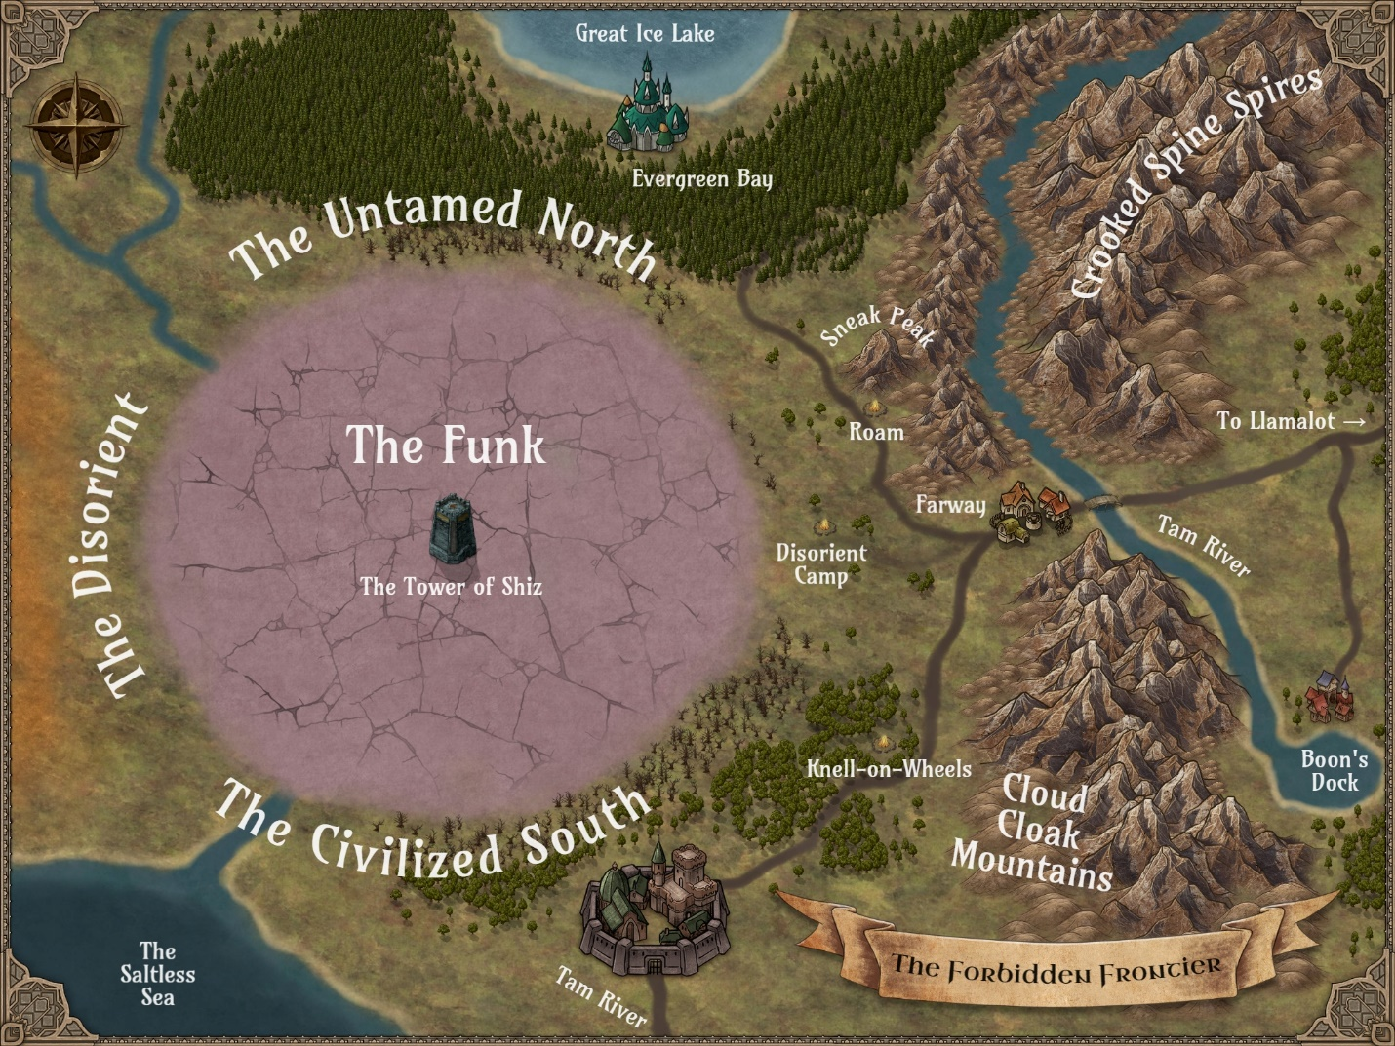
---------------------------------------------------------------------------------------------------------------------
The Forbidden Frontier
The Forbidden Frontier is a colloquial name given to the fringes of several countries, especially the hinterlands of the eastern human kingdoms. Prior to the appearance of the Funk, these frontier lands stretched for miles and miles. Explorers, prospectors, and homesteaders ventured far from the established humans realms. However, after the Funk swallowed these fledgling settlements, only the bravest dared to venture into the accursed region.

---------------------------------------------------------------------------------------------------------------------

Farway
Cradled at the foot of the Crooked Spine Spires, lies the village of Farway, the westernmost human settlement in the Forbidden Frontier. The white-capped vista sends the scent of pending winter even on the hottest of summer days. Calling Farway a village is generous, though, since very few people actually call Farway home. Most folks encountered in Farway are merely passing through, and the rest are shrewd merchants, desperate exiles looking for protection in a harsh land, criminals, or all of the above.
Because Farway is perched on the Tam River, it is accessible by road and water. Feral elves from the north paddle their way to port and trade for necessities. The river also serves as a deterrent from raiders, such as the clans of minotaurs that routinely ravage Boon’s Dock and other burgs that dot the wilderness.
Amenities in Farway are modest at best. The hard-edged and sometimes violent inhabitants echo the danger that lurks all around the village—from both the Forbidden Frontier and the Funk beyond.

---------------------------------------------------------------------------------------------------------------------

The Untamed North
First and foremost, the Untamed North is a misnomer. The elvish residents purposely foster a reputation of savagery to keep unwelcome trespassers at bay. In truth, there are more towns and, indeed, cities throughout the Untamed North than human settlements in the Forbidden Frontier, and the advancements found throughout the elves’ secretive country rival those found in the Civilized South.
From the outside, the Untamed North is just a wide swath of uncultivated prairies and forests. While outsiders believe the nomadic elves travel as game migrates across the land, with the deer, bears, and smaller mammals that serve as their chief food sources, the truth is only specialized hunting parties wander in this manner. Most elves keep to their villages and towns nestled among farmland, orchards, lumbermills, and even a few mines. Their horses are some of the fastest in Mezzo-Earth.
However, the so-called feral elves that call this region home protect their precious land with wild rumors and ferocious border guards who play the part of uncivilized and uncouth scavengers. This joke they play on the rest of the world is a source of amusement for not only the border patrols that roam the northern regions of the Forbidden Frontier, but also those who live deep within the realm, including the capital city of Evergreen Bay, an unmapped locale rumored to be situated somewhere on the coast of the Great Ice Lake.
Uninvited guests to the Untamed North are invariably greeted by a band of feral elf riders, whose sharp words and sharper spears encourage travelers to turn back.

---------------------------------------------------------------------------------------------------------------------

The Civilized South
When the dwarves emerged from their subterranean empire and planted their first colony on the surface, they called it Up Town. Over time, the city has grown so large as to become the seat of power for its own distinct empire. Because so much of the West remained unsettled for so long, visitors to Up Town started calling it the Civilized South to contrast the city with the wild frontiers around it. The dwarves eventually started referring to their growing empire broadly as the Civilized South.
According to dwarves, the Civilized South extends as far north as the Cloud Cloak Mountain Range, though the human who call Farway home might disagree. No one, however, can refute that the vast dwarven empire stretches as far south as the Saltless Sea. For centuries, the Funk all but separated the Civilized South from the Disorient—until now.
Boasting large cities behind nigh-impregnable walls, forges that never grow cold, and a network of well-maintained (and well-patrolled) roads, the Civilized South certainly lives up to its name. The vast majority of inhabitants are dwarves, though human and even some elves have made a permanent home there. Of its many innovations, the Civilized South is most renowned for its clockwork contraptions.
Those who travel to the Civilized South are welcomed with open arms and open purses— commerce is the lifeblood of an empire, after all!—but those who break the law face costly penalties.

---------------------------------------------------------------------------------------------------------------------

The Disorient
If the feral elves of the Untamed North are cold toward unwelcomed visitors, then the humans of the Disorient are downright hostile. Since its mysterious founding more than a millennia ago, the Disorient has kept the wider world at bay. To many outsiders, the Disorient (both the place and its people) are a myth, though traveling merchants from the Civilized South, elven sentries from the Untamed North, and Farway regulars may have had glimpsed the rare Disorient pilgrim.
Due to their staunch isolationist stance, very little is known about this region of the Far West, including how far west it goes. Even the dwarves of the Civilized South, who have had more dealings with the Disorient than any other people—some diplomatic, some militaristic—can say only that the Disorient now borders their empire more so than ever before, thanks to the dwindling of the Funk.
Even though the founders of the Disorient were humans, most scholars reject the idea that the Disorient resembles the eastern human kingdoms to any degree. In fact, some speculate that the Disorient people are no longer truly human, having either been corrupted by some malevolent influence or evolved due to conditions within their enigmatic homeland. Because they cover themselves entirely in black, deemphasize any sex traits, and speak an entirely different language from the human kingdoms of the East, a few folks have started referring to the Disorient as their own unique race.
Whether the realm itself is innately magical (as some of its people seem to be) remains unknown. Unfortunately, war may be the only way the rest of the world will ever learn anything about the Disorient.

---------------------------------------------------------------------------------------------------------------------

The Funk
Once upon a time, untouched wilderness reached as far west as anyone could fathom. A sect of humans who called themselves the Disorient settled a significant distance from their origin, leaving plenty of space between them and their erstwhile kin as well as the elves of the Untamed North. But something sinister happened to this unclaimed territory in the years that followed, a preternatural event that corrupted the land to its core.
No one alive really knows what caused the Funk, but rumors abound. The dwarves blame the uncivilized elves, who blame the Disorient. Naturally, what the humans of the Disorient believe remains a mystery.
While the source of the catastrophe that cloaked the land in purplish-gray fog remains the subject of debate, one thing is for certain: whatever eldritch phenomenon was uncorked, it attracted a number of threats that dissuade explorers from seeking out the source, including toxic snow, malevolent hallucinations, sudden fluctuations in gravity, tremors in the air itself, and a prevailing stench that tests a traveler’s sanity.
Many lives were snuffed out when the Funk erupted and engulfed the region—a territory the elves had long called the Unholy Land—and many more lives were lost because of foolish adventurers who breeched its borders in the years that followed. However, recent events suggest that the curse that caused the Funk has been broken. The anomaly continues to recede, emboldening many to predict that the Funk will soon cease to exist altogether—leaving behind an untouched land ripe for the picking.

---------------------------------------------------------------------------------------------------------------------
Here’s my cheat sheet for GMs:
- The Forbidden Frontier — the land that rings the Funk, especially the mostly human settlements to the east, including the village of Farway.
- The Untamed North — a secluded kingdom of elves that pretend to be uncultured to scare invaders away.
- The Civilized South — a dwarven empire that has been slowly growing over the past few centuries.
- The Disorient — a mysterious human nation that ventures from its borders only when it wants something.
— A.

---------------------------------------------------------------------------------------------------------------------

---------------------------------------------------------------------------------------------------------------------

Using Maps
The regional map of the Forbidden Frontier found in Appendix F on Page X and should be shared with the players at the start of the game—while the GM reads through the prologue, for example. Providing the party with a copy of the map is also recommended to make navigating this region, politically and geographically, a little easier.
The detailed regional map found in Appendix E should not be shared with players because it includes undiscovered destinations (i.e. spoilers). Similarly, maps of settlements (called Local Maps) and scaled, top-down topography for specific encounters (called Battle Maps), shouldn’t be shared with players ahead of time. They are for the GM’s eyes only until the characters arrive at the corresponding locales.
When all else fails or if you want to set a scene in a place without a provided map, you can always create your own from scratch or resort to “theater of the mind,” where you paint a picture of the setting using words only.

---------------------------------------------------------------------------------------------------------------------
You don’t need a special map for every little thing, such as stopping to inspect a strange tree while on the road or even when setting up camp for the night. Theater of the mind for the win!
— A.
---------------------------------------------------------------------------------------------------------------------
---------------------------------------------------------------------------------------------------------------------

---------------------------------------------------------------------------------------------------------------------
---------------------------------------------------------------------------------------------------------------------

Starting the Adventure
You’ve read (or at least skimmed) the front of this book, gathered your players, and are ready to don the mantle of Gamemaster. On with the adventure!
The story begins as one or more members of Good Company reach the outskirts of Farway to lead the peace talks. If you and your players are eager to dive into the main quest, proceed to Act 1 on Page X.
If you wish to ease your heroes into the game, however, an optional prologue follows to be used as a tutorial and/or to set the scene.
Regardless of where you begin, read or summarize the following text to provide the players with the background they need to enjoy the adventure:
You are a member of Good Company, a motley band of heroes who came together under unusual circumstances to defeat a great evil that threatened all of Mezzo-Earth. That was almost a year ago. Since then, you and your companions have gone your separate ways to attend to personal business.
But Good Company has been called to reunite once more.
More than a week ago, you received a summons from the distant village of Farway, asking you and your comrades-in-arms to return to the Forbidden Frontier, a far-flung land where Good Company once ventured in order to claim the coveted Staff of Er’Mah’Gerd, a relic that helped them save Mezzo-Earth.
The letter explains that ever since Good Company took the staff from the Forbidden Frontier, the cursed land to the west of Farway has begun to recede. On the surface, this is a blessing for the various settlers and wanderers of the Forbidden Frontier. And yet, three neighboring nations now vie for the newly freed territory.
Amos Tinsman, the sheriff of Farway, ends his message with an earnest plea for Good Company to return to the Forbidden Frontier to resolve a problem the heroes inadvertently caused by leading peace talks among the three factions—and, if the gods are good, to prevent a war from engulfing the region.

---------------------------------------------------------------------------------------------------------------------

---------------------------------------------------------------------------------------------------------------------

Prologue
If you and/or your players are new to tabletop gaming—and to 5E in particular—consider using the Session Zero encounter below to familiarize everyone with combat as well as get comfortable with roleplaying their characters.

---------------------------------------------------------------------------------------------------------------------

Session Zero
The heroes of Good Company are still a day away from their destination, the frontier village of Farway. The earthen road that stretches to the Forbidden Frontier has been long and uneventful, giving them plenty of time to share what they have been up to since saving the world together as well as their feelings about this unexpected mission.
Perhaps the travelers have become complacent because an unexpected threat has closed in on them without their knowing!
Encounter: Bunch of Wimps
Time
Because they are primarily nocturnal, possess darkvision, and are evil, wimps are more inclined to attack at night than during the day. However, these scavenging devils also can become desperate for prey, so if you want to go easy on heroes who lack darkvision, feel free to set this encounter in broad daylight.
Setting
The barren plains of the Forbidden Frontier’s eastern border surround Good Company on all sides. If this encounter takes place at night, the party has just started to prepare a camp for the night, settling in a handful of feet from the road. If this encounter takes place during the day, Good Company is following the long road west, enjoying fair, cool weather.
Scaling
This bunch of wimps lacks a leader of any kind, and their tactics are simple: overwhelm the enemy with numbers and engage in melee combat until no one is left standing. Use the table below to determine how many wimps swarm Good Company. You can always add a second wave of additional wimps if the first is defeated before all players have a chance to act.
This is designed to be an easy encounter.
Scaling for Bunch of Wimps Encounter
Number of Players | Number of Wimps
1 | 2
2 | 4
3 | 6
4 | 8
5 | 10
6 | 12

Initiative
Wimps aren’t especially stealthy, though they do try to sneak up on their prey. Characters with a passive Perception score of 12 or higher can’t be surprised by the wimps. However, those with lower scores (e.g. Sir Larpsalot and Lord Grimdark) suffer a surprise round of combat before joining the initiative order.
Aftermath
Sadly, wimps like to kill for the sake of killing and not, necessarily, to accumulate their victims’ wealth. Use the chart below to determine what loot can be found on the wimps’ corpses. Roll a d4 for each wimp defeated.
Wimp Loot
d4 | Loot | Description
1 | Squat | There is no loot to be found on the body.
2 | Stank water | This potion has no color but smells awful. A creature that consumes even a drop of it vomits and takes 1 point of poison damage.
3 | Ghoul’s gold | Bewitched to look like real gold coins, ghoul’s gold is, in fact, worthless.
4 | Money | 2 (1d4) copper coins can be found on the creature.

After this encounter, Good Company has an opportunity for a long rest before continuing their trek, so they will be well-rested and have all of their abilities available when they reach Farway. Proceed to Act 1 on Page X!

---------------------------------------------------------------------------------------------------------------------
---------------------------------------------------------------------------------------------------------------------
---------------------------------------------------------------------------------------------------------------------
---------------------------------------------------------------------------------------------------------------------

Act 1
The majority of Act 1 is set in the village of Farway, a frontier settlement with more travelers within its faded wooden walls than permanent residents at any given time. While most occupants are human transplants from the eastern kingdoms, a smattering of other races can be found milling about, including dwarves, elves, and maybe even a minotaur or two.
Most of the people found in Farway aren’t exactly unfriendly, but they are cautious and sometimes closed off when conversing with strangers, which includes Good Company. (Even though the heroes came through Farway on their way to retrieve the Staff of Er’Mah’Gerd, few residents would recognize them any more than they would one of the other hundred travelers that have passed through Farway in the meantime.
Like the populace itself, the half-dozen buildings that make up Farway are weathered and rough around the edges. All are made of planks from the reddish-brown fir trees that encompass the Untamed North, and all are single-story structures except for the inn. Visitors who don’t wish to make use of the inn—or can’t afford it—are permitted to camp within the village’s walls for a small price, resulting in a tent city scattered behind the wall.

---------------------------------------------------------------------------------------------------------------------

Running Act 1
Like all acts in this adventure, Act 1 includes a mix of exploration, social interaction, and battle. Here are a few tips to prevent it from becoming overwhelming—for the players and the GM:
- Read this section in its entirety before beginning Act 1.
- You don’t have to follow the subsections in any particular order, and it’s usually a good idea to let the players decide where they want to go and whom they wish to talk to next.
- All optional encounters—which may include dialogue, puzzles, or combat—are, in fact, optional. Use them to engage players or skip them to quicken the pace, as necessary.
- In fact, only four events must take place before completing Act 1: Quest: Peace Talks (Page X), Required Encounter: Ruffians (Page X), Quest: Pick a Side (Page X), and Required Encounter: Ambushed by a Rival Faction (Page X).

---------------------------------------------------------------------------------------------------------------------

Setting Overview: Farway
Population: 12 permanent residents, mostly human
Leader: Amos Tinsman (sheriff)
Militia: none
Allegiances: none
Rivals: none
Introduction: Read or summarize the following when Good Company arrives at Farway:
After many long days on the road, you have finally reached the eastern edge of the Forbidden Frontier, where you will arbitrate the peace talks with the dwarves, elves, and humans.
At first glance, Farway resembles a fort, but as you draw closer, you note the absence of watchtowers and sizable gaps between the sharpened logs forming a wall around the city. Through the open gate, you see a smattering of small wooden buildings and a few tents.
When you reach the gate, a tall, dark-skinned man with two hand crossbows hanging from his belt strolls toward you.
“Howdy, travelers. Unless my eyes are playing tricks on me, y’all must be those Good Company folks I sent for. I thank you kindly for makin’ the trip. My name is Amos Tinsman, and I’m the sheriff here in Farway, which only means I do what I must to keep the peace within these walls.”
He taps a scarred hand against one of his crossbows.
“I’m sure y’all are weary from your journey. Feel free to seek refreshments at The Winking Cyclops. The delegates are already gathered in the common room there, but I reckon the meetin’ won’t start for a little while yet. Otherwise, you’re free to wander the village, though there ain’t much to see.”
He spits something dark into the grass at his feet and waits for your reply.

---------------------------------------------------------------------------------------------------------------------
Some players may want to scope out Farway before entering the inn, learning what they can about the Forbidden Frontier and the three factions vying for the region, before starting the main quest. Others won’t look around until after the peace talks, if at all. Just go with the flow!
— A.
---------------------------------------------------------------------------------------------------------------------

Farway Locations & Residents
Use Local Map L1 – Farway in Appendix E to help the heroes find their way around Farway.
Tannery (F1)
Foul smells waft from the tannery, but beautiful pelts of indigenous mammals adorn the front of the ramshackle building and the racks that line the outside.
At night, the proprietor of the tannery, simply called Tanner, brings all of her wares inside, where she works and lives. She always conducts business outdoors, even in inclement weather.
Tanner
The half-elf that hunts the lands around Farway and prepares pelts and furs for trade is known only as Tanner to her neighbors and travelers alike. No one knows her real name, where she came from, or why she decided to settle in Farway, though rumors abound. She has no interest in the happenings of the outside world, seemingly content to stalk and trap prey, skin them, and sell what she doesn’t use herself.

Chapel of Caht-Tel (F2)
The two-roomed church distinguishes itself from the neighboring buildings only by the white triangle painted beneath its pointed roof.
The front door is always open, welcoming pilgrims and curious passersby alike—as well as flies. A modest altar dedicated to the goddess Caht-Tel, bearing an ever-burning white candle, along with two simple benches comprise the so-called sanctuary. The chapel’s sole minister keeps a modest living space behind a seldom-locked door.
Sister Sturdy
The first thing one notices of the old human who calls herself Sister Sturdy is her considerable size. As tall as she is round, the priestess does her best to keep her gown pristine, but stains from dirt and food typically sully the all-white garment. She is welcoming to all guests who come to revere the goddess and is completely unaware of the double-meaning of the name she chose to honor Caht-Tel’s resilience.

Stable (F3)
This barn-like structure might have been painted red once, but time has faded it to a rusty brown that resembles dried blood.
Three horses permanently reside at the stable: the sheriff’s black stallion, an old gray mare, and a white colt owned by the stablemaster. Travelers with mounts can access the stable from sunup to sundown.
Rick Ghastly
The stablemaster’s surname is more likely a nickname earned because of his gaunt appearance. The pale skin of this middle-aged human probably contributed as well. However, Rick is one of the friendliest fellows in Farway, willing to chew the fat with travelers as he tenderly cares for his elderly mare, which should have died years ago. (But he’s never gonna give her up.)

The Last Shop (F4)
A simple sign bearing three words carved in Common proclaim this compact building to be The Last Shop.
This modest-sized store offers more than one might assume at first glance. What the place lacks in décor—a sign on a wooden post outside and a small counter within are the only traits that hint at its mercantile nature—it makes up for in inventory, which is spread about the space in piles, strung up on walls, and even suspended from the ceiling. The Last Shop sells just about any mundane items an adventurer could want, albeit at a sharp markup.
Dave
Shopkeeper Dave is a shrewd businessman despite being only twenty-something years old. Because visits from traveling merchants are few and far between, he is a skilled haggler. Though he dresses modestly, some suspect he is quite wealthy. The bald, bearded human keeps a shortsword at his side to intimidate thieves and cheapskates alike.

Sheriff’s Office (F5)
The balanced scales carved above the doorframe of this cabin suggest an officer of justice dwells within.
Like the other hovels of Farway, the sheriff’s office resembles a simple home more than a place of business. The interior contains a small living space for the sheriff, a desk, and a single cell, which is usually unoccupied, since justice in the Forbidden Frontier is known to be swift and final.
Amos Tinsman
Amos is the latest in a long line of lawmen to try to keep Farway safe, his predecessors having been killed in the line of duty or quitting when the meager pay wasn’t enough to justify risking their lives. Amos is a grim but fair human. His salt-and-pepper hair and various scars suggest a long life of action.

The Winking Cyclops (F6)
Farway’s only two-story building, The Winking Cyclops has rustic charm to spare. A sign that bears the inn’s name in Common as well as a poorly sketched visage of the titular creature welcomes guests.
Inside, the common room is comprised of well-worn tables and chairs, where patrons can enjoy stale beer or moonshine and wash it down with stew. A crust of hard bread costs extra. Three closet-sized rooms on the second floor are available for rent, provided they aren’t already occupied. The proprietress, Mary Maker, seems to stand behind the bar morning, noon, and night.
Mary Maker
A no-nonsense businesswoman, Mary Maker knows when to flash a pretty smile, lend an understanding ear, or conk a rowdy patron over the head with the club stashed beneath her skirt. This dwarf of indeterminate age insists on getting payment up front and takes no guff. Customers who complain about the accommodations are promptly removed from the premises.
Gary Maker
Mary’s seldom-seen spouse, Gary Maker, spends most of his time working in the kitchen, balancing the books, or making more moonshine. Occasionally, he is spotted in the common room when delivering a new keg or on his way to fix a bed upstairs (again). The taciturn innkeeper is either a tall dwarf or a short human.
Old Man MacGuffin
Little more than a mass of wrinkles and wispy white hair, Old Man MacGuffin is a human who has lived for at least a century. Wearing threadbare trousers and an old-fashioned shirt that is more stain than dye, he tells extravagant—and exaggerated—stories from his many adventures in exchange for a drink. He spends most of his time at The Winking Cyclops, sometimes passing out in the common room and other times staggering outside to sleep under the stars.

Additional Farway NPCs
If you need other NPCs—perhaps a customer shopping at The Last Stop or fellow travelers sitting outside their tent—pick your favorite from the chart below, roll a d6 to select one randomly, or create your own.
Roll for a Random Farway NPC
d6 | Name | Race | Age | Occupation | Trait
1 | John D’oh | Human | Young adult | Thief | Has two different colored eyes that never stop moving
2 | Ima Girlboss | Elf | Adolescent | Adventurer | Talks as though she has already seen it all
3 | Sally Sarsaparilla | Human | Child | None | Wears expensive clothing and jewelry
4 | Peter Saltpeter | Dwarf | Young adult | Prospector | Whistles when he talks due to a gap between his front teeth
5 | Patty McMelt | Minotaur | Elderly | Retired warrior | Has one broken horn and wears a monocle
6 | Rando Calrissian | Human | Middle-aged | Gambler | Can’t resist a bet and always smiles, even after losing

---------------------------------------------------------------------------------------------------------------------

Farway Rumors
Like any tool, information can be helpful, harmful, or just confusing. If Good Company is able to warm up to any of Farway’s residents—or other visitors—you can use the chart below to convey rumors that may or may not help them on their way. Pick your favorite or roll a d10 to choose one randomly.
Roll for a Random Farway Rumor
d10 | Rumor | Reality
1 | “Amos Tinsman was once a Knight of the Coffee Table, but he betrayed Llamalot and was forced to flee for his life when More-Dread was routed.” | Every member of Good Company knows it was Sour Ron who betrayed Llamalot. If pressed, Amos will admit that he was a militiaman in Boon’s Dock and had an “unfortunate run-in” with the militia’s captain, prompting him to seek employment elsewhere.
2 | “Everybody knows the stew at The Winking Cyclops is made from travelers that Tanner stalks and kills and then sells to the Makers…it’s made out of people!” | While Tanner does sell meat to the Makers, it is primarily that of small game, such as rabbits and squirrels, and the occasional deer.
3 | “I have it on good authority that the peace talks today are a sham. The dwarves are going to pay off both the elves and the Disorient, buying up the land they want just like they buy everything else.” | Neither the elves of the Untamed North nor the humans of the Disorient would part with the land once consumed by the Funk for any amount of coin.
4 | “Old Man MacGuffin possesses a powerful artifact that makes him immortal. He’s hundreds of thousands of years old.” | While old for a human at 100, Old Man MacGuffin has survived this long by luck alone. However, he does possess a minor magic item. (See Optional Encounter: Riddles with a Drunk on Page X.)
5 | “There’ve been sightings of some kind of weird plant monster with glowing yellow eyes in the frontier lands. No one knows what it is or what it wants.” | The creature is a fosyth, and finding it is possible. (See Optional Encounter: Uprooted on Page X.)
6 | “If it hadn’t been for that meddling mage Er’Mah’Gerd, the Funk never would’ve existed in the first place. Never trust a wizard!” | Er’Mah’Gerd didn’t create the Funk, and it was only by her efforts that the spread of the Funk was contained.
7 | “The Disorient has spies everywhere, even Farway. Don’t trust nobody with nothing!” | None of the residents or travelers within Farway are spies for the Disorient. However, Tanner occasionally trades goods and news with a Disorient agent. If asked outright, Tanner won’t deny the claim and points out she isn’t breaking any laws by sharing news with anyone.
8 | “Something powerful evil is sucking up the dark magic of the Funk. I heard it’s an enormous eyeball creature that can kill ya at a glance!” | Something evil and powerful is absorbing the Funk. It’s not an eyeball creature, but a Commode-O Dragon (Tohubohu).
9 | “Sister Sturdy keeps a bastard half-minotaur baby hidden in the back of the church.” | Not everyone who worships Caht-Tel is a minotaur or loves minotaurs. Sister Sturdy has no children of her own or otherwise.
10 | “Mark my words, the peace talks will end with bloodshed. Those feral elves will kill anyone who tries to take their land.” | The peace talks will, in fact, end in bloodshed, though the elves are not behind the attack. (See The Three Factions & Their Delegates on Page X.)

---------------------------------------------------------------------------------------------------------------------

Farway Optional Encounters
Optional Encounter: What’s in the Box?
While exploring Farway, Good Company finds a six-sided box partially obscured by some weeds. The box, a glaringly imperfect cube, is made from an unfamiliar black metal, and each side has a small purple rune carved in the otherwise smooth surface. The largest side seems to be covered in a clear sticky substance.
Give the players the Disorient Puzzle Box handout in Appendix F to help them visualize the six sides of the puzzle box.
If the box is shaken, something can be heard rattling inside.
None of Farway’s residents or visitors will recognize the box or know how to open it. The only exception is Noh-Wei, who, if asked about it, will say only that children in the Disorient typically solve such a puzzle by age 5.

Solving the Puzzle
The runes are corrupted versions of the Common vowels—A, E, I, O, U, Y—with extra or missing lines.

A E I O U Y

Anyone who examines the runes can make a DC 12 Intelligence (Arcana) or Intelligence (History) check. On a successful roll, the examiner realizes that these are not characters from a known language or magical sigils, but in fact slightly obscured vowels.
Anyone examining the sticky side discovers the following with a successful DC 13 Intelligence (Nature) check: the resin covering this panel is a famously flammable sap from the tarbark palm tree. If fire is applied to the largest side, the following words in Common are revealed in bright white letters: “The answer is the recipient and the reward.”
Neither ordinary nor magical weapons can damage or destroy the box. Only solving the puzzle by pressing the Y, O, and U runes, in that order, will cause the largest side to slide open and reveal the prize inside. Nothing happens if any other combination of runes is pressed.

Results
When Y, O, and U are pressed in sequence, with no more than a few seconds passing in between, the box produces an audible click, and the largest side slides open to reveal a small, circular mirror with a crack across its reflective surface.
The Disorient Lens lets whoever is holding it reroll any one die for any reason once per day. The GM can make this boon known at any time, preferably for dramatic effect.
If a member of Good Company keeps the box without solving it, Unsolved Puzzle Box can be added to the character’s inventory.

---------------------------------------------------------------------------------------------------------------------

Optional Encounter: Riddles with a Drunk
Old Man MacGuffin, the Winking Cyclops’s best and worst customer, craves attention as much as alcohol. If Good Company buys him a drink, he will offer them the chance to win his most prized possession. No amount of cajoling will convince Old Man MacGuffin to disclose the identity of this object unless the challengers are able to answer his three riddles.
While only one guess can be made for each riddle, Old Man MacGuffin can be convinced to provide a single hint for each if the guesser succeeds on a DC 13 Charisma (Persuasion) or Charisma (Intimidation) check. (Use the Strength modifier instead of the Charisma modifier if Brutus the Bullheaded attempts to intimidate Old Man MacGuffin.)

Riddle 1
“What’s older than dirt, smells like stale beer, and seldom moves from this spot.”
Hint: “You’re lookin’ at ’im!”
Answer: Old Man MacGuffin

Riddle 2
“What’s golden and frothy going in and golden and frothy going out?”
Hint: “If you buy me another one, you’ll have your answer.”
Answer: Beer

Riddle 3
“What have I got in my pocket?”
Hint: “That’s for me to know and you to find out…but only if you win!”
Answer: The prize for this contest

Results
If Good Company answers all three riddles correctly on the first try—no do-overs!—then Old Man MacGuffin will reluctantly part with his prize: a blue gemstone that he claims is from the famed Staff of Er’Mah’Gerd but which, in fact, is a minor magical device created by the dwarves of the Civilized South. This MacGuffin Device can be attuned by any class and used once per day to cast the Shake, Rattle, Reroll spell without consuming a spell slot.

---------------------------------------------------------------------------------------------------------------------

---------------------------------------------------------------------------------------------------------------------

Quest: Peace Talks
Whenever Good Company arrives at The Winking Cyclops, the delegates representing the three factions—the Civilized South, the Disorient, and the Untamed North—are gathered in the inn’s common room, though they keep their distance from one another. They are all unarmed.
Mary Maker, the barkeeper, tells Old Man MacGuffin and any other patrons present to finish their drinks and move along so that the peace talks can begin.
Good Company can use this time to introduce themselves to the individual delegates, who will be taking stock of them as much as Good Company is scrutinizing them.
During the peace talks (and before), Good Company has a chance to engage the delegates. The heroes’ objective is to help broker a fair compromise for divvying up the land slowly breaking free of the effects of the Funk. Even as Good Company hears each faction’s demands and feelings about the other delegates’ motives, the heroes can gain or lose favor, depending on their words, deeds, and other details.
Each delegate has one of three attitudes toward Good Company—sweet, meh, or salty—which can be swayed and may impact the path they take in this adventure. You can elect to share the importance of how the characters present themselves or keep this a secret from the players.
The peace talks begin when Good Company clears the room or when Mary Maker ushers the other customers away and withdraws from the common room herself. If Good Company doesn’t take the initiative to proceed in an orderly way, Gildbert G. Goldbottom will insert himself in the process, suggesting they take turns stating their demands.
- Objective: Meet the delegates, learn their demands, and start the peace talks in earnest.

---------------------------------------------------------------------------------------------------------------------

The Three Factions & Their Delegates
The Civilized South
The dwarves of the Civilized South are eager to extend their empire northward. They believe their expansion would be in the region’s best interest for a variety of reasons, including the commerce and stability they would cultivate—unlike the barbaric approach that the feral elves of the Untamed North would surely take. Conversely, this faction cautions against letting the Disorient (and their secret agenda) get a foothold in the area.
Gildbert G. Goldbottom
Male Dwarf
Lavish of dress and eloquent of tongue, Gildbert G. Goldbottom represents himself and his empire with utmost aplomb. His shiny smile is as much a part of him as his braided brown beard and growing paunch. He is generous with both compliments and coin.
Regardless of his true feelings, Gildbert always presents an overtly jovial approach to engaging Good Company as well as his rival delegates. He is gifted in the art of diplomacy and says whatever he can to keep the atmosphere lighthearted. While he sues for peace—and a bigger piece of the pie for the dwarves—he is committed to proving to all just how civilized the South can be.
- Desire: He will claim as much of the newly available land as he can get his hands on for the Civilized South.
- Attitude: Sweet. If Elvish Presley is in the party (without Tom Foolery), his attitude worsens to meh.
- Concessions: The Civilized South is willing to split up the land, though Gildbert will do whatever he can to get more than the dwarves’ fair share—and to ensure the Disorient gets the smallest allotment.
- Secrets: The dwarves are prepared to take the land by force if Good Company’s ruling does not go in their favor, though Gildbert is hopeful it won’t come to that. He even hired a handful of ruffians to disrupt the peace talks to strengthen his argument for bringing structure and stability to the Forbidden Frontier.
Read or summarize the following text when introducing Gildbert. An illustration of this delegate has been provided in Appendix F.
Standing beside the bar, a middle-aged dwarf with a broad smile and broader belly raises his glass and nods in your direction. He is dressed in finely tailored attire that includes a polished brass belt buckle and a red cape with golden stitchwork. His brown beard is braided in a gentlemanly fashion.
As you draw near, he calls out to you, “Come, come! Let us share a drink before beginning our business!” With a low bow, he adds, “I am Gildbert G. Goldbottom, and it is my honor to serve as the delegate of the Civilized South.”

---------------------------------------------------------------------------------------------------------------------

The Untamed North
The so-called feral elves don’t want to claim the formerly Funk-plagued land for themselves. Rather, they want to uphold the status quo—keeping this region as unpopulated buffer between the nations. However, maintaining the uneasy peace in the region is only part of the elves’ purpose. An ancient prophecy foretells a horrible calamity should anyone settle in the Unholy Land.
- Desire: The Untamed North wants to keep everyone out of the land once consumed by the Funk, including the elves themselves, to prevent a dire prophecy from being fulfilled.
- Attitude: Meh. If Elvish Presley is in the party (without Tom Foolery), the attitude improves to sweet. If Tom Foolery is in the party (without Elvish Presley), the attitude worsens to salty.
- Concessions: None—if any of the land is parceled out to any or all of the factions, the Untamed North will harry all efforts to settle there.
- Secrets: The Untamed North is not nearly as wild as the elves pretend it to be.
River Eagle
Female Elf
Tall, stoic, and severe, River Eagle regards everyone around her as a possible threat. The elf warrior has been a member of the Untamed North’s border patrol for many years, and she has the battle scars to prove it. The smells of the wilderness cling to the elvish envoy, who is eager to return to the trees, her trusty bow Badger’s Bite in hand.
Although River Eagle has a firm grasp of the Common language, she purposefully slips in poor grammar or the wrong word so that her rivals (and Good Company) underestimate her intelligence. She speaks plainly and emotionally, never afraid to challenge perceived threats. Even when she is without her weapons, she unconsciously reaches for the comfort of her bow.
Read or summarize the following text when introducing River Eagle. An illustration of this delegate has been provided in Appendix F.
A long-legged elf in simple leathers sits, arms-crossed, by herself at one of the tables. She clutches a tankard but doesn’t drink, her narrowed eyes watching everything around her—watching you. Green and brown stripes of warpaint cover her face, and a pair of feathery tattoos drape down her bare arms like wings.
Her lips twitch, though don’t actually smile, at your approach. She stands and says, “Good Company, yes? I am River Eagle, and I represent the elves of the Untamed North.”

---------------------------------------------------------------------------------------------------------------------

The Disorient
As with most aspects of their secluded society, the Disorient’s motivations remain mysterious. All that the Disorient’s delegate will say is that their people would push eastward, enveloping the newly freed land and enforcing the same no-entry policy that their nation currently has in place. The Disorient is uniquely positioned to contend with the lingering effects of the Funk—though its delegate won’t explain why.
Noh-Wei
Human (gender unrevealed)
Clad in a hooded black gown from head to toe, Noh-Wei makes every effort to remain inscrutable. Age, gender, expression—all of these are actively obscured, and when Noh-Wei speaks, their whisper can be heard clearly despite the featureless opaque mask that covers their mouth and lacks eyeholes entirely.
To say that Noh-Wei is reserved would be an understatement. The Disorient’s delegate eschews gestures and other body language. When they deign to speak, the whispered words tend to form vague statements, double meanings, and riddles. Although their presence might be perceived as unnerving to others, Noh-Wei never engages in bickering or threatens their rivals with hostility.
- Desire: The Disorient has charged Noh-Wei with claiming no less than half of the newly available land.
- Attitude: Salty. If Lord Grimdark is in the party, the attitude improves to meh.
- Concessions: Noh-Wei will agree to keep a portion of the area unpopulated as a buffer but will insist that no other faction receives more land than the Disorient.
- Secrets: The Disorient has little faith in the peace talks but sees this as an opportunity to foment suspicion between the other two factions. Moreover, the Disorient is far more interested in the power still rumored to lurk within the Funk than the land itself.
Read or summarize the following text when introducing Noh-Wei. An illustration of this delegate has been provided in Appendix F.
A figure stands as still and silent as a statue near one of the common room’s grease-smudged windows. Seemingly draped in shadow, you can’t immediately tell the creature’s gender, race, or age, though their build suggests a healthy body beneath the flowing black robe. A closer look reveals a mask without eyeholes or an opening for the mouth.
When you approach, you hear a soft whisper: “Well met, Good Company. Welcome to the Forbidden Frontier. Or should I say, ‘welcome back’?”

---------------------------------------------------------------------------------------------------------------------
You can let the peace talks go on for as long as—and get as heated as—as you want. It’s a good opportunity for the players to get to know these important NPCs and their motivations as well interact with them in ways that impact the delegates’ attitudes toward Good Company.
— A.
---------------------------------------------------------------------------------------------------------------------

Required Encounter: Ruffians
Time
The ruffians have been instructed to interrupt the peace talks at a specific time fairly early in the proceedings. You can decide whether their arrival interrupts shortly after the formal introductions, breaks up the delegates’ heated debate, or intrudes at another appropriate moment.
Setting
The Winking Cyclops’s common room serves as the battlefield for this required encounter.
Scaling
What the ruffians lack in sophistication, they make up for in unbridled ferocity. They are also armed, unlike the three delegates, whose weapons are locked away elsewhere in the inn. Gildbert inserts himself in the skirmish so that he can suffer a nonlethal blow and feign unconsciousness; he does not otherwise contribute to the battle. Noh-Wei attacks only if attacked, dealing nonlethal damage with unarmed strikes. River Eagle, however, will put herself in harm’s way, eagerly confronting the ruffians with her fists and possibly becoming a casualty.
Use the table below to determine how many ruffians have been hired to disrupt the peace talks. This is designed to be an easy encounter.
Scaling for the Ruffians Encounter
Number of Players | Number of Ruffians
1 | 2
2 | 4
3 | 6
4 | 8
5 | 10
6 | 12

Initiative
Unless a member of Good Company is posted at the front door, actively watching and listening for trouble, the ruffians benefit from a surprise round of combat against Good Company and the delegates. If Good Company assigned one or more sentries, they must succeed on a DC 12 Wisdom (Perception) check to prevent the surprise round.
Aftermath
The ruffians carry nothing of value, but if Good Company keeps at least one of them alive, the party can try to ply them for information, such as who hired them. Because they want to collect the rest of the coin promised to them, they will not rat out Gildbert, who “regains consciousness” immediately after the battle. Only magic or a successful DC 15 Charisma (Intimidation) check will goad them into admitting they were hired by the dwarf to disrupt the peace talk—which Gildbert will vehemently deny. (Use the Strength modifier instead of the Charisma modifier if Brutus the Bullheaded attempts to intimidate a ruffian.)
Sheriff Tinsman arrives shortly after the scuffle to escort any surviving ruffians out of town. He regrets not being around to help out but acknowledges Good Company was more than equipped to handle the miscreants.
As for the delegates, any hope of continuing the peace talks are dashed. Gildbert blames Noh-Wei for orchestrating the fight (since she avoided combat), and River Eagle accuses Gildbert of hiring them (since the ruffians didn’t kill the dwarf when they had the chance). Noh-Wei casts no aspersions on the other delegates, content to state that they had no involvement and observe the others.
After this encounter, Good Company has an opportunity for a short or long rest at The Winking Cyclops, though waiting around in Farway may prevent them from allying with one or more factions. Proceed to Quest: Pick a Side on Page X for more details!

---------------------------------------------------------------------------------------------------------------------

---------------------------------------------------------------------------------------------------------------------

Quest: Pick a Side
Following the battle with the ruffians, none of the delegates are interested in pursuing the peace talks. There is no trust among them, and none believe a mutually beneficial compromise is possible anyway.
A delegate who has a sweet attitude toward Good Company will invite the party to join them on their journey home. A delegate with a meh attitude could possibly be convinced to let Good Company accompany them, though a delegate with a salty attitude can’t be convinced to ally with Good Company and will become hostile if followed.
If Good Company tries to cast a spell on a delegate, that faction automatically becomes salty.
- Objective: Determine which of the three factions to accompany.

---------------------------------------------------------------------------------------------------------------------

The Favor of the Three Factions
Use the chart below to calculate whether a specific faction will accept Good Company as traveling companions. A plus sign (+) indicates an improvement of one attitude level, a minus sign (–) indicates a worsening of one level, and a zero (0) indicates no change.
The Delegates & Their Attitudes
Faction | Default Attitude | Tom Foolery is in the Party | Elvish Presley is in the Party | Lord Grimdark is in the Party | Party Killed One or More Ruffians | Party Solved the Disorient Puzzle Box | Party is Unwilling to Leave Farway Immediately
Civilized South | Sweet | + | – | 0 | + | 0 | –
Untamed North | Meh | – | + | 0 | + | 0 | 0
Disorient | Salty | 0 | 0 | + | – | + | –

You can also factor in any other interactions, such as dialogue during the peace talks or actions during combat, to impact the factions’ attitude toward Good Company.
Factions that have a sweet attitude toward the party will welcome them, while meh factions may need more convincing. Succeeding on a DC 14 Charisma (Persuasion) check convince a delegate with a meh attitude to let Good Company join them on the road.
Any attempt to intimidate a faction will automatically drop the respective delegate’s attitude to salty.
A faction with a salty attitude will refuse Good Company’s attempts for an alliance.

---------------------------------------------------------------------------------------------------------------------
Some players might be tempted to interrogate the delegates, scour Farway for clues, or find other ways to stall so they feel good about which faction they pick. But time is of the essence.
If Good Company can’t make a decision—or one isn’t made for them—the sheriff will politely ask Good Company to leave Farway because the town doesn’t need any more trouble. Amos Tinsman could also suggest Good Company join up with a faction if only to keep an eye on them.
— A.
---------------------------------------------------------------------------------------------------------------------

Aftermath
Good Company must secure an alliance and agree to travel with one of the three factions. See below for details and then proceed to Setting Overview: The Road from Farway on Page X.
The Civilized South
The Civilized South represents the easiest alliance to secure and the most-likely path forward for the heroes.
Gildbert G. Goldbottom is eager to depart Farway, telling Good Company that he won’t feel truly safe until he has rejoined his contingent, which is camped a half-day’s hike south of the village. He promises to take Good Company to meet the ruler of the Civilized South, Emperor Stalagmight, in the capital city of Up Town. Together, they can create a treaty for the Forbidden Frontier that is fair and just.
The Untamed North
The Untamed North represents a slightly more challenging alliance to secure but is still a probable path forward for the heroes.
River Eagle is willing to remain in Farway a little while longer if Good Company needs to resupply for the journey ahead or do a little digging into who is responsible for hiring the ruffians. She suggests rendezvousing with her band of feral elves, encamped a half-day’s travel north of Farway, before venturing to the capital city of Evergreen Bay and sharing the news of the failed peace talks with the Elder.
The Disorient
The Disorient represents the most difficult alliance to secure and the least-likely path forward for the heroes.
Noh-Wei sees no reason to linger in Farway. The peace talks were sabotaged, and they must take what they have learned about the other factions back to their superior, the Nightbride. If Good Company is found to be acceptable allies, Noh-Wei will allow the heroes to join them, though Noh-Wei will continue to keep their secrets close to the vest.

---------------------------------------------------------------------------------------------------------------------

---------------------------------------------------------------------------------------------------------------------

Setting Overview: The Road from Farway
Introduction: Read or summarize the following when Good Company leaves Farway:
Three paths lead forth from Farway—the long road that brought you here from the East, a dirt trail that winds to the southwest toward the dwarven empire, and a faint path that hugs the Crooked Spine Spires to the north.
Stretching westward looms a vast prairie with the occasional patch of deciduous trees. The sky in all directions is draped with gray clouds, though the gloom becomes much darker to the west, where the Funk remains.
As the smattering of cold raindrops induce an involuntary shiver, you take one last look at sleepy Farway before pressing on, not knowing what the Forbidden Frontier has in store for Good Company.

---------------------------------------------------------------------------------------------------------------------

The Road from Farway Locations & Residents
Passersby are rare in this region, though solitary travelers and the occasional caravan are sometimes spotted. Feel free to use the characters outlined in Additional Farway NPCs on Page X and Farway Rumors on Page X if you wish to impart additional information during this leg of the journey.

---------------------------------------------------------------------------------------------------------------------
Remember to always ask for the party’s “marching order” when they are moving from place to place, even if you aren’t planning to slip in an encounter. If you only ask who is first and who is last right before a battle, the players will always know something big is about to happen!
— A.
---------------------------------------------------------------------------------------------------------------------

The Road from Farway Optional Encounters
Optional Encounter: Treasure in the Treetops
While following their guide to the delegate’s specific rendezvous, Good Company crosses beneath the canopy of tall, healthy trees. It is an ideal place to wait out the rain, which has grown bolder and colder since leaving Farway behind, or to take a moment’s reprieve from the road.
All of the trees bear bright green leaves except for one, whose foliage boasts autumnal hues of rich orange and vibrant yellow. If one or more members of Good Company are watching the treetops for a possible ambush, they automatically note the anomaly. Characters with a passive Perception of 13 or higher also catch the multicolor leaves out of the corner of their eyes.
- If Gildbert is in the party, he has no interest in the tree and is eager to move on.
- If River Eagle is in the party, she pauses to point out the unusual tree.
- If Noh-Wei is in the party, they notice the tree but do not draw attention to it. Neither will they assist in inspecting the tree.

Investigating the Autumn Tree
Other than the seasonal colors of the autumn tree, it resembles the other trees around it in every way. Like its neighbors, it stands roughly 60 feet tall, and the trunk is thick with many long, crooked branches entwining upward.
The following can be learned with successful skill checks:
- DC 12 Intelligence (Nature) or Wisdom (Survival): the tree is a common variety of oak found all across Mezzo-Earth, and nothing about the size, shape, or bark of the tree suggests anything unusual about it.
- DC 15 Wisdom (Perception): A glint of light catches on something high up in the branches, but the foliage is so thick that nothing else can be discerned from a distance.
If Sir Larpsalot or Lord Grimdark use Guidance of the Gods near the tree, a very faint sense of evil permeates the grove, while the autumn tree emanates a strong aura of good from one of the upper branches.
The tree can be climbed with a series of successful Dexterity (Acrobatics) checks—DC 12 for the first 20 feet, DC 14 for the next 20 feet, and DC 16 for the final 20 feet.
If damage is done to any of the trees, including the application of fire, every creature within 15 feet of any of the trees must make a DC 16 Dexterity saving throw, as all of the green leaves drop from the trees. The falling leaves become black, inflicting 10 (2d8 + 1) necrotic damage on a failure, or half as much damage on a success. However, the autumn tree does not lose its leaves in this manner.

Results
A character who makes it to the top of the autumn tree finds a bright yellow ribbon tied to one of the branches. The ribbon is magical, which can be discerned with a successful DC 15 Intelligence (Arcana) check. Guidance of the Gods reveals that the ribbon is a rich source of good.
The ribbon can be easily untied from the high branch. If the ribbon is removed, every creature that is not touching the ribbon within 15 feet of any of the trees must make a DC 16 Dexterity saving throw, as the green leaves and autumnal leaves alike blacken and fall to the ground. On a failure, a creature takes 10 (2d8 + 1) necrotic damage, or half as much damage on a success.
A character of good or neutral alignment can attune to the ribbon, Lady Larakeet’s Laurel, to gain resistance from necrotic damage.

---------------------------------------------------------------------------------------------------------------------

Optional Encounter: The Lone Granger
After a few hours on the road, a large humanoid figure is spotted on the path ahead. Between Good Company and the stranger is nothing but open plains, so there is nowhere to hide. The traveler does not slow as it approaches. At a distance of 90 feet, it is revealed to be a hulking black female minotaur.
The minotaur regards Good Company warily, her hand inches from the large scythe hanging from her belt.
- If Brutus the Bullheaded is in the party, the black-furred minotaur mumbles a curt greeting as their paths cross.
- If Gildbert is in the party, he recommends not making eye contact and proceeding past the minotaur without showing any fear.
- If River Eagle is in the party, she greets the minotaur politely but does not actively engage in conversation.
- If Noh-Wei is in the party, they ignore the minotaur entirely.

Interacting with the Minotaur
Any onlooker’s first impression of the minotaur is that she must be a formidable warrior, not only because of her muscular build, but also due to the massive sickle at her side and the bloody gash that starts above her jawline and extends down her neck.
The minotaur will only attack if she must defend herself. If she is outnumbered by at least three-to-one, she will dash away, risking attacks of opportunity in hopes of reaching safety.
The following can be learned with successful skill checks:
- DC 14 Wisdom (Perception) or Wisdom (Medicine): the minotaur’s wound is fairly fresh, a couple days old at most. It looks infected.
- DC 15 Intelligence (Investigation): a few pieces of hewn grain cling to the scythe, and the minotaur carries a heavy backpack across her shoulders, out from which peeks the top of a large green squash.
While the minotaur is reluctant to stop and chat with Good Company, she can be persuaded to share information about herself and the region—and even give into her curiosity about a minotaur traveling with non-minotaurs, if Brutus is in the party.
Intimidation tactics do not work on this minotaur. However, success on Charisma (Deception) or Charisma (Persuasion) checks can reveal the following information through dialogue. Roll with advantage if Brutus is in the party or if one of the heroes heals the minotaur’s wound.
- DC 12: The only other traveler who has bothered to talk with her on the road was a dwarf who offered to pay her to cause a ruckus in Farway to interrupt an important meeting. She refused. (If Gildbert is in the party, she recognizes him and asks if these warriors ended up helping him. Gildbert insists the minotaur has mistaken him for some other dwarf.)
- DC 14: Her name is Agri. She left her clan, High Steaks, because she is not interested in raiding, but wants to start her own farm. She’s a vegetarian and has no appetite for slaughter of any kind.
- DC 16: When she refused to join a recent raiding band against the humans of Broken Fork, her brother Agro attacked her. He is responsible for the wound on her face and neck. She disarmed him, knocked him unconscious, and fled the clan.
- DC 18: She would swear to Caht-Tel she saw something large and dark flying above the Funk yesterday, but the thing was too far away to make out any details.

Results
Other than information, Agri has little to offer Good Company. She parts ways as gracefully as she can, bound for Farway in hopes of making an offering to her goddess at the Chapel of Caht-Tel and asking for guidance on where to establish her farm.

---------------------------------------------------------------------------------------------------------------------

---------------------------------------------------------------------------------------------------------------------

Quest: Escort Mission
Regardless of which faction Good Company has allied with, the heroes now travel with a virtual stranger. The road is a wonderful place to get to know someone—or suffer through long hours of awkward silence.
The delegates have their own unique destinations, as outlined below.
- Objective: Learn as much as possible from your traveling companion (and keep them alive) en route to the rendezvous.

---------------------------------------------------------------------------------------------------------------------

Traveling Companions
A traveling companion’s attitude toward Good Company will determine how much information they share and what secrets they will keep. Events, including dialogue, that occur on the road can further improve or deteriorate the delegate’s attitude.
Gildbert G. Goldbottom
Destination
Gildbert is eager to return to his caravan south of Farway, where he left the contingent of dwarves charged with seeing him safely to the peace talks, and then back to the capital city of Up Town.
Interactions & Intel
If Attitude is Meh
- Gildbert remains as gregarious as ever, though for all of his warm words, he shares precious little information.
- He will not provide many details about the Civilized South’s plans for the region, other than that he expects Emperor Stalagmight will draft a treaty so fair that the feral elves and the Masked Ones of the West will have choice but to sign it.
- He will not speculate on the rival factions’ motivations or how they will react to the attack at the peace talks.
- If Tom Foolery is in the party, he addresses most of his questions to him, as though the fellow dwarf were Good Company’s leader.
If Attitude is Tight
- Gildbert’s mood is upbeat, almost celebratory. He can’t wait to show Good Company around the Civilized South and introduce them to Emperor Stalagmight. He is fully confident that together they will come up with a treaty that is fair and promotes peace in the region.
- He unabashedly shares his opinions about the feral elves: the brutish denizens of the North are a superstitious lot, but they respect strength. If they are told how things are going to be going forward, they will begrudgingly respect the decision.
- He unabashedly shares his opinions about the Disorient humans: the lot of them are loony, and he doesn’t expect them to respect any legal document, even if it is in their best interest. Sadly, there will probably be clashes along their ever-growing shared border in the weeks, months, and perhaps even years ahead.
- If Tom Foolery is in the party, he actively seeks him out for private conversations not only about their current situation, but also about Tom Foolery’s past and what it was like growing up among humans.
Enduring Secrets (revealed only under duress)
- Gildbert will not admit that he hired the ruffians to disrupt the peace talks unless confronted with irrefutable proof. If backed into a corner, he will relent and explain that no harm was meant. It was merely a diplomatic measure to emphasize the need for law and order in the region.
- The Civilized South has been secretly preparing to take the lands once ravaged by the Funk by force, if necessary. Gildbert is aware of several military camps in addition to his own, including one that harbors a secret weapon.

---------------------------------------------------------------------------------------------------------------------

River Eagle
Destination
River Eagle must take news of the peace talk’s failure back to her people. The nearest settlement is Roam, currently located near the Untamed North’s southern border at the foot of Sneak Peak.
Interactions & Intel
If Attitude is Meh
- River Eagle will interact with Good Company in a courteous, if brusque, manner.
- She will not provide many details about the Untamed North’s plans, other than that she suspects the Elder will stop at nothing to keep settlers out of the Unholy Land.
- She will say no more about the feral elves’ prophecy, other than that the consequences will make the Funk look like a common cold in comparison to the plague that will come if the elves’ warnings are not heeded.
- She will not speculate on the rival factions’ motivations or how they will react to the attack at the peace talks.
- If Elvish Presley is in the party, she addresses most of her questions to him, as though the fellow elf were Good Company’s leader.
If Attitude is Tight
- River Eagle remains reluctant to engage her traveling companions in conversation, but if others take the first step, she slowly warms up to them.
- She is willing to recite the elves’ prophecy about the Unholy Land. See The Prophecy on Page X.
- She cautiously shares her opinions about the Uncivilized South: the dwarves can always be trusted to do what’s best for the dwarves. They would exploit the region for its resources, heedless of the consequences.
- She cautiously shares her opinions about the Disorient: these humans are unspeakably dangerous. They caused the Funk in the first place and now seek to continue what they started centuries ago—whatever that may be.
- If Elvish Presley is in the party, she actively seeks him out for private conversations not only to learn more about the high elves of the East, but to forewarn him of a harmless surprise that awaits Good Company in the Untamed North.
Enduring Secrets (revealed only under duress)
- The elves of the Untamed North are not at all a primitive society. They only pretend to be wild to keep outsiders from taking advantage of them.
- The elves were partially responsible for the Funk in the first place.

---------------------------------------------------------------------------------------------------------------------

Noh-Wei
Destination
Noh-Wei must return to the Far West, and while Good Company will not be permitted to enter the Disorient, her superior awaits them on the edge of the Funk.
Interactions & Intel
If Attitude is Meh
- Noh-Wei speaks only when spoken to.
- The only information they share is that their superior, a Nightbride, will determine how best to incorporate Good Company into the Disorient’s plans.
- If pressed for more information, Noh-Wei simply whispers, “I am not at liberty to say.”
- If Lord Grimdark is in the party, they addresses most of their comments to him, as though the edgelord were Good Company’s leader.
If Attitude is Tight
- Noh-Wei speaks only when spoken to.
- If pressed, Noh-Wei will share some of their opinions about the Untamed North: the so-called feral elves keep secrets of their own, and prophecies can be interpreted many different ways.
- If pressed, Noh-Wei will share some of their opinions about the Civilized South: the dwarves’ blades are as sharp as their attire; they will take what they aren’t given.
- If Lord Grimdark is in the party, they may reveal the following to him in private: more is at stake here than mere land, and the Disorient will not allow anyone else claim the power that is rightfully theirs.
Enduring Secrets (revealed only under duress)
- The Disorient has spies in the Untamed North, the Civilized South, and scattered throughout the human kingdoms of the East.
- The Disorient was partially responsible for the Funk in the first place.
- While Noh-Wei does not know much about the power lurking at the center of the Funk, they do know that the Disorient unsuccessfully tried to harness it in the past, but their chances of controlling it are better now that the Funk’s power is ebbing.

---------------------------------------------------------------------------------------------------------------------

Required Encounter: Ambushed by a Rival Faction
The details of this encounter, including the adversaries, is determined by which path Good Company chose—in other words, their allied faction.
Time
Depending on when the peace talks began and when Good Company left Farway, this encounter could take place during the day or at night. (If the latter, characters without darkvision will be at a distinct disadvantage.)
Setting
What started as sporadic sprinkles has grown into a steady rain with the occasional gust of cold wind. While this doesn’t necessarily impact the terrain or other battle conditions, feel free to use it to flavor the combat, such as implying that a slippery surface caused a combatant to miss an attack.
The rival faction strikes when Good Company and its guide is still an hour away from their destination so that reinforcements can’t arrive in time to help. Use Battle Map B3 – The Road from Farway in Appendix E with this encounter.

If Traveling with Gildbert
Ambusher: Noh-Wei and the N’ajin
Traveling alone and unhampered, Noh-Wei has already reconnoitered with her allies at a hidden encampment west of Farway. There, her commanding officer (a Nightbride) instructed her to sabotage any possible alliance between the dwarves and Good Company, who have strong roots in the East. Killing Gildbert and his companions will also give the Nightbride an opportunity to reach the center of the Funk unharried by interlopers.
Neither Noh-Wei nor the other n’ajin speak prior to or during the battle. They cannot be convinced to break off the attack or explain themselves. All Disorient warriors fight to the death.
Illustrations of Noh’Wei and the n’ajin can be found in Appendix F.
Scaling
Noh-Wei commands at least one n’ajin. Use the table below to determine how many. This is designed to be a medium-difficulty encounter.
Scaling the N’ajin Encounter
Number of Players | Number of N’ajin
1 | 2
2 | 4
3 | 5
4 | 6
5 | 8
6 | 10

Initiative
Having used their Unseen Shadow feature, Noh-Wei and the n’ajin are invisible until they attack, granting them a surprise round against Good Company. Noh-Wei always attacks the first round, though any n’ajin present may elect to remain invisible until the most opportune moment to strike a weakened enemy.
Aftermath
Because the Disorient warriors fight to the death, they will do whatever they can to kill their quarry. If Good Company manages to incapacitate Noh-Wei or a n’ajin, they will not willingly respond to any questions. If compelled to answer via magic, see Noh-Wei’s Enduring Secrets on Page X.
As far as loot goes, the Disorient warriors possess only their opaque masks, black gowns, and chakrams, which can be wielded only by someone who has been trained as a n’ajin.
Anyone who attempts to remove the mask of a Disorient warrior must make a DC 15 Dexterity saving throw, taking 14 (2d10 + 3) psychic damage on a failure and half as much damage on a success. The body of the unmasked Disorient warrior and mask itself immediately melt into a black, liquid-like smoke. Whoever removed the mask also loses his or her voice and is unable to speak above a whisper for 24 hours.

If Traveling with River Eagle
Ambusher: Gildbert and the Devisors
After things went sour at The Winking Cyclops, Gildbert wasted no time in rejoining the dwarven contingent, some of whom were hiding in the foothills outside Farway. Not wanting the feral elves to gain an advantage in the negotiations, Gildbert and his men pushed themselves nearly exhaustion to get ahead of Good Company and set up an ambush before they can reach River Eagle’s allies. The dwarves buried a number of poison mines on the battlefield.
Gildbert is apologetic but insists that eliminating Good Company—a confounding variable at best—will make it easier for the dwarves to establish a foothold in the area and begin the process of stabilizing the region. Neither Good Company nor River Eagle can persuade Gildbert to change his mind.
Illustrations of Gilbert G. Goldbottom and the devisors can be found in Appendix F.
Scaling
Gildbert commands at least one dwarven devisor. Use the table below to determine how many devisors as well as how many poison mines are in play. This is designed to be a medium-difficulty encounter.
Scaling the Devisors Encounter
Number of Players | Number of Devisors | Number of Poison Mines
1 | 1 | 2
2 | 2 | 3
3 | 3 | 4
4 | 5 | 5
5 | 6 | 6
6 | 8 | 7

Traps
Disarming the Traps
Once activated, the poison mines cannot be disarmed .
Identifying the Traps
A poison mine can be detected if a creature uses an action to actively search for one. A successful DC 12 Wisdom (Perception) check reveals the trap closest to the creature, provided it is no more than 30 feet away.
Tripping the Traps
If a creature steps on a poison mine, it must make a DC 13 Dexterity saving throw. On a failure, the target takes 7 (2d6) poison damage and gains the poisoned condition. A creature poisoned this way has disadvantage on all attacks and saving throws until it takes a short or long rest. On a success, the target takes half of the damage and doesn’t gain the poisoned condition.
Initiative
Because there is nowhere to hide on the open road, the dwarves instead create a living wall between Good Company and the road north, with the field of poison mines between them. They use ranged attacks until their enemies get close enough for melee, never venturing into the minefield themselves.
Aftermath
While the devisors will fight to the death, Gildbert attempts to escape if he has been reduced to half of his hit points or less and he has lost half or more of his devisors (round down).
If Good Company manages to incapacitate Gildbert or one of the devisors, they will not willingly respond to any questions. If compelled to answer via magic, see Gildbert’s Enduring Secrets on Page X.
River Eagle isn’t excited about the prospect of taking prisoners into the Untamed North, though she can be persuaded to keep Gildbert in custody as a bargaining chip. As for any surviving devisors, she will let Good Company decide whether to release them or kill them.
While the equipment of the dwarves can be claimed following the battle, only a character with Intelligence 12 or higher can successfully use a clockwork sling. For other possible loot, roll using the table below for each defeated dwarf.
Devisors Loot
d6 | Loot | Description
1 | Weapons and armor only | This dwarf had nothing of value besides its weapons and armor.
2 | A little money | 5 (1d10) CP can be found in the dwarf’s coin purse.
3 | More money | 11 (2d10) SP can be found in the dwarf’s coin purse.
4 | Jackpot | 16 (3d10) GP can be found in the dwarf’s coin purse.
5 | A flask | This platinum-plated flask bears the coat of arms of some great dwarven family. It is worth 2 PP.
6 | Unidentified tool | This custom tool has a leather-grip handle with 3 (1d4 + 1) steel protrusions stemming from it. Only a devisor could extrapolate the purposes for any of them.

If Traveling with Noh-Wei
Ambusher: River Eagle and the Feral Elves
Immediately following the incident at The Winking Cyclops, River Eagle signaled some of her warriors to rendezvous with her near the village. The elves have secretly followed Good Company westward, hoping to learn what they and their Disorient accomplices have planned. But not even the hunters of the Untamed North can sneak up on a n’ajin. Rather than lead the elves to the Disorient camp, Noh-Wei chooses this battlefield to confront the pursuing elves.
Noh-Wei gives River Eagle and her allies one chance to flee. They refuse, so Noh-Wei attacks, and the elves respond in kind. Caught up in their righteous fervor, the feral elves will not respond to any pleas from Good Company to cease fighting.
Illustrations of River Eagle and the feral elves can be found in Appendix F.
Scaling
River Eagle commands at least one feral elf. Use the table below to determine how many. This is designed to be a medium-difficulty encounter.
Scaling the Feral Elves Encounter
Number of Players | Number of Feral Elves
1 | 1
2 | 2
3 | 3
4 | 5
5 | 6
6 | 8

Initiative
There is no opportunity for a surprise attack in this scenario. Roll initiative. Noh-Wei, River Eagle, and the feral elves all attack on the first round. The elves use ranged attacks. Good Company can choose to attack, defend, or attempt diplomatic tactics—though the results will prove unsuccessful.
Aftermath
If Good Company refuses to engage the elves in combat, Noh-Wei uses her Unseen Shadow feature to turn invisible and retreats. The party can switch sides, accompanying River Eagle and her companions to the Untamed North. At this point, River Eagle’s attitude toward Good Company will be meh.
If Good Company joins Noh-Wei in attacking the elves, Noh-Wei will fight to the death. If Noh-Wei is killed in battle, Good Company can stop fighting and try to persuade River Eagle to take them north. (At this point, River Eagle’s attitude toward Good Company will be salty.)
If alive at the end of the battle, Noh-Wei insists on killing any elves not already dead before continuing westward. However, Noh-Wei can be convinced to keep one or more elves alive in the short term for interrogation.
Captured elves will not willingly respond to any questions. If compelled to answer via magic, see River Eagle’s Enduring Secrets on Page X.
River Eagle’s spear and magical shortbow Badger’s Bite can be claimed if she falls in battle. For each feral elf defeated, use the loot table below to determine the spoils.
Feral Elves Loot
d4 | Loot | Description
1 | Weapons only | This elf had nothing of value besides their weapons and leathers.
2 | A little money | 4 (1d8) CP can be found in the elf’s coin purse.
3 | More money | 9 (2d8) SP can be found in the elf’s coin purse.
4 | Jackpot | 13 (3d8) GP can be found on the creature.

---------------------------------------------------------------------------------------------------------------------
In the unlikely event that your players want to abandon their guides and venture into the Funk alone, you can certainly let them, though the consequences could prove deadly. Not only will they be short one NPC ally, but they will be under-leveled, too!
— A.
---------------------------------------------------------------------------------------------------------------------
Advancing to Level 4
After completing the ambush encounter above, the adventure’s first major milestone is reached, and all members of Good Company level up. While the Player Characters section (starting on Page X) explains each character’s Level 4 upgrades in greater detail, the following summary can be used as a cheat sheet for the GM to remind the players that they have new abilities and attributes.
Sir Larpsalot
- Maximum hit points increase.
- Charisma ability score increases.
- Spell DC and spell attack increase.
- Capacity of Guidance of the Gods increases.
- Maximum hit points of Gallant’s Blessing increase.
- 1st-level spell slots increase.
- The hero learns the following spell: Ward Warden.
- The hero gains the following traits: Poisonproof.
Elvish Presley
- Maximum hit points increase.
- Charisma ability score increases.
- Spell DC and spell attack increase.
- Capacity of Melodic Inspiration increases.
- 2nd-level spell slots increase.
- The hero learns the following spell: Pana Seeya.
- The hero gains the following traits: Hunk o’ Luck and Songs and S’mores.
Brutus the Bullheaded
- Maximum hit points increase.
- The hero gains the following traits and actions: Charge, Gore, Hooves of Cah-Tel, Mess with the Bull, Rugged Instinct, and Tuff Cuff Buffs.
Master Prospero
- Maximum hit points increase.
- Intelligence ability score increases.
- Spell DC and spell attack increase.
- 2nd-level spell slots increase.
- Shadowbright’s Boon also imposes disadvantage on ranged attacks.
- The hero learns the following spells: Arcane Artillery and Torchnado.
- The hero gains the following bonus action: O RLY?
Tom Foolery
- Maximum hit points increase.
- 1st-level spell slots increase.
- The hero learns the following spells: Roast and Whoopee Concussion.
- The hero gains the following actions and bonus action: ability to throw Slice and Dice and Summon Dagger.
Lord Grimdark
- Maximum hit points increase.
- Charisma ability score increases.
- Spell DC and spell attack increase.
- Capacity of Guidance of the Gods increases.
- Maximum hit points of Life is Pain increase.
- 1st-level spell slots increase.
- The hero learns the following spell: Snark.
- The hero gains the following traits: Poisonproof.

---------------------------------------------------------------------------------------------------------------------
---------------------------------------------------------------------------------------------------------------------

---------------------------------------------------------------------------------------------------------------------
---------------------------------------------------------------------------------------------------------------------

Act 2
Following the ambush that wraps up the opening chapter of the adventure, Act 2 provides some reprieve from the road. Good Company finds themselves in one of three possible destinations, depending on their allied faction: a mobile elven hamlet, a dwarven caravan, or a Disorient encampment.
However, Good Company can’t afford to spend too much time wherever they end up because it quickly becomes clear the remaining rival faction is already making its to the center of the Funk for reasons unknown. The heroes must resume their journey and head to the west in hopes of thwarting an international incident—or worse.
Both before and after Good Company returns to the road, there are opportunities to interact with NPCs. A new set of optional encounters are included to add variety in the form of information-gathering and puzzle-solving—or to heap on more combat, if that’s what you and your players prefer. Some of the strangest travelers and treasures can be found in the Forbidden Frontier.
And it only gets weirder the closer the party draws to the Funk.

---------------------------------------------------------------------------------------------------------------------

Running Act 2
Here some suggestions for a smooth second act:
- Before beginning Act 2, read the sections that pertain to Good Company’s chosen path.
  - If Gildbert is guiding the party, proceed to Setting Overview: Knell-on-Wheels on Page X.
  - If River Eagle is guiding the party, proceed to Setting Overview: Roam on Page X.
  - If Noh-Wei is guiding the party, proceed to Setting Overview: Disorient Encampment on Page X.
- Start with Good Company arriving at the destination of their chosen delegate and let them take a long rest.
- If you took a break between acts, consider starting out the session by reminding each player what new abilities their characters gained at Level 4.
- Pick whichever optional encounters your players seem like they would enjoy most, select those that shed more light on the overarching plot, or ignore them entirely to keep the main questline moving.
- The following three events must take place before completing Act 2: Quest: Take Me to Your Leader (Page X), Quest: Enter the Funk ( Page X), and Required Encounter: Confronting the Remaining Faction (Page X).

---------------------------------------------------------------------------------------------------------------------
Depending on how much fun your players are having, Act 2 can be the shortest or the longest part of the adventure. The optional encounters add a lot of flavor to the game, but some players (and GMs) might not have the patience for more than one on the way to the final dungeon.
— A.
---------------------------------------------------------------------------------------------------------------------

---------------------------------------------------------------------------------------------------------------------

Setting Overview: Knell-on-Wheels
Population: 10 dwarves
Leader: Gildbert G. Goldbottom (delegate)
Militia: all residents are trained warriors
Allegiances: Civilized South
Rivals: Disorient, Untamed North
Introduction: Read or summarize the following when Good Company reaches the dwarven caravan:
Despite many hours on the southbound road, Gildbert’s pace quickens the closer you draw to a wall of trees. Your guide leads you off the road down a path you might not have spotted on your own, though you can now see twin grooves winding through the dirt at your feet.
A few minutes later, you are greeted by a strange sight: four oversized wagons form a wall of wood, metal, and fabric around an encampment within. So unusual are the coaches that it takes a moment to realize what are missing—pack animals to pull them!
“Welcome to Knell-on-Wheels,” Gildbert exclaims proudly. “Before you stands the latest innovation in exploratory transportation, though I expect our horseless carriages will be a common spectacle as the Civilized South expands its territory and more people settle throughout the region.”
A dwarven sentry salutes Gildbert as you approach, the contraption affixed to his wrist clanging against his shiny steel helmet. She then steps aside so that you can walk between two of the vehicles and enter the camp. A dwarf seated beside a cooking fire snaps to attention when he sees Gildbert, who promptly asks for refreshments to be brought to their esteemed guests.
“We may as well regain our strength while our escorts prepare to disembark,” Gildbert tells you. “It will take at least an hour before the motor carts are ready for the road.”

---------------------------------------------------------------------------------------------------------------------
What do the dwarves of the Civilized South eat and drink? Heavy beers, robust cuts of meat in savory sauces, vegetables boiled and brined…I imagine it’s a lot like German food.
— A.
---------------------------------------------------------------------------------------------------------------------

Knell-on-Wheels Locations & Residents
Use Local Map L2 – Knell-on-Wheels in Appendix E to help the heroes find their way around the dwarven caravan.
Command Cart (K1)
Sporting more metal than wood, the largest of the four motor carts resembles the others in shape for the most part. However, there is no raised platform for a driver.
A sliding panel in the front serves as a means to see what lies ahead, with the controls housed safely inside. This is the only cart that is locked. It is Gildbert’s private wagon, and he is not keen on displaying his “untidy quarters” with guests. (See Optional Encounter: Gildbert’s Secrets on Page X.)

Dining Cart (K2)
Roughly the size of the others, this cart distinguishes itself with a stumpy chimney that sprouts from the roof near the front. A single word in Dwarvish is neatly stenciled on the side (“Dining”).

Because the cooking fire at the center of camp is currently serving as the main means for preparing meals, no smoke rises from the dining cart’s chimney. Yet savory smells cling to the interior of the coach, which is large enough to accommodate a modest galley and a table with six anchored seats. Tall visitors, including Brutus, Master Prospero, and Lord Grimdark, have to stoop a little so as not to hit their heads on the ceiling.
Sarge
None among the dwarven caravan know Sarge’s real name, and she is not quick to divulge it to strangers. A former soldier, this almost-elderly dwarf woman doesn’t take any flack from anyone (including Gildbert), though her cooking is far less spicy than her words. Her clockwork leg—a souvenir from a scrape with minotaur marauders years ago—hisses from the hydraulics within whenever she walks.

Dormitory Cart (K3)
Nothing on the exterior of this motor cart distinguishes it from its neighbor. A single word in Dwarvish is neatly stenciled on the side (“Dormintory”).
The least ornate of the motor carts, the dormitory cart contains six dwarf-sized beds, each with a plain footlocker welded to the floor at its foot. Currently unoccupied, these spartan beds bear thin, drab blankets with corners tucked at precise angles. Gildbert intends for Good Company to settle in here for the journey to the capital.

Supply Cart (K4)
Nothing on the exterior of this motor cart distinguishes it from its neighbor. A single word in Dwarvish is neatly stenciled on the side (“Supply”).
Although Gildbert insists there is nothing of interest in a coach relegated to securing supplies for the road, he won’t stop Good Company from entering. A solitary dwarf, the quartermaster, is responsible for cataloging the caravan’s stock. In addition to wooden crates, metal chests, and hanging burlap sacks, the supply cart houses its own workshop, where tools both mundane and mindboggling are strapped to shelves, the wall, and the ceiling.
Derrock Dwarfsplain
The handsome young dwarf who runs the Supply Cart fancies himself smarter than his compatriots in no small part because he contributed to the invention of the motor carts. Derrock is eager to share the esoteric details of his latest project—improvements to the gauntlet-like clockwork slings every dwarven devisor wears—and displays forced patience when asked what he considers silly questions. He will sell basic items to Good Company at a 10% markup but can be haggled with if the conditions are right. (See Optional Encounter: Wanna Bet? on Page X.)

Additional Knell-on-Wheels NPCs
If you need more NPCs to fill out the ranks of dwarven devisors, pick your favorite from the chart below, roll a d4 to select one randomly, or create your own.
Roll for a Random Knell-on-Wheels NPC
d4 | Name | Race | Age | Occupation | Trait
1 | Tallulah Tacklebox | Dwarf | Young adult | Devisor | Talks fast, often interrupting herself
2 | Phillip “Pip” Rosenthorn | Dwarf | Young adult | Devisor | Covered in grease smudges
3 | Juliana Rotunda | Dwarf | Adult | Devisor | Shorter and wider than the average dwarf
4 | Kendall Cranny | Dwarf | Adult | Devisor | Painfully shy and tugs his beard when flustered

---------------------------------------------------------------------------------------------------------------------

Knell-on-Wheels Rumors
If Good Company has cultivated a tight attitude with the dwarven faction, you can use the chart below to convey information that may or may not be true. Pick your favorite or roll a d6 to choose one randomly.
Roll for a Random Knell-on-Wheels Rumor
d6 | Rumor | Reality
1 | “That Derrock Dwarfsplain can’t say no to a bet. Why, he’d ante his own mother if the payoff were high enough!” | Quartermaster Dwarfsplain does, in fact, like to gamble. (See Optional Encounter: Wanna Bet? on Page X.)
2 | “Emperor Stalagmight won’t let the unenlightened elves and humans of the Disorient stop him from bringing order to the frontier.” | The dwarves are, in fact, prepared to take the land formerly consumed by the Funk by force if necessary.
3 | “Gildbert won’t let anyone in the command cart. The man must be hiding something. I heard him say something about ‘Thomas,’ so maybe he keeps an unauthorized pet in there?” | T.H.O.M.A.S. is the codename of a top-secret weapon, not a pet. (See Optional Encounters: Gildbert’s Secrets on Page X.)
4 | “According to some sources, there never was a person named Er’Mah’Gerd. It’s all just a story the frontiersmen made up.” | This is simply untrue.
5 | “Sarge didn’t lose her leg to minotaurs. She cut it off herself because she loved cooking for more than combat and wanted to retire.” | This is simply untrue.
6 | “The Funk was here long before the dwarves settled in the area. Leave it to the feral elves to create a curse!” | The elves are only partially responsible for the Funk.

---------------------------------------------------------------------------------------------------------------------

Knell-on-Wheels Optional Encounters
Optional Encounter: Gildbert’s Secrets
Gildbert G. Goldbottom might come off as a blowhard at times, but behind the gregarious smile lurks a shrewd mind—which is why the emperor selected him for the mission in Farway.
As Good Company explores Knell-on-Wheels, they can discover clues through dialogue (see Knell-on-Wheels Rumors above), by breaking into the Command Cart, or through other means that the dwarves of the Civilized South have already begun to prepare for war against the Disorient and the Untamed North to claim the newly available land.
Good Company can gain access to the Command Cart by picking the lock on the only door into the coach (DC 16) or by convincing Gildbert into letting them in with a successful DC 18 Charisma (Deception, Intimidation, or Persuasion) check. The following can be easily discovered within the Command Cart:
- An edict from Emperor Stalagmight ordering Gildbert to sabotage the peace talks in order to accelerate the inevitable military incursion
- The schematics of a massive humanoid construct labeled “Project T.H.O.M.A.S.” (See T.H.O.M.A.S. the Tank in Appendix B. An illustration of the construct can also be found in Appendix F and shared with players.)
- A half-written love letter and poem addressed to someone named Julianna
Results
If Good Company confronts Gildbert on any of the secrets above or the dwarven delegate becomes aware they obtained the intel, he will reluctantly admit to the dwarves’ duplicity, though he truly believes the ends justify the means: the expansion of the Civilized South will benefit everyone.
Because Good Company is considered an ally, Gildbert will not attempt to attack or otherwise subdue the heroes. Instead, he is willing to make the following concessions, if pressed:
- Gildbert offers Good Company 500 GP to keep what they learned to themselves.
- Gildbert offers one clockwork sling and training for its use to each member of Good Company.
- Gildbert promises to write a formal apology to the people of Farway, Noh-Wei, and River Eagle for hiring the ruffians to disrupt the peace talks (once they reach Up Town).
- Gildbert promises to do everything he can to convince Emperor Stalagmight not to unleash T.H.O.M.A.S. the Tank on their enemies.
No matter what threats might be issued, Gildbert will not return to Farway. When Quest: Take Me to Your Leader begins (Page X), he uses the new information about the elves to justify the dwarves’ plans for a preemptive strike.

---------------------------------------------------------------------------------------------------------------------

Optional Encounter: Wanna Bet?
Quartermaster Dwarfsplain considers himself intellectually superior to everyone around him, but his good sense runs out when it comes to gambling. He prefers contests of whit, such as Liar’s Dice, but will condescend to play games that rely more on luck, including Higher or Lower or even making a single roll, with the highest number winning the round.
Results
Use Charisma (Persuasion) checks to increase the value of what the quartermaster is willing to risk. Players roll with advantage because Dwarfsplain can’t easily resist a bet!
- Up to a 50% discount on the everyday items he sells
- Up to 100 GP
- 1 or more clockwork slings
- 1 pair of boots of dwarven tread (when worn by any humanoid creature, all difficult terrain is ignored)

---------------------------------------------------------------------------------------------------------------------

---------------------------------------------------------------------------------------------------------------------

Setting Overview: Roam
Population: 10 elves
Leader: Bold Hart (patrol captain)
Militia: all residents are trained warriors
Allegiances: Untamed North
Rivals: Civilized South, Disorient
Introduction: Read or summarize the following when Good Company reaches the traveling elven settlement:
After several hours on the northbound road, River Eagle stops, as though finally ready to take a break. Instead, she cups her hands around her mouth and mimics a type of birdsong you’ve never heard before. A few seconds later, the sound is echoed back from some distance ahead.
“Come,” the elf tells you. “Our destination is near.”
A few minutes later, you are greeted by an unremarkable, if unexpected, sight: a modest community nestled at the edge of the coniferous tree line. No elvish settlements have ever been mapped, yet here lies a hamlet out in the open!
“This is Roam,” River Eagle explains. “The settlement before you is an itinerate community that travels along the border. It is from here that my captain coordinates patrols…and from her that you will undoubtedly learn more about my people.”
As you draw nearer, you can see that knots, rather than nails, support the modest wooden structures. Even a stout watchtower, while sturdy, sports a number of interlocking grooves and a hinged ladder. The elf sentry looks down at you, his warpainted face expressionless and his shortbow in hand.
“Forgive the lack of hospitality,” River Eagle says, “but we should seek out Bold Hart, the patrol captain, immediately.”

---------------------------------------------------------------------------------------------------------------------

Roam Locations & Residents
Use Local Map L3 – Roam in Appendix E to help the heroes find their way around the elves’ mobile hamlet.
Captain’s Office (R1)
A pair of grim-faced guards stand on either side of the door of this wooden-framed, hide-walled building, their spears crossed.
The sentries step aside for River Eagle while studying Good Company coolly. If unaccompanied by a resident elf, they will not permit entry. Inside the modest structure are a bed of furs, a wooden chest, a large table upon which sits a map of the Forbidden Frontier, and the patrol captain herself.
Bold Hart
Fiery red tresses spill down the relatively broad shoulders of Roam’s leader, framing a face lined by weather and worry. Her arms and legs are covered in vibrant tattoos of animals native to the Untamed North. Pale green eyes shine with wisdom earned through prolonged communion with nature. An ornately carved spear is always strapped to her back, and the faunamancer smells faintly of musk.
Bold Hart is a faunamancer (see Appendix B). An illustration of this faunamancer can be found in Appendix F and shared with players.

Mess Tent (R2)
A sailcloth-like canopy covers an open-air space filled with small, simple tables and stools or blankets around them. A sparse, makeshift kitchen stands in the center.
The mess tent is always open to accommodate warriors newly returned from a patrol or those about to depart. During the day, the cook prepares meals at prearranged intervals at a simple stove, while fruit, trail mix, and jerky is displayed for those seeking sustenance after dark. Water and tea are the only beverages served here, though Silver Fox has been known to share his private stock of milkwine with those willing to chat.
Silver Fox
Try as he might to keep up the pretense of being an aloof and primitive elf, River Otter is betrayed by his jokes and the dimples that come readily to his face. As Roam’s cook, he spends more time in the kitchen than in battle, but the large knife hanging from his belt can skin a foe as swiftly as a doe. The handsome, mature elf is a notorious gossip and has dated most of the elves stationed there at one time or another.

Barracks (R3)
This structure sports more wood than fabric and resembles an ordinary lodge at first glance, but the interlocking planks look more like a complex puzzle than the expected symmetry of a true cabin.
Brothers- and sister-in-arms share close quarters in the wooden-walled building that serves as the barracks. When not in use, bedrolls are folded and tied neatly along the edges of the room. Extra spears, shortbows, quivers, and knives hang from the walls—long planks that are interrupted by a single window on each of the four sides. A single leather satchel rests beside each bedroll, containing what few personal effects the warriors are allowed to carry.

Stable (R4)
The largest structure within the settlement, Roam’s stable is little more than a skeletal frame of wood from which are suspended tarps that welcome the breeze but keep out the rain and snow. Bails of straw, piled in several wagons, serve as a back wall.
Inside the stable are fifteen stalls, though only ten are occupied—five by sleek mounts bred for speed and five by stockier horses that pull the wagons. (The remaining five horses are being used by the warriors currently on patrol.)
Palomino
Of all the so-called feral elves that currently call Roam home, Palomino is the best at maintaining the ruse. Perhaps it is because the muscular elf is more at home among the horses than even his own kind. Regardless, Palomino is very protective of his charges and only begrudgingly engages in conversation with anyone.

Commissary (R5)
Unlike the other structures in Roam, this building is completely enclosed by windowless wooden walls and a solid ceiling.
Situated between the stable and the captain’s office, the commissary is part storage and part store. While most of the warriors’ needs are met, such as a steady supply of arrows, luxuries can be purchased from Swift Squirrel, including skins of winemilk, chewy confectionaries, and darts and targets for a game called Quill Pig’s Spines.
Swift Squirrel
As frantic and twitchy as her namesake, Swift Squirrel never seems to sit still, especially when rummaging through her not-so-organized supplies. The black-haired elf loses her train of thought easily and almost never remembers that she is supposed to pretend to be uncivilized. In addition to her quartermaster duties, she also is Roam’s best healer.

Additional Roam NPCs
If you need more NPCs, such as a random elf warrior, pick your favorite from the chart below, roll a d4 to select one randomly, or create your own.
Roll for a Random Roam NPC
d4 | Name | Race | Age | Occupation | Trait
1 | Stalwart Turtle | Elf | Adult | Warrior | Is covered in tattoos that resemble a turtle shell
2 | Woods Wender | Elf | Elder | Warrior | Seeks new competitors for a game of Quill Pig’s Spines
3 | Feathered Death | Elf | Adult | Warrior | Purposefully speaks in mangled Common
4 | Serpent’s Folly | Elf | Young adult | Warrior | Becomes obsessed with anyone who isn’t an elf or half-elf

---------------------------------------------------------------------------------------------------------------------

Roam Rumors
If Good Company has nurtured a tight attitude with the elves, you can use the chart below to convey information that may or may not be true. Pick your favorite or roll a d6 to choose one randomly.
Roll for a Random Roam Rumor
d6 | Rumor | Reality
1 | “I know most elves believe in the Prophecy, but what if it’s just a hoax? Or maybe it already happened, and the danger is over now that the Funk is receding?” | The fading Funk is, in fact, a harbinger of a greater danger to come.
2 | “The only reason Swift Squirrel joined the border guard is because she wanted to get away from her fifteen children!” | This is simply untrue. Swift Squirrel has no progeny.
3 | “Forget the dwarves. The Masked Ones are the true threat to the frontier. They’re the ones who caused the Funk in the first place!” | The Disorient is only partially responsible for the Funk.
4 | “Honestly, I think it’s rather silly that we pretend to be primitive to the outside world, and I’m not the only one. Get a few drinks in Silver Fox, and he’ll go on a tirade!” | It is true that Silver Fox would prefer the elves present a more genuine face to the world. (See Optional Encounter: When in Roam on Page X.)
5 | “Everyone says I just had too much milkwine that night, but I swear by the Conductor of Creation I saw a plant with glowing yellow eyes in the forest.” | The creature is a fosyth, and finding it is a possible encounter. (See Optional Encounter: Uprooted on Page X.)
6 | “My grandmother told me Er’Mah’Gerd was a half-elf who betrayed the Untamed North to serve the Disorient.” | Er’Mah’Gerd joined the Disorient in order to spy on them and their efforts in the Unholy Land.

---------------------------------------------------------------------------------------------------------------------
What exactly is Quill Pig’s Spines? I imagine it’s a fancy game of darts that includes one or more bullseyes. If Good Company wants to have a go at it, you can fudge it by having players make Dexterity checks or even contested Dexterity saving throws. Or if you’re feeling ambitious, you can invent the rules yourself.
— A.
---------------------------------------------------------------------------------------------------------------------

Roam Optional Encounters
Optional Encounter: When in Roam
Time often crawls for the elf warriors stationed in Roam, so a few of them might be cajoled into sharing a few drinks with Good Company. Silver Fox in particular likes to chitchat, and he spends most of his wages on milkwine, a fermented beverage made from elks’ milk.
If the heroes want to learn more about Silver Fox, Roam, and the Untamed North, they can try to keep up with him or even challenge him to drinking contest if they want to win some coin—or some milkwine for the road.
However, milkwine is an acquired taste, and it tends to hit most creatures harder than the elves who invented it and imbibe it regularly.
Playing the Game
Here are some recommended “rules” for drinking with Silver Fox:
- Every creature starts out sober.
- For the first mug of milkwine, make a DC 13 Constitution saving throw. On a success, the creature remains sober. On a failure, it becomes drunk.
- For each subsequent drink, the DC increases by 2.
- All elves and half-elves roll with advantage, including Elvish Presley and Lord Grimdark.
- All dwarves, including Tom Foolery, have disadvantage on the saving throws.
- When a creature fails three saving throws, it becomes unconscious.
Results
The Good
Silver Fox will reveal the following information after one drink:
- Silver Fox thinks it’s time for the Untamed North to retire the “feral elves” sham.
- He once dated River Eagle. It didn’t end well.
Silver Fox will reveal the following information when he becomes drunk:
- Silver Fox thinks the elves should ally with the dwarves to put up a unified front against the Disorient.
- He doesn’t believe in the Prophecy. The only thing primitive about the elves are their lingering superstitions.
- When River Eagle found out Silver Fox was cheating on him, she gave him a black eye that lasted a month.
If Silver Fox passes out before the challenger does, the challenger wins the ante or any other agreed-upon terms for the drinking contest.
The Bad
Unlike other alcohol, overindulging in milkwine does not cause a creature to become poisoned. However, there are other ill effects that accompany a traditional hangover:
- When a creature fails its first saving throw, it becomes drunk and must make all ability checks and saving throws at disadvantage for the next hour. (Elves have advantage on Constitution saving throws for milkwine, so this is a wash.)
- When a creature fails a second saving throws, it becomes very drunk and must make all ability checks and saving throws at disadvantage for the next 8 hours. (Elves have advantage on Constitution saving throws for milkwine, so this is a wash.)
- When a creature fails a third saving throw, it becomes unconscious for the next 8 hours and can’t be awakened by conventional means. It also must make all ability checks and saving throws at disadvantage for the next 8 hours after waking up.
Of course, if a challenger bet money or some other ante, and he or she passes out before River Otter does, the challenger loses the bet.

---------------------------------------------------------------------------------------------------------------------

Optional Encounter: Built in a Day
While exploring Roam, Good Company finds five pieces of carved wood on a table or in a corner of a space. Much like the buildings of the hamlet itself, this is a puzzle of interlocking pieces that presents a moderate challenge to most players. A DC 11 Intelligence check reveals that the five shapes are, in fact, pieces of a puzzle.
Solving the Puzzle
Two skill checks are required to successfully complete the puzzle. The first check reveals the shape of the completed puzzle (a pyramid), and the second check reveals that it can only be assembled upside-down (i.e. with the tip of the pyramid serving as the base of the puzzle).
First Check
The character identifies the goal of the puzzle—to create a pyramid—with any of the following:
- A successful DC 14 Intelligence (Investigation) check
- A successful DC 16 Intelligence check
- A successful DC 16 Dexterity check
Second Check
The character discovers the trick to solving the puzzle—to construct the pyramid upside-down—with any of the following:
- A successful DC 16 Intelligence (Investigation) check
- A successful DC 16 Dexterity (Sleight of Hand) check
- A successful DC 18 Wisdom (Insight) check
Results
If a character fails the first check, the pieces do not fit together correctly. If a character fails the second check, the puzzle forms a pyramid when the pieces are held together, but when the character releases them, they fall apart.
Correctly completing the puzzle by succeeding on both checks results in a wooden pyramid that balances perfectly on its tip. Whoever inserts the final piece receives legendary inspiration until the end of the day. Inspiration gained in this way allows a player to automatically succeed on any ability or skill check or saving throw. The inspiration can be spent after a check or saving throw is made but before learning whether it was a success or a failure. The creature must have possession of the puzzle (either still together or in pieces) to use this reaction.
Once a creature knows how to solve the Puzzle of the Untamed North—either by successfully completing or watching someone else do so—the two checks can be avoided. However, only the first creature to solve the puzzle can gain legendary inspiration from the pyramid puzzle each day.
If Good Company keeps the pieces without having solved it, add “Unsolved Elf Puzzle” to one of the heroes’ inventory.

---------------------------------------------------------------------------------------------------------------------

---------------------------------------------------------------------------------------------------------------------

Setting Overview: Disorient Encampment
Use Local Map L4 – Disorient Encampment in Appendix E to help the heroes find their way around the Masked Ones’ camp.
Population: 6 humans
Leader: The Nightbride
Militia: all residents are trained warriors
Allegiances: Disorient
Rivals: Civilized South, Untamed North
Introduction: Read or summarize the following when Good Company reaches the Disorient camp:
Following a long stretch of silence, Noh-Wei whispers, “We are here.”
You see nothing but empty plains before you, with the gray-purple fog of the Funk forming an ever-growing backdrop in the distance. A few steps later, however, a large tent seems to pop into existence several yards in front of you.
Two dark figures stand on either side of the black pavilion’s opening. They look almost identical to your guide, including the long robes that obscure their builds and opaque masks that hide their features. Each of the sentries clutch a pair of large, razor-sharp rings in one hand. They move not at all as Noh-Wei approaches.
Before entering the pavilion, Noh-Wei tells you, “I must consult with the Nightbride before introductions are made. You will excuse me.”
The sentries step aside to allow Noh-Wei’s entry, quickly resuming their statue-still stances once the flap of black fabric falls silently back into place. Unseen eyes bore into you from behind the guards’ masks.

---------------------------------------------------------------------------------------------------------------------

Disorient Encampment Locations & Residents
The Black Pavilion (D1)
From the outside, the completely black pavilion resembles the unlikely offspring of a carnival tent and a funeral shroud. It seems to be the only structure in the so-called encampment.
The pavilion appears as a trapezoid from all sides, and every side appears to have an opening guarded by two n’ajin, though whether they are separate sentries or it is some kind of trick remains is unclear. When entering the black pavilion (without wearing a Disorient mask), the visitor is consumed in thick shadow for a few seconds. Then, an unnatural blue light fills the large space that seems to be empty except for the Nightbride and any other occupants.
The Nightbride
At a glance, the only difference between the Nightbride and the other n’ajin is the black lace at the end of the sleeves and hem at the base of the gown as well as the dark veil that entirely covers the face beneath. But when the Nightbride speaks, the voice is loud and steady, though it is still impossible to discern whether the voice belongs to a female or male.
An illustration of the Nightbride can be found in Appendix F and shared with players.

Additional Disorient Encampment NPCs
If you need more NPCs, such as the lower-ranking n’ajin sentries, pick your favorite from the chart below, roll a d4 to select one randomly, or create your own.
Roll for a Random Disorient Camp NPC
d4 | Name | Race | Age | Occupation | Trait
1 | Miu-Tu | Human | Unrevealed | N’ajin | Does not speak aloud but can employ telepathy
2 | Solo-Han | Human | Unrevealed | N’ajin | Appears to be missing an arm
3 | Joh-King | Human | Unrevealed | N’ajin | Punctuates each sentence with a wheezy laugh
4 | Nu-Song | Human | Unrevealed | N’ajin | Softly sings their words

---------------------------------------------------------------------------------------------------------------------

Disorient Encampment Rumors
If Good Company has cultivated a tight attitude with the Disorient faction, you can use the chart below to convey information that may or may not be true. Pick your favorite or roll a d6 to choose one randomly.
Roll for a Random Disorient Camp Rumor
d6 | Rumor | Reality
1 | “Evidence suggests Er’Mah’Gerd was a renegade witch from Gothym. Her dark magics spawned the Funk.” | This is intentionally false.
2 | “Evidence suggests Er’Mah’Gerd was a half-elf outcast, who mother was an elf and whose father was from the Disorient.” | This is entirely true.
3 | “The feral elves invented the Prophecy as a means to justify their isolationist ways.” | This is intentionally false.
4 | “The feral elves only pretend to be a primitive people. Truth be told, they are at least as civilized as the dwarves.” | This is entirely true.
5 | “The Disorient will one day conquer all of Mezzo-Earth.” | This is intentionally false.
6 | “The Disorient is more concerned with the powerful magic coursing through the Funk than the land itself.” | This is entirely true.

---------------------------------------------------------------------------------------------------------------------
Players may find the Disorient people and culture confusing or even frustrating. This is intentional.
— A.
---------------------------------------------------------------------------------------------------------------------

Disorient Encampment Optional Encounters
Optional Encounter: Shadow Boxing
The Nightbride needs time to orchestrate her plans. In the meantime, Noh-Wei is interested in taking stock of Good Company. They challenge any hero interested in one-on-one combat, assuring the heroes that while the pain will be real, any damage or loss of spells will be an illusion only.
Noh-Wei is willing to offer a prize to the winner, if necessary, though they will not disclose what it is before the contest.
Results
Once combat is initiated, Noh-Wei will show no mercy, using all of their might to best Good Company’s champion. The battle ends when Noh-Wei or the challenger drops to 0 hit points.
Afterward, both Noh-Wei and the challenger return to their condition prior the sparring match, including the number of hit points, available spell slots, and use of other limited abilities.
Regardless of whether Noh-Wei wins or loses, they bestow upon the challenger the Blade of Attrition.

---------------------------------------------------------------------------------------------------------------------

Optional Encounter: Half-truth or Dare
Rumor speaks of a game that those in the Disorient play with some regularity, though they seldom invite outsiders. Llep-Llem, which roughly translates to “Words and Deeds,” was initially designed to test the n’ajin physically and mentally, though its popularity endures among all Disorient citizens, including children.
While on the road with Good Company, Noh-Wei might be inclined to challenge Lord Grimdark or Master Prospero to Llep-Llem. Or an arbitrary n’ajin, eager for a fresh opponent, could engage the party at the camp before they meet with the Nightbride.
Playing the Game
Llep-Llem resembles a cross between Truth or Dare and H-O-R-S-E. A roll of the dice determines who leads off the first round (lowest roll wins), though traditionally a newcomer to the game does not lead, deferring instead to the more experienced player.
Each round of Llep-Llem consists of two phases: llep (words) and llem (deeds).
Llep
During the llep phase, the leader of the round makes a single statement comprised of two related sentiments. One of these sentiments is true, while the other is false. The goal is to be ambiguous enough so that one’s opponent can’t determine which is which.
Then the follower of the llep round then follows suit, making a statement that houses a truth and a lie. The follower must adhere to the theme set by the leader. For example, if the leader makes a statement about their personal preferences, the follower must share equally personal information.
Never at any point in the game is it revealed which half of the statement is true and which is false.
Here are some “lleps” you can use for Noh-Wei or another n’ajin challenger. Choose your favorites, roll a d6 to randomly select one, or invent your own:
Roll for a Random Llep
d6 | Statement | Truth | Lie
1 | “The Daygroom rules within, but the Nightbride rules without.” | The Nightbride commands the n’ajin outside the borders of the Disorient. | There is no such thing as a “Daygroom.”
2 | “We court disaster, but disaster does not court us.” | The Disorient seeks the source of the entropy magic that falls within the domain of Disastrex. | The source of the Funk does not easily give up its gifts.
3 | “I have no eyes; neither have I hair.” | The n’ajin is bald. | The n’ajin does in fact possess eyes.
4 | “I love only one and hate only one.” | Every citizen of the Disorient loves only their nation/creed. | The humans of the Disorient hate no one.
5 | “The Funk grows, and the Forbidden Frontier shrinks.” | The power of the Funk continues to grow, even though it appears to be fading. | While the Forbidden Frontier has grown in recent months, it is only temporary.
6 | “I have never killed, except for myself.” | Every citizen of the Disorient must kill their sense of self as a rite of passage. | Although killing is a last resort, every n’ajin has taken the life of at last one opponent before achieving that rank.

Games of Llep-Llem seldom exceed six rounds, since the llem phases tend to escalate in severity and, perhaps, lethality.
If a player is unable to come up with a “llep” in a reasonable amount of time or realizes they told two truths or two lies in the same statement, they lose the game.
Llem
The leader for the round remains the same in both the llep and llem phases. In the llem phase, the leader declares a challenge that the leader will first perform. The deed can range from challenging to arbitrary to embarrassing to deadly. The follower must repeat the deed exactly as the leader performed it.
Here are some “llems” you can use for Noh-Wei or another n’ajin challenger. Choose your favorites, roll a d6 to randomly select one, or invent your own.
Roll for a Random Llem
d6 | Deed | Conditions for Success | Consequences of Failure
1 | Hold your breath for 3 minutes. | A creature can hold its breath for a number of minutes equal to its Constitution modifier +1. | If the creature’s Constitution modifier is less than 3, the creature gasps for air but takes no damage. This failure ends the game.
2 | Stand on one leg for 2 minutes. | Succeed on a DC 13 Strength saving throw. | On a failure, the creature falls prone but takes no damage. This failure ends the game.
3 | Hit a stationary target with a dagger from 20 feet away. | Succeed on a DC 14 attack roll, adding in the proficiency bonus if proficient with finesse weapons. Tom Foolery automatically rolls with advantage. | On a failure, the dagger misses the target. If a natural 1 is rolled, the contender fumbles the throw and takes 1 point of piercing damage. This failure ends the game.
4 | Speak the following tongue-twister five times fast: Who slew the loose fluke in the sluice? | Succeed on a DC 12 Charisma (Performance) check. | On a failure, the creature misspeaks but takes no damage. This failure ends the game.
5 | Drink a vial of stank water without vomiting. | Succeed on a DC 20 Constitution saving throw. All Disorient natives, including Noh-Wei, automatically succeed. | On a failure, the creature vomits and takes 1 point of poison damage. This failure ends the game.
6 | Juggle two daggers for 1 minute. | Succeed on a DC 14 Dexterity check or a DC 14 Charisma (Performance) check. Elvish Presley automatically rolls with advantage. | On a failure, the creature must succeed on a DC 12 Dexterity saving throw or take 2 (1d4) piercing damage.

If a player is unwilling to perform—or attempts and fails to satisfactorily perform—the declared “llem,” they lose the game.
The follower of the first round becomes the leader of the second round, with players alternating roles each subsequent round. After the first round, the llep or llem phases can be held in either order—leader’s choice.
Results
There are never any prizes earned for Llep-Llem. Winning is its own reward, and even the loser gains knowledge—if not about their opponent, then about themselves.

---------------------------------------------------------------------------------------------------------------------

---------------------------------------------------------------------------------------------------------------------

Quest: Take Me to Your Leader
Dire news has reached the settlement in which Good Company now finds itself: a rival faction has forsaken any pretense at peace and has sent forces directly into the heart of the Funk!
The details of the incursion—as well as the bearer of this bad news—varies based on location.
- Objective: Meet the leader of the faction and learn more about the rivals and their aims for the Funk.

---------------------------------------------------------------------------------------------------------------------
GMs can use their own discretion to determine how a delegate/faction’s attitude might have changed since leaving Farway. If everyone is getting along, bump it up to sweet. If tensions have mounted on the road, maybe a formerly sweet delegate now has a meh attitude toward Good Company. Do whatever makes the most sense.
— A.
---------------------------------------------------------------------------------------------------------------------

---------------------------------------------------------------------------------------------------------------------

If Accompanying Gildbert in Knell-on-Wheels
News bearer: Gildbert G. Goldbottom
After Good Company has spent some time exploring Knell-on-Wheels, read or summarize this:
Gildbert approaches the party, his usual grin lost beneath an expression of worry.
“Forgive me for interrupting, but I have just received dire news. River Eagle and her feral elves were spotted making a beeline westward from Farway toward the center of the Funk. So much for those Unholy Land and prophecies of hers!”
He shakes his head angrily.
“Emperor Stalagmight suspected the elves were trying to keep everyone away because of the rich resources found there. The elves’ actions seem to support his theory, and I have been ordered to give chase to learn their true intentions.”
The dwarf folds his hands in front of him and asks, “Will you do me the honor of accompanying me to the Funk?”
Once Gildbert G. Goldbottom has convinced Good Company to pursue the elves, go to Setting Overview: the Funk on Page X.
Gildbert G. Goldbottom
Intentions
Gildbert is determined to catch up with the elves and confront them or to get to the prize first—whatever it might be!
While venturing into the Funk is risky, gathering reconnaissance on the feral elves and their aims is Gildbert’s top priorities. If the elves are, in fact, making a play for the region or the resources therein, Gildbert is prepared to use lethal force.
Getting the motor carts prepared to disembark will take time, and even though the vehicles would grant them much speed en route to their destination, the loud contraptions would alert everyone to their presence. Gildbert is set on traveling on foot with a smaller force comprised of Good Company and himself.
Interactions & Intel
If Attitude is Meh
- Much of Gildbert’s superficial enthusiasm has faded, though he remains civil.
- He shares only what he must about the Civilized South’s plans for the Forbidden Frontier to convince Good Company to make haste to the Funk.
- Emperor Stalagmight’s orders are clear: do not let a rival faction get a foothold in the region.
- He will not speculate on the elves’ motivations or how the Disorient will react.
- If Tom Foolery is in the party, Gildbert addresses most of his questions to him, as though the fellow dwarf were Good Company’s leader.
If Attitude is Tight
- Gildbert is candid about his anxiety about exploring the Funk, but he is glad to have Good Company at his side in this venture.
- He unabashedly shares his opinions about the feral elves: the brutish denizens of the North are a superstitious lot, but they respect shows of strength. Their current course is proof enough of that!
- If Tom Foolery is in the party, he is more willing to impart the following in private: if Good Company can’t convince the elves to turn back, Emperor Stalagmight will use this situation as an excuse to declare war on the Untamed North.
Enduring Secrets (revealed only under duress)
- Gildbert will not admit that he hired the ruffians to disrupt the peace talks unless confronted with irrefutable proof. If backed into a corner, he will relent and explain that no harm was meant. It was merely a diplomatic measure to emphasize the need for law and order in the Forbidden Frontier.
- The Civilized South has been secretly preparing to take the lands once ravaged by the Funk by force, if necessary. Gildbert is aware of several military camps in addition to his own, including one that harbors a secret weapon (T.H.O.M.A.S. the Tank).
Past & Future
The Prophecy
The details of the elves’ prophecy have never been shared with the dwarves. The Civilized South views the prediction as paranoid doomsaying from a primitive people—or a myth fabricated to keep outsiders away from their prize.
Er’Mah’Gerd & the Funk
The Funk exixted before the dwarves surfaced from their subterranean empire to establish Up Town. They do not know what caused it, nor do they particularly care.
The dwarves are equally ignorant about the historical figure known as Er’Mah’Gerd.

---------------------------------------------------------------------------------------------------------------------

---------------------------------------------------------------------------------------------------------------------

If Accompanying River Eagle in Roam
News bearer: Bold Hart
After Good Company has spent some time exploring Roam, read or summarize this:
River Eagle approaches the party, her expression as grim as ever. She apologizes for interrupting but says it is urgent that Good Company accompanies her to Bold Hart, the patrol captain of Roam.
You follow the elf, barely able to keep up with her swift strides, as she storms past the sentries outside the command tent and introduces you to the red-haired elf warrior inside.
“I am sorry to interrupt your respite,” says the elf covered in tattoos of animal patterns and colorful feathers, “but we have just received a dire report from one of our scouts. Noh-Wei and their n’ajin were rushing westward toward the center of the Funk—the very site spoken of in the Prophecy!”
She shakes his head angrily. The knuckles gripping her ornate spear are white.
“We must make all haste to prevent them from despoiling the Unholy Land. Will you please accompany River Eagle on her mission to confront the Disorient agents?”
Once Bold Hart (the faunamancer) has convinced Good Company to pursue the Disorient, go to Setting Overview: the Funk on Page X.
Bold Hart
Intentions
Bold Hart sees the Disorient as the greatest threat to the region, and whatever has compelled them to enter the Funk can’t be good. She will do whatever it takes to prevent the Prophecy from being realized!
Bold Hart implores Good Company to join River Eagle in hunting down the profane trespassers. The party is free to pursue diplomacy, but she is resigned to the likelihood that violence will be the only way to dissuade the Disorient from doing what they wish. While River Eagle and Good Company scout ahead, Bold Hart will marshal her forces along the border.
Interactions & Intel
Bold Hart’s attitude toward Good Company reflects that of River Eagle’s.
If Attitude is Meh
- Bold Hart is courteous but curt when speaking with Good Company.
- She does nothing to dispel the façade of the “feral elves.”
- She won’t provide many details about the Untamed North’s plans, other than that the elves will stop at nothing to keep people away from the lands consumed by the Funk.
- She will say little about elves’ prophecy, other than that it foretells the coming of a great evil that will consume Mezzo-Earth.
- She is reluctant to share the elves’ role in creating the Funk.
- She will speculate on the Disorient’s motivations inasmuch as she believes they are driven by a hunger for power, no matter the cost.
- Bold Hart has little to say about the dwarves, who are a mere nuisance compared to the Disorient’s dark machinations.
- If Elvish Presley is in the party, she addresses most of her comments to him, as though he were Good Company’s leader.
If Attitude is Sweet
- Bold Hart is as candid as she needs to be with Good Company, even admitting that the “feral elves” reputation is just an act, if the topic arises.
- She readily tells Good Company the specifics of the prophecy. (See The Prophecy on Page X.)
- She readily tells Good Company about Er’Mah’Gerd and how the Funk came to be. (See History on Page X.)
- She openly shares her opinions about the Disorient: these humans are unspeakably dangerous. They were at least partly responsible for the Funk and now seek to continue what they started centuries ago—whatever that might be.
- She openly shares her opinions about the Uncivilized South: the dwarves can always be trusted to do what’s best for the dwarves. They would exploit the region for its resources, heedless of the consequences. The dwarves likely know nothing of the threat lurking at the center of the Funk.
- If Elvish Presley is in the party, she addresses most of her comments to him, as though he were Good Company’s leader.
Enduring Secrets (revealed only under duress)
- None—given her desperation, Bold Hart is willing to divulge whatever it takes to gain Good Company’s assistance.

---------------------------------------------------------------------------------------------------------------------

---------------------------------------------------------------------------------------------------------------------

If Accompanying Noh-Wei in the Disorient Encampment
News bearer: the Nightbride
After Good Company has spent some time exploring the Disorient Encampment, read or summarize this:
You turn around, and Noh-Wei is standing there, silent as the grave. They say, “The Nightbride wishes to speak with you.”
Noh-Wei immediately turns and walks back toward the black pavilion, entering without looking to see if you follow. As you near the pavilion, the n’ajin sentries do not acknowledge your presence and allow you to enter.
Once your eyes become adjusted to light—or lack thereof—inside, the Nightbride speaks in voice that seems as loud as thunder in comparison to Noh-Wei’s whisper:
“Greetings, heroes of Good Company. We have learned a disquieting fact. Rather than reconnoiter with his caravan in the south, the Civilized South’s delegate, Gildbert G. Goldbottom, has made all haste westward. Our spies witnessed him enter a small war camp secreted at the edge of the Funk, a base that harbors a never-before-seen siege engine.”
The Nightbride sighs, causing their veil to undulate slightly.
“We will send Noh-Wei to stymie the dwarves’ mission in the Funk, whatever it may be. You are encouraged to accompany Noh-Wei and learn what you may.”
Once the Nightbride has convinced Good Company to pursue the dwarves, go to Setting Overview: The Funk on Page X.
the Nightbride
Intentions
The Nightbride tells Good Company that fragile magics are still at play in the Funk. Noh-Wei is ordered to pursue the dwarves—and Good Company is welcome to go along.
Interactions & Intel
If Attitude is Meh
- The Nightbride won’t provide any details about what they believe lurks in the Funk, only that the dwarves could inadvertently loose a danger upon the world.
- They are not willing to discuss the elves’ Prophecy, only that “even a blind squirrel finds the nut sometimes.”
- They are not willing to discuss Er’Mah’Gerd or the origin of the Funk.
- If Lord Grimdark is in the party, they addresses most of their comments to him, as though the edgelord were Good Company’s leader.
- If Master Prospero is in the party, the Nightbride will ask to examine the Staff of Er’Mah’Gerd—and then return it unharmed a few seconds later.
If Attitude is Sweet
- The Nightbride is willing to share information but only if Good Company asks the right (specific) questions.
- If pressed, they tell Good Company the specifics of the Prophecy. (See The Prophecy on Page X.)
- If pressed, they tell Good Company about Er’Mah’Gerd and how the Funk came to be—without remorse or recriminations. (See History on Page X.)
- If pressed, they share their opinions about the Untamed North: the so-called feral elves keep secrets of their own, including the true nature of the culture (they are not at all feral).
- If pressed, they share their opinions about the Civilized South: the dwarves’ selfish aims make them predictable, but their ignorance makes them dangerous.
- If Master Prospero is in the party, the Nightbride asks to examine the Staff of Er’Mah’Gerd, states that the staff lacks the power to ward off what lurks in the Funk, and then returns it to the magus.
Enduring Secrets (revealed only under duress)
- The Disorient has spies in the Untamed North, the Civilized South, and scattered throughout the human kingdoms of the East.
- While the Nightbride does not know much about the power lurking at the core of the Funk, they will seek out more information before making a decision about what to do. Meanwhile, there may be long-lost relics from the Disorient’s earliest days to be recovered.

---------------------------------------------------------------------------------------------------------------------

---------------------------------------------------------------------------------------------------------------------

Setting Overview: The Funk
Introduction:
There are two sections of the Funk: the land that was once consumed by the curse but is now (mostly) free of it and the land that is still fully engulfed by chaos. Good Company starts off in the former and ends up in the latter.

---------------------------------------------------------------------------------------------------------------------

Funk Locations & Residents
Where the Funk has Receded
Read or summarize the following when Good Company first embarks for the Funk:
There are no roads leading into the Funk and no signs to serve as waypoints, so you simply head west. You know the instant you reach the land that was once fully engulfed by the curse. It start as a smattering of trees, all twisted and bereft of leaves except for one perfectly straight elm with brilliant blue foliage. Then you notice a flock of birds, flying without an apparent destination and forming complex geometric patterns in the sky.
The weather grows steadily colder, peppering you with sleet. The clouds seem to hide all traces of the sun, and when it peeks through the quilt work of gray and violet, the pale orb seems never to be where it ought to be. Meanwhile, the wind whispers strange words in your ears.
Eventually, you find the trail of your rivals and begin to follow it.
This region is mostly open plains, though the occasional woods and stream crisscross the landscape.
Regardless of the time of day, the light level remains that of twilight, with the sun and moon looking strikingly similar behind the omnipresent layer of clouds.
In addition to the details provided in the read-aloud text above, the following phenomena may also be observed:
- A strong smell clings to the air, sweet one moment and acrid the next.
- Moss grows on all sides of trees and rocks except for the north.
- Fish can be seen swimming just above the surface of the water.
- Sounds inexplicably echo at random intervals.
- A creatures arm or a leg will occasionally tingle as though from poor circulation.
Where the Funk Remains
Read or summarize the following before starting Required Encounter: Confronting the Remaining Rival Faction on Page X.
A steady snow starts to fall as you approach a wall of purple fog. The mist contains no moisture, however, and once you step into it, the phenomenon seems to vanish entirely. Inside the Funk proper, the air is unexpectedly hot, and a layer of sweat quickly coats your skin. Oddly, it continues to snow, though the flakes that land on your face are lukewarm.
The vague silhouette of a tower splits the horizon before you, but no matter how hard you focus, the structure never comes clearly into view. Footsteps in the white-sand snow indicate your quarry is headed toward the mirage-like edifice.
Once Good Company enters the gray-violet fog, the Funk’s influence shifts from mischievous to malevolent. Pick your favorite anomaly from the chart below, roll a d6 for a random effect, or create your own.
d6 | Effect | Consequence
1 | Air Quakes | Sudden vibrations erupt across the landscape. Make a DC 16 Strength saving throw. On a failure, a creature takes 7 (2d4 + 2) thunder damage and is knocked prone. On a success, a creature takes half the damage and doesn’t fall prone.
2 | Gravity Intensity | Every step seems to become harder than the last. For the next hour, everyone gets a -2 to AC, Dexterity checks, and Dexterity saving throws.
3 | Sticky Path | For the next 2 (1d4) hours, all ordinary surfaces are considered difficult terrain.
4 | Disturbing Hallucinations | Unsettling sounds and sights lurk at the edge of the party’s senses. Make a DC 15 Wisdom saving throw. On a failure, a creature takes 6 (2d4 + 1) points of psychic damage, and saving throws for Wisdom, Intelligence, and Charisma must be made at disadvantage for the next hour. On a successful save, a creature takes half the damage only.
5 | Magic Unreliability | The arcane weave becomes frayed. For the next hour, any spell or magical effect from an item as well as class-bestowed abilities and features have a 50% chance of failing. A failure does not consume a use of the spell or ability.
6 | Poisonous Snow | Traces of toxins permeate each snowflake. Make a DC 17 Constitution saving throw. A creature takes 8 (2d6 + 1) poison damage on a failure or half as much damage on a success. Creatures that can’t be poisoned make the saving throw at advantage.

Funk NPCs
Few, if any, people call the Funk home, and those who spend a significant amount of time there suffer consequences to their sanity that range from idiosyncratic to idiotic.
If you need any NPCs for this leg of the journey, pick your favorite from the chart below, roll a d4 to select one randomly, or create your own.
d4 | Name | Race | Age | Occupation | Trait
1 | Bull Spit | Minotaur | Adult | Explorer | Claims to be an elf who was transformed into a minotaur by the Funk
2 | “Er’Mah’Gerd” | Human | Young Adult | Aspiring Cult Leader | Fancies herself Er’Mah’Gerd reborn
3 | Blair Hardrock | Dwarf | Adult | Minstrel | Searches the Funk for inspiration for new songs
4 | Babbling Brooke | Elf | Elder | Hermit | Speaks nothing but nonsense

---------------------------------------------------------------------------------------------------------------------

Funk Rumors
While travelers in the Funk are few and far between, those who are bold (or foolish) enough to explore the area might be willing to share what they (think they) know. Pick your favorite or roll a d4 to choose one randomly.
Roll for a Funk Rumor
d4 | Rumor | Reality
1 | “The goddess Scoundrelle herself dwells at the heart of the Funk. She speaks to me in my dreams.” | Scoundrelle is a neutral-evil deity, but the source of Funk is chaotic evil.
2 | “I saw a great winged beast fly overhead, I did. ’Twas black and gray and violet all at once!” | A draconic beast does, in fact, prowl the skies of the Funk. (See Required Encounter: Enter the Dragon on Page X.)
3 | “When the last of the Funk vanishes, a paradise will be revealed!” | A land completely rid of the Funk will be ordinary land—territory that the neighboring nations will undoubtedly compete for.
4 | “Every day at midnight, something repeats the word ‘tohubohu’ over and over again in my mind…it lasts a full hour!” | This is probably true. (See Required Encounter: Enter the Dragon on Page X.)

---------------------------------------------------------------------------------------------------------------------

Funk Optional Encounters
Optional Encounter: A Song of Ice & Lava
A 50-foot-wide chasm separates Good Company from their destination. The supposed river at the bottom—10 feet down—seems to be capped with solid ice, but as with most things in the Funk, looks can be deceiving. The seemingly still river is, in fact, a lava floe.
No bridge can be seen in either direction, and the footsteps of the party’s quarry stop at the edge of the bank, resuming on the other side, though not directly across. An invisible plank stretches across the chasm.
Identifying the Danger
From all appearances, the river is ordinary frozen water. No steam rises from it, and the camouflaged lava does not move. The searing temperature of the lava cannot be felt until a creature is 5 feet from the surface. However, characters can discover the true nature of the river through the following:
- Dropping an object, such as a snowball, onto the surface results in the object sinking down out of view. The motion is accompanied by a hiss, though no smoke appears. Flammable objects start on fire an instant before disappearing from sight.
- With a successful DC 17 Intelligence (Investigation) check, a creature deduces that black smudges along the bank indicate that the river has scorched the land around it.
- With a successful DC 18 Wisdom (Insight) check, a creature concludes that, like the lukewarm snow, the ice probably doesn’t have the same properties as normal ice.
- A creature within 5 feet of the river’s surface feels the intense heat and takes 5 (2d4) points of fire damage per round.
- A creature that falls into the lava river takes 25 (10d4) fire damage per round.
Crossing the River
While Good Company might come up with a number of creative ways to cross the chasm, jumping isn’t one of them due to the 50-foot span, and because there is nothing but flat earth on the other side, a grappling hook isn’t a viable solution either.
The easiest means for making it across is the invisible plank that stretches from where the footprints stop and where they resume on the other side: 15 feet to the right. This route can be discovered with a successful DC 13 Intelligence (Investigation) check or DC 15 Wisdom (Perception) check.
Alternatively, sand or even ball bearings could be used to try to discern the dimensions and direction of the invisible bridge. If snow is used, the powder melts 6 seconds after landing on the bridge. The plank is 5 feet wide and 60 feet long.
Other than the fact that it is invisible, the plank is made of ordinary wood that can support up to 350 lbs. If more than one character attempts to cross at the same time, the plank creaks ominously, and it breaks if it supports 350 lbs. or more for 6 seconds.
Three DC 12 Dexterity checks must be made for each creature crossing along the invisible bridge—at 1/4, 1/2, and 3/4 of the way across. If a creature fails on the Dexterity check, they must succeed on a DC 14 Dexterity saving throw or fall into the lava river.
The DC for the Dexterity checks and saving throw above decreases by 2 if the invisible bridge is crossed while something is covering it.

---------------------------------------------------------------------------------------------------------------------

Optional Encounter: Bah, Bah, Black Sheep
Good Company comes across a scruffy human shepherd tending his flock of dark-wooled sheep. The shepherd does his or her best to make the party feel at ease but secretly sees all strangers as food for his flock. The shepherd—actually a nerf herder—attacks the party when it seems most advantageous, commanding his flock of bedlambs to kill.
Scaling
Use the table below to determine how many nerf herders and bedlambs comprise this flock. This is designed to be a deadly encounter for 4th-level characters or a hard encounter for 5th-level characters.
You can reduce the number of enemies to decrease the challenge.
Scaling the Nerf Herder Encounter
Number of Players | Number of Nerf Herders | Number of Bedlambs
1 | 1 | 2
2 | 1 | 6
3 | 2 | 8
4 | 3 | 7
5 | 4 | 7
6 | 4 | 7

Results
The nerf herder and his bedlambs fight to the death. Unfortunately, neither enemy is likely to carry much treasure. If the party loots the nerf herder, his weapons and equipment can be taken, including dwarven boots of tread.

---------------------------------------------------------------------------------------------------------------------
If you want to scare the crap out of your players and see how long it will take them to run for their lives, throw these seemingly harmless shepherds and sheep at Good Company before they advance to level 5. If you just want them to face a tough band of wandering monsters, wait until after they level up.
— A.
---------------------------------------------------------------------------------------------------------------------

Optional Encounter: Uprooted
Rumor speaks of a yellow-eyed plant creature prowling the Forbidden Frontier—the likes of which Mezzo-Earth has never seen. Wandering the Funk, this fosyth could easily be mistaken for a monster borne of the curse.
In actuality, the fosyth is a benign creature that came to Mezzo-Earth from another world (Othwyr). It enjoys exploring new places and meeting new people, communicating with fellow travelers telepathically.
If treated with respect, the fosyth can share some potentially helpful information with Good Company. Pick which insights you wish to share from the table below, roll a d6 to select one randomly, or invent your own.
Fosyth Knowledge
d6 | News | Details
1 | “Other travelers crossed this one’s path today.” | The fosyth saw the rival faction that Good Company now follows from a distance. It can provide a rudimentary description of the faunamancer, the Nightbride, or T.H.O.M.A.S. the Tank, depending on the faction still in play.
2 | “Dark-scaled winged reptile rules the heavens here.” | A strange dragon has lately stretched in wings the skies of the Funk. (See Required Encounter: Enter the Dragon on Page X.)
3 | “Does your world have bees? This one always looks for them.” | Mezzo-Earth does, in fact, have bees—though it is unlikely Good Company will have any handy.
4 | “Very few creatures in the area, though frenzied thoughts blow outward from that tower.” | The fosyth is picking up the chaotic musings of Tohubohu. (See Required Encounter: Enter the Dragon on Page X.)
5 | “To trust the one with the sheep is a mistake.” | The fosyth picked up troubling thoughts from the wandering nerf herder. (See Optional Encounter: Bah, Bah, Black Sheep on Page X.)
6 | “Golden Eye above never escapes the clouds. This one will go hungry before long.” | In the Funk, the sun doesn’t truly shine, which deprives the fosyth of what it needs for photosynthesis.

If attacked, the fosyth will defend itself, incapacitating its adversaries before retreating. All of its attacks tend to be nonlethal.
The fosyth is not inclined to travel with the party, preferring to keep its perambulations solitary and peaceful.
Results
As a species, fosyth have little interest in possessions, though the plantfolk realize that other people value the giving of gifts. If Good Company is friendly and makes conversation with the fosyth, it is inclined to bestow upon the party a small glass jar filled with 6 (1d6 + 3) honeybees. (Small holes in the lid allow the insects to breath.)
The jar of bees can also be claimed if Good Company slays the fosyth.

---------------------------------------------------------------------------------------------------------------------

---------------------------------------------------------------------------------------------------------------------

Quest: Enter the Funk
Despite their best efforts, Good Company can’t catch up to the remaining rival faction before it reaches the land where the Funk’s hold is strongest.
- Objective: Make all haste to the center of the Funk to gain more information about the rival faction’s aims and, if necessary, thwart them.

---------------------------------------------------------------------------------------------------------------------

Required Encounter: Confronting the Remaining Rival Faction
The details of this encounter, including the adversaries, is determined by which path Good Company chose—in other words, their allied faction.
Time
Time is a strange concept within the Funk. Even though day and night look alike, the GM should keep track of how much time has passed since the party took a long rest and penalize characters with exhaustion as appropriate. Whenever this encounter occurs, the light level suggests twilight.
Setting
This encounter can occur as an ambush on the other side of the gray-purple wall of fog that marks the beginning of the Funk proper, a “reverse ambush” where Good Company sneaks up on the unsuspecting rivals midway to their ultimate destination (the Tower of Shiz), or as a scrimmage near the final dungeon itself.
Regardless of where and when the battle occurs, use battle map B4 – Entering the Funk. The map includes patches of rough terrain. Add pockets of anti-magic—spaces where magic spells can’t be cast and magical effects fail—if you want to increase the difficulty of the encounter.

If Traveling with Gildbert
Ambusher: River Eagle and the Faunamancer
Following the failed peace talks at Farway, River Eagle rendezvoused with her leader, the faunamancer Bold Hart. They decided to take advantage of the chaos to explore what lay at the root of the Funk—before the dwarves could disturb it or the Disorient could exploit it.
Unfortunately, the power that grows within the Tower of Shiz recognized the threat that the elves represent and used its vile influence to warp their minds. In a cruel twist of irony, River Eagle and her companion(s) have been transformed into truly feral creatures, interested only in killing their pursuers.
Illustrations of the faunamancer, River Eagle, and the feral elves can be found in Appendix F and shared with players.
Scaling
Depending on the size of the party, River Eagle and Bold Hart may be accompanied by other feral elves. Use the table below to determine how many. If there is only one player character, Bold Hart is exempted from this intentionally hard encounter.
Scaling the Feral Elves Encounter
Number of Players | Number of Feral Elves
1 | 2 (but no Bold Hart)
2 | 0
3 | 1
4 | 2
5 | 5
6 | 9

Initiative
If you wish to run this encounter as another ambush against the player, give the elves a surprise round of combat. If you want Good Company to have an opportunity to ambush the elves, a DC 17 Dexterity (Stealth) check is recommended.
Aftermath
The confused elves will fight to the death. If captured, they will not respond to any questions except with bestial cries and snarls—even if compelled by magic.
The faunamancer carries nothing of value besides her weapons and equipment. River Eagle’s spear and magical shortbow Badger’s Bite can be claimed if she fell in battle. For each feral elf defeated, use the loot table below to determine the spoils.
Feral Elves Loot
d4 | Loot | Description
1 | Weapons only | This elf had nothing of value besides their weapons and leathers.
2 | A little money | 4 (1d8) CP can be found in the elf’s coin purse.
3 | More money | 9 (2d8) SP can be found in the elf’s coin purse.
4 | Jackpot | 13 (3d8) GP can be found on the creature.

If Traveling with River Eagle
Ambusher: Noh-Wei and the Nightbride
After reconnoitering with her allies at a hidden encampment west of Farway, Noh-Wei and her commanding officer (the Nightbride) set out westward. Instead of circumventing the Funk, they decided to use the opportunity for reconnaissance. It is better to ask for forgiveness than permission—especially since the elves will never allow them to reclaim the territory and its secrets without a fight.
Neither the Nightbride nor any other n’ajin speak prior to or during the battle. They cannot be convinced to break off the attack or explain themselves. Away from prying eyes, they intend to eradicate all witnesses to their trespassing.
Illustrations of the Nightbride, Noh-Wei, and the n’ajin can be found in Appendix F and shared with players.
Scaling
Depending on the size of the party, Noh-Wei and the Nightbride may be accompanied by one or more n’ajin. Use the table below to determine how many. If there is only one player character, the Nightbride is exempted from this intentionally hard encounter.
Scaling the N’ajin Encounter
Number of Players | Number of N’ajin
1 | 2 (but no Nightbride)
2 | 0
3 | 1
4 | 2
5 | 5
6 | 9

Initiative
Unless Good Company can collectively succeed on a DC 16 Dexterity (Stealth) check, the Disorient faction becomes aware of their presence and orchestrates an ambush. Given time to prepare, the Nightbride, Noh-Wei, and any n’ajin accompanying them are invisible until they attack, granting them a surprise round against Good Company. Noh-Wei always attacks the first round, though the Nightbride and any n’ajin may elect to remain invisible until the most opportune moment to strike a weakened enemy.
If you want Good Company to have an opportunity to ambush the n’ajin, a DC 20 Dexterity (Stealth) check is recommended.
Aftermath
Because the Disorient warriors fight to the death, they will do whatever they can to kill their quarry. If Good Company manages to incapacitate Noh-Wei or a n’ajin, they will not willingly respond to any questions. If compelled to answer via magic, see Noh-Wei’s Enduring Secrets on Page X.
As far as loot goes, the Disorient warriors possess only their opaque masks, black gowns, and chakrams, which can be wielded only by someone who has been trained as a n’ajin.
Anyone who attempts to remove the mask of a Disorient warrior must make a DC 15 Dexterity saving throw, taking 14 (2d10 + 3) psychic damage on a failure and half as much damage on a success. The body of the unmasked Disorient warrior and mask itself immediately melt into a black, liquid-like smoke. Whoever removed the mask also loses his or her voice and is unable to speak above a whisper for 24 hours.

If Traveling with Noh-Wei
Ambusher: Gildbert G. Goldbottom and T.H.O.M.A.S. the Tank
After things went sour in Farway, Gildbert G. Goldbottom decided against rejoining the dwarven caravan south of the village and instead made haste to a war camp hidden to the southwest. Not wanting the Disorient to gain an advantage in negotiations, Gildbert and his men pushed themselves to the point of exhaustion to reach the Funk as soon as possible. His pace was helped by the presence of the dwarves’ secret weapon: T.H.O.M.A.S. the Tank.
Bitter that Good Company chose to ally themselves with the nefarious Disorient faction—and eager to flex his new mechanical muscle—Gildbert gives the party no quarter.
Illustrations of T.H.O.M.A.S. the Tank, Gildbert G. Goldbottom, and the devisors can be found in Appendix F and shared with players.
Scaling
Depending on the size of the party, Gildbert and T.H.O.M.A.S. the Tank may be accompanied by dwarven devisors. Use the table below to determine how many. If there is only one player character, T.H.O.M.A.S. the Tank is exempted from this intentionally hard encounter.
Scaling the Devisors Encounter
Number of Players | Number of Devisors
1 | 2 (but no T.H.O.M.A.S. the Tank)
2 | 0
3 | 1
4 | 2
5 | 5
6 | 9

Initiative
Unless Gildbert prepares for Good Company on the other side of the wall of gray-violet fog that marks the start of the Funk proper, it is impossible to ambush his pursuers due to the sheer size of T.H.O.M.A.S. the Tank. If Gildbert ambushes the party in this way, he and his allies get a surprise round.
If you want Good Company to have an opportunity to ambush the dwarven faction, a DC for the Dexterity 14 (Stealth) check is recommended.

Aftermath
While any devisors present will fight to the death, Gildbert attempts to escape if he has been reduced to half of his hit points or less and T.H.O.M.A.S. the Tank has been defeated.
If Good Company manages to incapacitate Gildbert or one of the devisors, they will not willingly respond to any questions. If compelled to answer via magic, see Gildbert’s Enduring Secrets on Page X.
While the equipment of the dwarves can be claimed following the battle, only a character whose Intelligence is 12 or higher can successfully use a clockwork sling. If defeated, Gildbert’s magic hammer, The Honorable Hammond Humblebrag, can be claimed. For other possible loot, roll using the table below for each defeated dwarven devisor.
Devisors Loot
d6 | Loot | Description
1 | Weapons and armor only | This dwarf had nothing of value besides its weapons and armor.
2 | A little money | 5 (1d10) CP can be found in the dwarf’s coin purse.
3 | More money | 11 (2d10) SP can be found in the dwarf’s coin purse.
4 | Jackpot | 16 (3d10) GP can be found in the dwarf’s coin purse.
5 | A flask | This platinum-plated flask bears the coat of arms of some great dwarven family. It is worth 2 PP.
6 | Unidentified tool | This custom tool has a leather-grip handle with 3 (1d4 + 1) steel protrusions stemming from it. Only a devisor could extrapolate the purposes for any of them.

---------------------------------------------------------------------------------------------------------------------

---------------------------------------------------------------------------------------------------------------------

Advancing to Level 5
After surviving the second encounter with a rival faction, the adventure’s second major milestone is reached. While the Player Characters section (starting on Page X) explains each character’s Level 5 upgrades in greater detail, the following summary can be used as a cheat sheet for the GM to remind the players that they have new abilities and attributes.
Sir Larpsalot
- Maximum hit points increase.
- Spell DC and spell attack increase.
- Proficiency bonus increases.
- Maximum hit points of Gallant’s Blessing increases.
- 1st-level spell slots and 2nd-level spell slots increase.
- The hero learns the following spell: Righteous Smite.
- The hero gains the following action and trait: Extra Attack and Shield Boss.
Elvish Presley
- Maximum hit points increase.
- Spell DC and spell attack increase.
- Proficiency bonus increases.
- 3rd-level spell slots increase.
- The hero learns the following spell: Return to Slumber.
- The hero gains the following trait and action: Inspiration Strikes and Potion Roulette.
Brutus the Bullheaded
- Maximum hit points increase.
- Proficiency bonus increases.
- Capacity of Mess with the Bull increases.
- The hero gains the following traits and action: Hooves of Cah-Tel Times Two, Extra Attack, Second Sight, Stampede, and Tuff Cuff Buffs.
Master Prospero
- Maximum hit points increase.
- Proficiency bonus increases.
- 3rd-level spell slots increase.
- The hero learns the following spell: Fog of War.
- The hero gains the following bonus action: Spell Stash.
Tom Foolery
- Maximum hit points increase.
- Proficiency bonus increases.
- 1st-level spell slots and 2nd-level spell slots increase.
- The hero learns the following spells: Best Friends for Now and Double Trouble.
- The hero gains the following traits, bonus action, and action: Every Last Drop, Summon Daggers, Super Stealth, and Yeet.
Lord Grimdark
- Maximum hit points increase.
- Spell DC and spell attack increase.
- Proficiency bonus increases.
- Maximum hit points of Life is Pain increases.
- 1st-level spell slots and 2nd-level spell slots increase.
- The hero learns the following spell: Vengeful Smite.
- The hero gains the following action and trait: Extra Attack and Greatsword Boss.

---------------------------------------------------------------------------------------------------------------------
---------------------------------------------------------------------------------------------------------------------

---------------------------------------------------------------------------------------------------------------------
---------------------------------------------------------------------------------------------------------------------

Act 3
The defeat of the remaining rival faction concludes the second act and sets the stage for Act 3: a good, old-fashioned dungeon crawl. Good Company must make their way through a gauntlet of puzzles, monsters, and other perils to reach the summit, where “the Big Bad” awaits them.
After slaying Tohubohu, Good Company is treated to one of three endings, depending on their allied faction. There is even a built-in hook to encourage players to restart the adventure from the beginning.
This act contains no optional encounters, as it is intended to be the homestretch of the adventure, though optional encounters from Act 2 could certainly be inserted prior to the heroes’ arrival at the Tower of Shiz.

---------------------------------------------------------------------------------------------------------------------

Running Act 3
Here some recommendations for running a fun and satisfying finale:
- Before beginning Act 3, read the section in its entirety.
- Start with Good Company arriving outside the Tower of Shiz, having already taken a long rest after battling the remaining rival faction.
- If you took a break between acts, consider starting out the session by reminding each player what new abilities their characters gained at Level 5.
- Every encounter detailed in this act must be overcome to reach the summit of the temple, though the dungeon’s layout can be modified for expediency by omitting the obstacles on one or more of the floors.

---------------------------------------------------------------------------------------------------------------------
Short and long rests are discouraged once Good Company enters the Tower of Shiz. What boss is gonna let a bunch of heroes camp out in its home? Minions nipping at the heels and the loud roars of a certain dragon above are a couple of creative ways to keep Good Company moving forward!
— A.
---------------------------------------------------------------------------------------------------------------------

---------------------------------------------------------------------------------------------------------------------

Setting Overview: Tower of Shiz
Introduction: Read or summarize the following when Good Company approaches the Tower of Shiz:
An eerie silence settles over the party as you make the final leg of your journey to the indistinct outline of a tower. At times the edifice seems perfectly symmetrical and straight; at others, crooked and crumbling.
As you finally approach the tower, the structure seems to shrink, though several stories of black marble still loom above you. Each section of the tower sits slightly askew, perfectly level but off-centered by a few feet, like an unstable layer cake.
A swirling vortex of gray-violet clouds engulf the summit.
Twin pillars frame a single set of massive doors. Above them stretches an epigraph carved into the archway, ringed on either side by a pair of grasping claws. The letters seem to squirm, forming Dwarven runes, Elfish script, Disorient glyphs, followed by the familiar characters of the Common tongue. The words always spell out the same sentiment: “Abandon all reason, ye who enter here.”
Even as you consider how you will open the knob-less, black-iron doors, they slowly creak outward in an ominous invitation.

---------------------------------------------------------------------------------------------------------------------

---------------------------------------------------------------------------------------------------------------------

Quest: Dungeon Crawl
To learn what lies at the center of the Funk and prevent that power from descending on Mezzo-Earth, Good Company must enter the Tower of Shiz—and the only way forward is up!
- Objective: Climb the tower to confront the evil perched at its peak.

---------------------------------------------------------------------------------------------------------------------
The Tower of Shiz was built to be as secretive and confounding as possible. There are no windows and only one point of entry. If the heroes try to scale the side of the tower or somehow fly to the top, an unstoppable force knocks them back to the ground, which causes fall damage.
— A.
---------------------------------------------------------------------------------------------------------------------

First Floor
Read or summarize the following when Good Company enters the Tower of Shiz:
You enter a chamber bisected by a stone wall bearing a single wooden door shaped like a shield. The space is dimly lit, thanks to a pair of torches crackling at the far corners of the room.
Beside the entryway is an ornate wooden altar gilded with gold and silver, upon which rests a yellowed scroll, an inkwell, and a gray quill. Six swords of various shapes and sizes are mounted above the table.
The double doors slam shut behind you.
Use battle map B5 – Tower of Shiz, First Floor in Appendix E to help players visualize the space.
Both the door separating one half of the room from the other as well as the door leading outside are enchanted. Neither can take damage from mundane or magical weapons. There are no doorknobs and no locks.
The swords hanging above the table are as follows:
- A dull wooden sword likely used for sparring
- A bejeweled ceremonial sword made of gold
- A razor-sharp rapier forged of black steel
- A rusty cutlass stained with blood
- A greatsword that looks suspiciously like Lord Grimdark’s Angstbringer
- A longsword that bears an uncanny resemblance to Sir Larpsalot’s Excaliburnt
The following is written in Elfish on the scroll: “Only the mightiest will prevail.”
Solving the Puzzle
While the door leading out of the tower is effectively sealed until the dungeon is completed, the heroes can move forward by deciphering a puzzle, either through deduction or trial and error.
Anyone who touches or strikes the shield-shaped door with any of the six swords takes 5 (2d4) points of psychic damage. Striking the door with any other weapon does not result in any negative consequences.
Tapping the quill against the shield-shaped door causes it to disappear—because the pen is mightier than the sword. A character can deduce the quill’s purpose by succeeding on a DC 17 Intelligence check.
Reward
Upon successfully solving the puzzle, the quill, parchment, and inkwell, along with any remaining swords, fizzle out of existence.
Likewise, the shield-shaped door vanishes, clearing a path to the other half of the room, where a spiraling staircase leads up to the second floor.

---------------------------------------------------------------------------------------------------------------------

Second Floor
Read or summarize the following when Good Company ascends to the second level of the Tower of Shiz:
Like the ground floor, the second level of the tower is split in half by a solid stone wall. However, the windowless semicircle in which you find yourself seems much larger than what was below, and the single door is of unremarkable design, constructed from roughly hewn planks.
Beside the door is a crooked wooden table covered in scratches and dents. An unskilled but unmistakable rendering of an open toothy maw has been carved into its surface. The only item on the table is an unlit candle. Its blue-black wax, flecked with specks of white, is reminiscent of the night’s sky.
Use battle map B6 – Tower of Shiz, Second Floor in Appendix E to help players visualize the space and coordinate combat.
Although there is no knob, the door can be pushed open easily. Opening it reveals a chamber bathed in an intense light that is painful to behold. A creature that crosses the threshold is immediately consumed in a magical light that cannot be banished by conventional means or even spells and is blinded while in that space. Even closing one’s eyes can’t shield a character from the ill effects, which include:
- If a creature travels more than 5 feet from the door, the opening is no longer visible, and the creature becomes blinded and discombobulated. The creature must succeed on a DC 14 Wisdom saving throw or travel in a random direction other than the way back.
- If a creature travels more than 5 feet from the door, the wimposters are activated. (See Required Encounter: Wimposters below.)
- Every 5 feet of movement spent moving through the blinding light deals 3 points of radiant damage, unless the creature is a wimposter.

Solving the Puzzle
The blue-black candle is key to mitigating this obstacle. If the candle is lit in the room with the table, the space is plunged into magical darkness. If the candle is lit inside (or lit and then taken into) the room with the blinding light, the darkness from the candle mutes the light, making it so that all creatures can see normally—except for the wimposters.
The wimposters ringing the second room attack once a creature moves 5 feet or more into their room. However, they make all attacks at disadvantage once the bright light is dispelled by the candle. The wimposters are confined to the second floor.
If Good Company charges ahead without confronting them (avoiding battle), the wimposters will not follow Good Company up the spiral staircase in their room, which can be found easily once the light enchantment has been foiled by the lit candle.
If players struggle with solving the puzzle on their own, you can have them make the following ability checks to learn more about what they face:
- With a successful DC 14 Wisdom (Perception) check, the character notices that while the candle shows signs of being lit in the past, none of its wax has dripped onto the table, as though it was used and extinguished elsewhere.
- With a successful DC 16 Intelligence (Arcana) check, the character remembers that candles can be used to produce a variety of magical effects.
- With a successful DC 18 Intelligence (Arcana) check, the character recalls hearing about a magical candle that snuffs out light rather than producing it.

---------------------------------------------------------------------------------------------------------------------

Required Encounter: Wimposters
Scaling
The number of wimposters depends on the size of the party. Use the table below to determine how many. This is designed to be a medium or hard encounter, depending on whether the heroes fight while blinded.
Scaling the Wimposters Encounter
Number of Players | Number of Wimposters
1 | 2
2 | 4
3 | 5
4 | 6
5 | 7
6 | 9

Initiative
If the wimposters are activated before the light is dispelled by the candle, the wimposter get a surprise round against the party. Wimposters themselves can’t be surprised, even by very stealthy creatures.
Aftermath
Once the blinding light is dispelled by the candle and the wimposters are either dispatched or avoided, Good Company can proceed to the third floor.
When defeated, the wimposters crumble to bright-orange dust, leaving no loot behind.

---------------------------------------------------------------------------------------------------------------------

Third Floor
Read or summarize the following when Good Company reaches the third level of the Tower of Shiz:
The third floor of the tower is smaller than either of its predecessors, with barely enough room for Good Company and the space’s sole occupant—a tall, slim figure wrapped in a gray cloak and cowl.
The cloaked stranger lowers her hood, revealing somewhat pointed ears, almond-shaped eyes, and a face that is pretty but petulant. Phasing in between a solid state and a translucent facsimile of life, the phantom says:
“Ages ago, I gave my very life to seal away the entropy magic that sought to corrupt Mezzo-Earth. However, my sacrifice was squandered when you ventured into this unholy land and seized my staff, which had served as lock and key for containing this catastrophe.
“Now a great evil has escaped its shackles and is drawing on the power of the Funk, concentrating the entropy magic into its vile personage. Very soon, this principality from Disastrex’s domain become unstoppable.
“Supposed heroes of the realm, what have you to say for yourselves?”
Use battle map B7 – Tower of Shiz, Third Floor in Appendix E to help players visualize the space.
The lingering spirit of Er’Mah’Gerd stands between Good Company and the ladder leading up to summit of the tower, and she will not move until she has taken measure of the party. Any creature that tries to attack Er’Mah’Gerd or move past her to reach the ladder without her permission must make a DC 18 Charisma saving throw. On a failure, the creature takes 11 (2d10) psychic damage. On a success, the creature takes half the damage.

---------------------------------------------------------------------------------------------------------------------
Throwing a legendary character at the party near the end of the adventure might have some players thinking Er’Mah’Gerd is the final boss. Feel free to play that up!
— A.
---------------------------------------------------------------------------------------------------------------------

Earning Er’Mah’Gerd’s Favor
Although Er’Mah’Gerd’s body was destroyed when she infused her staff with the power needed to seal away Tohubohu, she still has one last boon that she might bestow upon Good Company to aid them in the impending conflict. However, whether or not she is willing to relinquish all that remains of her essence to help them depends on her attitude toward the party.
Use the chart below to calculate Er’Mah’Gerd’s attitude. A plus sign (+) indicates an improvement of one attitude level, and a minus sign (–) indicates a worsening of one level. You can also use any other factors you deem appropriate to impact Er’Mah’Gerd’s attitude.
Er’Mah’Gerd’s Attitude
Character | Default Attitude | Party Offers a Heart-felt Apology | Party Promises to Give Their Lives, if Necessary, to Make Things Right | Party Offers to Return the Staff of Er’Mah’Gerd to Her | River Eagle is among the Party | Noh-Wei is among the Party
Er’Mah’Gerd | Salty | + | + | + | + | –

Aftermath
The table below details which boon, if any, Good Company receives, based on Er’Mah’Gerd’s attitude toward the party.
Er’Mah’Gerd’s Boon
Attitude | Boon | Description
Salty | None | Er’Mah’Gerd wishes Good Company good fortune in the battle ahead—for the sake of Mezzo-Earth, if not their own.
Meh | Hint | Er’Mah’Gerd tells Good Company, “Keep the corrupted king from his throne, or he will recover.”
Sweet | Gift | Er’Mah’Gerd transforms her very soul into a tawdry gray satchel. Whoever claims the item can add Purse of Er’Mah’Gerd to their inventory.

Regardless of her attitude toward Good Company, Er’Mah’Gerd will bade the heroes to hasten on their way to the summit to confront Tohubohu the Commode-O Dragon. She blinks out of sight, leaving the ladder to the summit unobstructed.

---------------------------------------------------------------------------------------------------------------------

Summit
Read or summarize the following when Good Company reaches the top of the Tower of Shiz:
The flat top of the tower, impossibly, is far more spacious than the floors beneath it. Open air surrounds the platform, which appears to be little more than a disc of black stone hovering upon a layer of gray-violet clouds that undulate violently as far as the eye can see.
A gleaming white throne large enough for a giant stands in the center of the space—empty for now. For several seconds, an absolute silence engulfs the party, and even the vortex surrounding the summit ceases its swirling.
Then, a deafening noise overwhelms you, a cross between rushing floodwaters and a roar. Dark brown smoke erupts from the seat of the throne, undulating wildly, before settling into an unmistakably draconic shape. Even as the beast’s features come into focus—soulless black eyes, twisted horns, massive black wings, and scales that range from a dull gray-violet to a slick, revolting brown—the shape of thing retains a smoky, shadowy quality.
Perched on the porcelain throne, the Commode-O Dragon leans forward, flashes a toothy grin, and growls, “Though I have yet to regain my full strength, I am more than capable of dispatching the likes of you. Come, taste the power of entropy!”

---------------------------------------------------------------------------------------------------------------------

Required Encounter: Enter the Dragon
Time
The Commode-O Dragon (Tohubohu) appears no matter which hour Good Company arrives. Moreover, time is irrelevant in the twilight void in which the dragon thrives.
Setting
Use battle map B8 – Tower of Shiz, Summit in Appendix E for the showdown with Tohubohu. An illustration of the dragon can be found in Appendix F and shared with players.
So shiny and slippery are the stones that comprise the top floor of the tower that they constitute difficult terrain. A creature other than Tohubohu that moves—or is moved—within 5 feet of the edge must succeed on a DC 13 Dexterity saving throw or fall from the tower top, taking 14 (4d6) bludgeoning damage plus 7 (2d6) psychic damage if it hits the ground beneath. A creature that falls from the tower takes 3 rounds to return to the battlefield, arriving via the interior ladder.
The porcelain throne has a DC 14 and 37 hit points. If the Commode-O Dragon ends its turn on its throne, it regains 7 (2d6) hit points.
Scaling
Depending on the size of the party, Tohubohu may be accompanied by minions. Use the table below to determine how many. This is designed to be a hard encounter. If there is only one player character, make the following modifications to Tohubohu for this intentionally hard encounter:
- AC: 14
- Hit Points: 105 (10d12 + 40)
- Porcelain Throne regains 3 (1d6) hit points
- No Royal Flush
- Stank Breath recharges on 6
- Only 1 legendary action between turns
Scaling the Commode-O Dragon Encounter
Number of Players | Number of Minions
1 | 1 (and make the aforementioned changes to Tohubohu’s stats)
2 | 0
3 | 1
4 | 2
5 | 6
6 | 10

Tohubohu chooses a minion based on Good Party’s traveling companion:
- If Gildbert G. Goldbottom is in the party, all minions are devisors.
- If River Eagle is in the party, all minions are feral elves.
- If Noh-Wei is in the party, all minions are n’ajin.
While the minions are shadowy, corrupted versions of their counterparts, they otherwise perfectly resemble the creatures that inspired them. Use the stat blocks of the respective minion.
Initiative
Tohubohu attacks during the first round of combat, taking measure of his opponents. At the top of the second round, he summons one or more minions, if appropriate (see table above). This is a free action.
Neither Tohubohu nor Good Company can benefit from a surprise round of combat for this encounter.
---------------------------------------------------------------------------------------------------------------------
The battlefield can get mighty crowded with a large party, a dragon, and so many minions! Feel free to stagger the introduction of new minions, maybe bringing in more every other round. Summoning minions is always a free action for Tohubohu.
— A.
---------------------------------------------------------------------------------------------------------------------
Aftermath
Tohubohu and any minions fight to the death and give no quarter. When defeated, a minion evaporates in a puff of noxious smoke that deals 2 (1d4) poison damage to any creature within 5 feet of it.
When Tohubohu perishes, read or summarize the following text:
With the final blow, a cacophony of wailing and other discordant sounds flood your senses. The shadowy silhouette of the dragon solidifies and seems to melt into a pile of brown sludge that briefly flashes with every color of light before vanishing entirely. The stench of decay, however, lingers.
The miasma of clouds surrounding the tower’s summit, as well as those in the sky, fade away. For the first time since entering the Funk, Good Company can see the sky.
There is no sign of Er’Mah’Gerd’s shade as the heroes exit the tower. Neither are there any traps or puzzles; the interior is entirely hollow. Good Company finds the doors on the ground floor wide open. The party may go where it wishes.
Congratulate the party and proceed to the Epilogue!

---------------------------------------------------------------------------------------------------------------------
---------------------------------------------------------------------------------------------------------------------

---------------------------------------------------------------------------------------------------------------------
---------------------------------------------------------------------------------------------------------------------

Epilogue
Depending on the actions and allies of Good Company, this adventure has several possible endings. The most likely conclusions are described below, though the GM is encouraged to make any customizations that will reflect individual choices the party made throughout the adventure.
You can read or summarize the appropriate ending outlined below.

---------------------------------------------------------------------------------------------------------------------

Endings
If Good Company Allied with the Civilized South
Overview
The Forbidden Frontier is finally freed of the Funk, making the region even more attractive to settlers—not only the dwarves of the Civilized South, but also citizens of the eastern human kingdoms. Yet the Tower of Shiz remains as a sinister monument to entropy magic, and who can say what unscrupulous forces might start picking at the scab formed by Tohubohu’s defeat?
One or more member of Good Company might decide to settle in the recently liberated no-man’s land to serve as its protector.
The Civilized South
Realizing the tremendous danger that the Tower of Shiz represents, Emperor Stalagmight makes securing the area his top priority, pushing north and building a fortification around the tower. He installs his heir as regent of the northern province. Prince Stalagtyke makes the prudent decision to dismantle the tower, though whether its destruction is for good or for ill remains to be seen.
The Disorient
Following the disappearance of the Funk, the humans of the Disorient abandon their aims to harness entropy magic—at least for now. Meanwhile, the Masked Ones withdraw further from the world, with fewer n’ajin seen throughout the Forbidden Frontier in the decade to come. Only the Disorient citizens themselves know where the nation’s new ambitions lie.
The Untamed North
When the Elder learns the sad fate of Bold Hart and River Eagle, he mourns their loss but honors the border patrol as heroes of the Untamed North. The elves’ collective sigh of relief at the defeat of Tohubohu is undermined by an anxiety that the dwarves who settled at the site of the Tower of Shiz might inadvertently cause the Prophecy to yet come true. Therefore, the so-called feral elves watch and wait, ready to intervene at the first sight of entropy magic’s return.

If Good Company Allied with the Untamed North
Overview
The Forbidden Frontier is finally freed of the Funk, making the region even more attractive to settlers, including the dwarves of the Civilized South, citizens of the eastern human kingdoms, and even the elves of the Untamed North. In fact, one or more member of Good Company might decide to settle in the recently liberated no-man’s land at the invitation of the Elder. The province is going to need a governor, after all!
The Temple of Shiz remains as a sinister monument to entropy magic. Who can say what unscrupulous forces in the future may pick at the scab formed by Tohubohu’s defeat—and who better than Good Company than to keep an eye on it?
The Untamed North
The Elder welcomes Good Company and River Eagle (if she survived) to the capital city of Evergreen Bay with a great feast. Working in tandem with the party, he proposes a treaty that fairly divides up the region among the three factions, with the Tower of Shiz securely in the elves’ territory. When the Disorient refuses to reply, their third is allocated as a new province with its own government. Eventually, humans from the West, dwarves from the South, and the elves of the North settle there in relative harmony.
The Civilized South
The disappearance of the remaining Funk makes Emperor Stalagmight all the more eager to expand his empire. He wheels and deals to amass prime real estate, giving the Tower of Shiz to the elves in exchange for advantageous concessions. The dwarves are overjoyed by the sudden withdrawal of the Disorient back to their own borders. Successful trade with the “newly civilized” elves as well as the fledgling independent state will only help the dwarven empire prosper.
The Disorient
Following the disappearance of the Funk, the humans of the Disorient abandon their aims to harness entropy magic—at least for now. Meanwhile, the Masked Ones withdraw further from the world, with fewer n’ajin seen throughout the Forbidden Frontier in the decade to come. Only the Disorient citizens themselves know where the nation’s new ambitions lie.

If Good Company Allied with the Disorient
Overview
The Forbidden Frontier is finally freed of the Funk, making the region even more attractive to settlers; however, the Disorient descends on the western half of the territory in the days that follow Tohubohu’s defeat. Clearly, they were prepared for war. Battles erupt along the border with the Civilized South, though the elves of the Untamed North keep within their borders, seemingly uninterested with the landgrab.
Meanwhile, dwarves, elves, and humans alike worry that the Disorient will pick up where they left off centuries ago and that it’s only a matter of time before the Funk—or something worse—consumes the region.
The Disorient
Following the defeat of Tohubohu, Noh-Wei explains that their ancestors were careless when they tried to harness entropy magic in the past, but the Disorient will not make the same mistake twice. Good Company is thanked for their aid in neutralizing the threat and summarily asked to vacate the area.
The Untamed North
The elves’ collective sigh of relief at the defeat of Tohubohu is undermined by an anxiety that the Disorient has taken possession of the Tower of Shiz. To prevent the Prophecy from coming to pass, the so-called feral elves amass a great army, intent on invading the new annex to the Disorient. The only silver lining is that an alliance between the elves and the dwarves seems possible for the first time in history.
The Civilized South
The disappearance of the remaining Funk makes Emperor Stalagmight all the more eager to expand his empire. Ignoring the Disorient for now, the dwarves swarm north, snatching up as much land as they can, unopposed. The emperor entertains the idea of an alliance with the not-so-primitive-after-all elves, but he is more excited by the prospect of increased trade with them than the notion of attacking the Disorient.

---------------------------------------------------------------------------------------------------------------------

---------------------------------------------------------------------------------------------------------------------

Adventure Replay Hooks
The Curse of Er’Mah’Gerd was designed with multiple playthroughs in mind. Following the first adventure, Good Company learns that the Staff of Er’Mah’Gerd (currently in the possession of Master Prospero) is capable of manipulating time, allowing them to rewind events to the point when they entered Farway for the peace talks—though, conveniently, no earlier or later than that.
Whether or not he is in the party, Master Prospero can use the staff’s magic to initiate a do-over. What follows are a few ways to make subsequent playthroughs unique and satisfying in their own right.

A New Party
Each member of Good Company has his or her own strengths and weaknesses. Players can try their hand at a character someone else previously played or select a hero from the roster that has yet to complete the adventure. (And maybe let someone else try their hand at being the GM.)

A New Path
One of the biggest benefits of replaying The Curse of Er’Mah’Gerd are the alternate paths players can take to reach different endings. By allying with a different faction on subsequent playthroughs, the party will face new foes in battle.

Different Side Quests
Rather than replaying all the same side quests, select different optional encounters throughout the adventure to keep the game feeling fresh.

A Greater Challenge
If players would like to keep their characters from the first playthrough, you can make all of the encounters more challenging by scaling up the difficulty of each battle with additional creatures as well as upping the DCs for puzzle- and dialogue-based scenarios.
You can also add the faunamancer, the Nightbride, or T.H.O.M.A.S. the Tank to the ambush at the end of Act 1 to give the Level 3 heroes a greater challenge.

---------------------------------------------------------------------------------------------------------------------
---------------------------------------------------------------------------------------------------------------------

---------------------------------------------------------------------------------------------------------------------
---------------------------------------------------------------------------------------------------------------------

Appendices
The following appendices are here for quick reference and more in-depth information related to this adventure. Enjoy!
- Appendix A: Items (magical and otherwise)
- Appendix B: Creatures (including NPCs)
- Appendix C: Magic (all spells for this adventure)
- Appendix D: Pantheon (extra info about Mezzo-Earth’s gods)
- Appendix E: Maps (regional, local, and battle maps)
- Appendix F: Handouts (illustrations to share with players)

---------------------------------------------------------------------------------------------------------------------

---------------------------------------------------------------------------------------------------------------------

Appendix A
Items
From wearables to consumables, magical treasure is always a welcome reward for winning battles, solving puzzles, and overcoming other obstacles. This appendix details the magic items and other loot available to PCs and NPCs in The Curse of Er’Mah’Gerd, alphabetically.

Angstbringer
Weapon (greatsword), uncommon (requires attunement by an edgelord)
You gain a +1 bonus to attack and damage rolls made with this magic weapon. In addition, the weapon grants a +1 to all Charisma (Deception) checks.

Badger’s Bite
Weapon (shortbow), uncommon (requires attunement)
You gain a +1 bonus to attack and damage rolls made with this magic weapon. In addition, the weapon grants a +1 to all Intelligence (Nature) checks and Wisdom (Survival) checks.

Blade of Attrition
Weapon (dagger), rare
You gain a +5 bonus to attack and damage rolls made with this magic weapon. When you attack a creature with this magic weapon, roll a d4. If the result is even, the weapon increases the target’s hit points by the amount of the damage instead of reducing them.

Boots of Dwarven Tread
Wondrous item, uncommon
While you wear these boots, you ignore all difficult terrain.

Bottomless Bag
Wondrous item, uncommon
This bag has an interior space significantly larger than its exterior dimensions, roughly 1 foot in diameter at the mouth and 5 feet deep. The bag can hold up to 400 pounds, not exceeding a volume of 64 cubic feet. The bag weighs 10 pounds, regardless of its contents. Retrieving an item from the bag costs an action.
If the bag is overfilled, ripped, or pierced, it ruptures and is destroyed, and its contents spill out into the nearest unoccupied space. If the bag is turned inside out, its contents spill forth, unharmed. Breathing creatures inside the bag can survive up to a number of minutes equal to 10 divided by the number of creatures (minimum 1 minute), after which time they start to suffocate.
Placing a bottomless bag inside an extradimensional space destroys the bottomless bag.

Cloak of Shadowbright
Wondrous item, rare (requires attunement)
While you wear this cloak with the hood up, you can will yourself to become translucent until the start of your next turn. While you are translucent, all melee attacks made against you have disadvantage.

Clockwork Sling
Weapon (martial ranged weapon), common
This light weapon deals 1d6 points of bludgeoning damage. Small stones, ball-bearings, or other tiny items that are near-spherical in shape can be used for ammunition. The clockwork sling’s range is 30/120 feet.
Proficiency with a clockwork sling allows you to add your proficiency bonus to the attack roll for any attack you make with it. Your Intelligence must be 12 or higher to successfully use this weapon.

Disorient Lens
Wondrous item, uncommon
While holding this cracked enchanted mirror, you can reroll any one die for any reason as a free action once per day.

Excaliburnt
Weapon (longsword), uncommon (requires attunement by a paragon)
You gain a +1 bonus to attack and damage rolls made with this magic weapon. In addition, the weapon grants a +1 to all Charisma (Persuasion) checks.

Honorable Hammond Humblebrag, The
Weapon (warhammer), uncommon (requires attunement)
You gain a +1 bonus to attack and damage rolls made with this magic weapon.
In addition, you can shout into a gadget affixed to the hammer to magically augment your voice as an action. Any creatures within a 15-foot cone must succeed on a DC 13 Constitution saving throw or take 2d4 thunder damage and be deafened for 1 minute.

Lady Larakeet’s Laurel
Wondrous item, rare (requires attunement by a creature of good or neutral alignment)
While wearing and attuned to this bright yellow ribbon, you gain resistance to necrotic damage.

Lemon Thistle
Weapon (dagger), uncommon (requires attunement by a minstrel)
You gain a +1 bonus to attack and damage rolls made with this magic weapon. In addition, the weapon grants a +1 to all Charisma (Performance) checks.

MacGuffin Device
Wondrous item, uncommon (requires attunement)
While attuned to this blue gemstone, you can use your reaction to give a creature you can see within 60 feet that has failed an attack or saving throw the chance to reroll. The value of the reroll must be used. The MacGuffin Device can be used only once per day.

Poison Mine
Wondrous item, uncommon
This dwarven-made trap activates only if a living creature steps on it. The target must make a DC 13 Dexterity saving throw. On a failure, the target takes 7 (2d6) poison damage and gains the poisoned condition. A creature poisoned this way has disadvantage on all attacks and saving throws until it takes a short or long rest. On a success, the target takes half of the damage and doesn’t gain the poisoned condition.
Your Intelligence must be 12 or higher to successfully arm a poison mine. If a creature with an Intelligence score of 11 or lower attempts to arm the mine, it must roll a d4. A result of 1 or 2 results in immediate detonation. A result of 3 or 4 results in a dud that does no damage to targets.

Purse of Er’Mah’Gerd
Wondrous item, very rare
This gray pouch has an interior space significantly larger than its exterior dimensions. Items can only be removed from the bag, not added. It weighs 2 pounds, regardless of its contents. Retrieving an item from the bag costs an action.
You can use an action to pull a potion out of the purse. Roll a d100 and use the table below to determine the type of potion. In addition, you can use a bonus action to administer the potion pulled from the purse on yourself or a creature within 5 feet of you.
d100 | Potion | Effect
1–49 | Stamina Elixir | This bubbly, bright green concoction tastes unnaturally sweet. A creature that consumes this potion regains 7 (1d6 + 4) hit points.
50–89 | Super Stamina Elixir | This bubbly, bright green concoction is almost too sweet to drink. A creature that consumes this potion regains 13 (2d6 + 6) hit points.
90–100 | Super Duper Stamina Elixir | This bubbly, bright green concoction is so sweet it makes one’s teeth hurt. A creature that consumes this potion regains 31 (6d6 + 10) hit points.

Puzzle of the Untamed North
Wondrous item, uncommon
When you solve this puzzle by combining the five wooden pieces to form an upside-down pyramid, you gain 1 point of legendary inspiration, which can be spent as a reaction after an ability check or saving throw is made but before learning whether it was a success or failure. The legendary inspiration can be gained only once per day in this way, and it expires at the end of the day.
To solve the puzzle, you must identify the shape of the solved puzzle with a successful DC 14 Intelligence (Investigation) check, a DC 16 Intelligence check, or a DC 16 Dexterity check and then discover the trick to solving the puzzle—assembling it upside down—with a successful DC 16 Intelligence (Investigation) check, a DC 16 Dexterity (Sleight of Hand) check, or a DC 18 Wisdom (Insight) check.
Once you know how to solve the puzzle, you do not need to make the aforementioned checks. Only the first creature to solve the puzzle each day gains legendary inspiration from it.

Slice and Dice
Weapon (set of daggers), uncommon (requires attunement by a clerogue)
You gain a +1 bonus to attack and damage rolls made with these magic weapons.
In addition, attuning to both daggers grants the Ambidextrous feature. (When you take the Attack action and attack with a light melee weapon that you’re holding in one hand, you can use a bonus action to attack with a different light melee weapon that you’re holding in the other hand, adding your ability modifier to the damage of the bonus attack.)

Staff of Er’Mah’Gerd
Staff, legendary (requires attunement by a magus)
This staff can be wielded as a magic quarterstaff.
A second-level spellcaster attuned to the staff gains the O RLY? feature. (If a spell misses its target, you can use a bonus action to recast the spell, regardless of whether the spell missed because of a failed attack roll or a successful save from the target. If the spell required a spell slot, no additional slot is spent. You can’t use this feature again until after a long rest.)
A third-level spellcaster attuned to the staff gains the Spell Stash feature. (As a bonus action, you can roll a d4 and consult the Spell Stash Effects chart to determine how many spell slots you regain. You can’t use this feature again until after a short rest.)
Spell Stash Effects
d4 | Effect
1–2 | You regain 1 (one) 1st-level spell slot.
3 | You regain 2 (two) 1st-level spell slots or 1 (one) 2nd-level spell slot.
4 | You regain 2 spell slots of any level you choose.

Stamina Elixir
Potion, varies
You regain hit points when you drink this fizzy, green elixir. The number of hit points depends on the potion’s rarity, as shown in the table below.
Type | Rarity | HP Regained
Stamina Elixir | Common | 7 (1d6 + 4)
Super Stamina Elixir | Uncommon | 13 (2d6 + 6)
Super Duper Stamina Elixir | Rare | 31 (6d6 + 10)

Tuff Cuff
Wondrous item, rare (requires attunement by a berzerker)
While wearing this bangle at 1st level, you gain a +1 bonus to AC if you are wearing no armor and using no shield. A second-level berzerker gains a +2 bonus to AC and +2 to maximum hit points. A third-level berzerker gains a +3 bonus to AC and +4 to maximum hit points.

---------------------------------------------------------------------------------------------------------------------

---------------------------------------------------------------------------------------------------------------------

Appendix B
Creatures
Descriptions and stats for NPCs, monsters, and other creatures that could become involved in combat are included in this appendix, alphabetically.

---------------------------------------------------------------------------------------------------------------------

Bedlamb
Easily mistaken for an ordinary lamb, this carnivorous creature is the proverbial black sheep of its kind. Its red eyes are always glaring; its unnaturally sharp teeth, bared.

Bedlamb
Small beast, neutral evil
Armor Class: 13 (natural armor)
Hit Points: 33 (6d6 + 12)
Speed: 30 ft.
STR 12 (+1) DEX 12 (+1) CON 14 (+2) INT 2 (-4) WIS 10 (+0) CHA 5 (-3)
Senses: passive Perception 10
Languages: —
Challenge: 1/4 (50 XP)
Pack Tactics: The bedlamb has advantage on an attack roll against a creature if at least one of its allies is within 5 feet of the creature and the ally isn’t incapacitated.
Sure-Footed: The sheep has advantage on Strength and Dexterity saving throws made against effects that would knock it prone.
ACTIONS
Bite: Melee Weapon Attack: +3 to hit, reach 5 ft., one target. Hit: 4 (1d6 + 1) piercing damage.

---------------------------------------------------------------------------------------------------------------------

Commode-O Dragon (Tohubohu)
Native to a dark realm engulfed in everlasting and exaggerated entropy, Tohubohu takes the form of a great wyrm unaffectionately dubbed the Commode-O Dragon when terrorizing the denizens of Mezzo-Earth.
Tohubohu’s scales range from a dull gray-violet to a slick, revolting brown, depending on how they catch the light. Its soulless black eyes possess no warmth, though the dragon’s hot, fetid breath more than makes up for its icy demeanor. Tohubohu’s giant porcelain throne serves as a perch from which to survey the mayhem around it as well as a source of entropy magic that can heal the corrupted dragon.
Rumored to be the misbegotten offspring of the vile god Disastrex, Tohubohu harbors but one desire: to spread the Funk throughout all of Mezzo-Earth.

Commode-O Dragon
Huge dragon, chaotic evil
Armor Class: 16 (natural armor)
Hit Points: 126 (12d12 + 48)
Speed: 40 ft., fly 60 ft.
STR 17 (+3) DEX 10 (+0) CON 18 (+4) INT 10 (0) WIS 12 (+1) CHA 12 (+1)
Saving Throws: Dex +3, Con +3, Wis +2, Int +2
Skills: Insight +2, Perception +2, Stealth +2
Damage Vulnerabilities: necrotic, radiant
Damage Resistances: psychic
Damage Immunities: poison
Condition Immunities: charmed, grappled, paralyzed, petrified, poisoned
Senses: blindsight 10 ft., darkvision 120 ft., passive Perception 10
Languages: Common, Disorient, Draconic
Challenge: 5 (1,800 XP)
Porcelain Throne: If the dragon ends its turn on its throne, it regains 7 (2d6) hit points.
Royal Flush (2/Day): The dragon flaps its wings furiously, sending wet, putrid wind gusting out in a 40-foot cone. Each creature in that area must make a DC 14 Strength saving throw. On a failed save, the target is thrown back 20 feet and knocked prone. On a successful save, the target isn’t thrown but is still knocked prone.
Sticky Fingers: When the dragon makes a successful claw attack, it can use a bonus action to grapple the creature (escape DC 14). Until the grapple ends, the target is retrained and takes 2 (1d4) necrotic damage at the start of its turn. The dragon can grapple only one target at a time.
ACTIONS
Multiattack: The dragon makes one bite attack and one claw attack.
Bite: Melee Weapon Attack: +6 to hit, reach 10 ft., one target. Hit: 8 (1d10 + 3) piercing damage plus 2 (1d4) poison damage.
Claw: Melee Weapon Attack: +6 to hit, reach 5 ft., one target. Hit: 10 (2d6 + 3) slashing damage.
Stank Breath (Recharge 5–6): The dragon exhales a cloud of fetid gas in a 20-foot cone. Each creature in that area must make a DC 15 Constitution saving throw, taking 28 (8d6) poison damage on a failed save, or half as much damage on a successful one.
LEGENDARY ACTIONS
Tohubohu can take 2 legendary actions, choosing from the options below. Only one legendary option can be used at a time and only at the end of another creature’s turn. Tohubohu regains spent legendary actions at the start of its turn.
All Tends Toward Maximum Disorder: The dragon selects two creatures that it can see and causes them to switch places using the power of entropy. A target that is prone remains prone. This movement does not provoke an attack of opportunity.
Bite: The dragon makes a bite attack.

---------------------------------------------------------------------------------------------------------------------

Devisor
While this industrious dwarf prefers to spend its days in workshops, crafting weapons and other tools of war, field testing also holds a certain appeal. Divisors are considered the elite inventors of the Civilized South. Equipped with a clockwork sling and an engineer’s mind, devisors give their hammers a glorious name when their apprenticeships end.

Devisor
Medium humanoid (dwarf), lawful neutral
Armor Class: 14 (scale mail)
Hit Points: 26 (4d8 + 8)
Speed: 25 ft.
STR 14 (+2) DEX 10 (+0) CON 14 (+2) INT 12 (+1) WIS 11 (+0) CHA 10 (+0)
Skills: Athletics +3, Perception +1, Survival +1
Senses: darkvision 60 ft., passive Perception 11
Languages: Common, Dwarvish
Challenge: 1/4 (50 XP)
Dwarven Resilience: The devisor have advantage on saves against poison and resistance against poison damage.
ACTIONS
Hammer: Melee Weapon Attack: +4 to hit, reach 5 ft., one target. Hit: 5 (1d6 + 2) bludgeoning damage.
Clockwork Sling: Ranged Weapon Attack: +4 to hit, range 30/120 ft., one target. Hit: 3 (1d6) bludgeoning damage.

---------------------------------------------------------------------------------------------------------------------

Faunamancer
Elves with a strong connection to the land and all its creatures can rise to the rank of faunamancer, a spellcaster whose magic links the elf to animals. Faunamancers eschew the comforts of city life and prefer to dwell in wide-open spaces. This makes them ideal candidates for the patrols that scour the Forbidden Frontier for threats.
One such faunamancer is Bold Hart, who leads the feral elves of Roam. Her arms and legs are covered in vibrant tattoos of animals native to the Untamed North. Pale green eyes shine with wisdom earned through prolonged communion with nature. An ornately carved spear is always strapped to her back, and the faunamancer smells faintly of musk.

Faunamancer
Medium humanoid (elf), neutral
Armor Class: 14 (natural armor)
Hit Points: 75 (10d8 + 30)
Speed: 35 ft., burrow 20 ft., swim 30 ft.
STR 16 (+3) DEX 15 (+2) CON 16 (+3) INT 12 (+1) WIS 14 (+2) CHA 12 (+1)
Skills: Nature +2, Stealth +2, Survival +2
Senses: darkvision 60 ft., passive Perception 12
Languages: Common, Dwarvish, Elfish
Challenge: 3 (700 XP)
Amphibious: The faunamancer can breathe air and water.
Explorer of the Woods: While traveling in forests, difficult terrain doesn’t slow the faunamancer’s speed.
Fey Ancestry: The faunamancer has advantage on saves against being charmed, and magic can’t put her to sleep.
Fleet of Foot: The faunamancer’s base walking speed increases to 35 feet.
Mask of the Wild: The faunamancer can attempt to hide even when she is only lightly obscured by foliage, heavy rain, falling snow, mist, and other natural phenomena.
Owl Howl: Once each turn, the faunamancer can let out a preternaturally loud screech. All creatures within 100 feet that can hear must make a DC 12 Wisdom saving throw or take 2 (1d4) psychic damage and lose concentration on any spell it has cast. On a successful save, the target doesn’t take any damage or lose concentration.
Pack Tactics: The faunamancer has advantage on an attack roll against a creature if at least one of her allies is within 5 feet of her and the ally isn’t incapacitated.
Trance: The faunamancer doesn’t need to sleep, but meditate semiconsciously for 4 hours a day. After resting in this way, she gains the same benefits that a human does from 8 hours of sleep.
ACTIONS
Multiattack: The faunamancer makes an antler and a spear attack or two spear attacks.
Astral Antlers: Melee Weapon Attack: +5 to hit, reach 10 ft., one target. Hit: 10 (2d6 + 3) piercing damage. Massive spectral antlers appear upon the faunamancer’s head. The target must succeed on a DC 13 Strength saving throw or be knocked prone.
Spear: Melee Weapon Attack: +5 to hit, reach 5 ft., one target. Hit: 13 (3d6 + 3) piercing damage, or 16 (3d8 + 3) piercing damage if used with two-hands.
Plague of Frogs (Recharge 5–6): The faunamancer summons a small storm of poisonous amphibians, which fall upon a 20-foot-radius space it can see within 60 feet. All creatures in that area must make a DC 13 Dexterity save. On a failed save, a target takes 9 (3d4 + 2) bludgeoning damage plus 7 (2d4 + 2) poison damage and is poisoned for 1 minute. While poisoned in this way, the creature’s speed is reduced by 10 feet, and it can’t take reactions. On a successful save, a target takes half as much damage and is not poisoned.
REACTIONS
Grace of the Ground Squirrel: If hit by a melee attack, the faunamancer can defend herself by burrowing up to 20 feet away, ending the movement back on the surface. This action does not invoke attacks of opportunity. Any bludgeoning, piercing, or slashing damage dealt to the faunamancer prior to using this feature is reduced by half.

---------------------------------------------------------------------------------------------------------------------

Feral Elf
So-called feral elves patrol the Untamed North, preventing threats from the Forbidden Frontier from breaching their borders. Dressed in animal skins and sporting colorful tattoos, a feral elf embraces a reputation of savagery to keep would-be intruders from despoiling their secretly sophisticated settlements. However, the feral elf’s proficiency with shortbow and spear is anything but an act.

Feral Elf
Medium humanoid (elf), neutral
Armor Class: 12
Hit Points: 32 (5d8 + 10)
Speed: 30 ft.
STR 12 (+1) DEX 14 (+2) CON 14 (+2) INT 12 (+1) WIS 13 (+1) CHA 11 (+0)
Skills: Nature +2, Stealth +2, Survival +2
Senses: darkvision 60 ft., passive Perception 12
Languages: Common, Elfish
Challenge: 1/4 (50 XP)
Fey Ancestry: The feral elf has advantage on saves against being charmed, and magic can’t put it to sleep.
Pack Tactics: The feral elf has advantage on an attack roll against a creature if at least one of the feral elf’s allies is within 5 feet of the creature and the ally isn’t incapacitated.
Trance: The feral elf doesn’t need to sleep, but meditate semiconsciously for 4 hours a day. After resting in this way, it gains the same benefits that a human does from 8 hours of sleep.
ACTIONS
Spear: Melee Weapon Attack: +3 to hit, reach 5 ft., one target. Hit: 4 (1d6 + 1) piercing damage, or 5 (1d8 + 1) piercing damage if used with two-hands.
Shortbow: Ranged Weapon Attack: +4 to hit, range 80/320 ft., one target. Hit: 5 (1d6 + 2) piercing damage.

---------------------------------------------------------------------------------------------------------------------

Fosyth
Passersby may dismiss the fosyth as an exotic tree due to its vine-like branches, mix of broad leaves and fernlike fronds, and brightly colored flowers. When the creature opens its glowing yellow eyes and speaks a greeting in the traveler’s mind, however, there can be no mistaking the intelligence of this mobile plant. A natural-born explorer, the fosyth likely came to Mezzo-Earth from another world entirely.

Fosyth
Medium plant, chaotic neutral
Armor Class: 14 (natural armor)
Hit Points: 130 (20d8 + 40)
Speed: 35 ft.
STR 12 (+1) DEX 14 (+2) CON 15 (+2) INT 16 (+3) WIS 12 (+1) CHA 11 (+0)
Damage Vulnerabilities: acid, necrotic
Damage Resistances: psychic
Senses: darkvision 60 ft., truesight 60 ft., passive Perception 12
Languages: telepathy 60 ft.
Challenge: 4 (1,100 XP)
Advanced Telepathy: The fosyth can perceive the content of any telepathic communication used within 60 feet of it, and it can’t be surprised by creatures with any form of telepathy.
False Appearance: While the fosyth remains motionless, it is indistinguishable from an ordinary plant.
Plant Camouflage: The fosyth has advantage on Dexterity (Stealth) checks it makes in any terrain with ample obscuring plant life.
Regeneration: The fosyth regains 8 hit points at the start of its turn. Increase this to 10 hit points if it is positioned in direct sunlight. If it takes acid or necrotic damage, this trait doesn’t function at the start of the fosyth’s next turn. The fosyth dies only if it starts its turn with 0 hit points and doesn’t regenerate.
ACTIONS
Woody Tendrils: Melee Weapon Attack: +4 to hit, reach 10 ft., one target. Hit: 29 (5d10 + 2) bludgeoning damage.
Sleep Spores (Recharge 4–6): Each creature within a 15-foot cone originating from the fosyth must succeed on a DC 12 Constitution saving throw or fall unconscious for 1 minute. A creature awakens if it takes damage or if someone uses an action to shake or slap it awake.
Stink Sap (1/Day): Each creature within a 20-foot sphere originating from the fosyth must succeed on a DC 13 Dexterity saving throw or be coated in a foul-smelling liquid. A coated creature is knocked prone, becomes incapacitated for 1 round, and exudes a horrible stench for 2 (1d4) hours. A creature can remove the sap on itself by using a short rest to bathe in water, alcohol, or vinegar.

---------------------------------------------------------------------------------------------------------------------

Gildbert G. Goldbottom
Lavish of dress and eloquent of tongue, Gildbert G. Goldbottom represents himself and his empire with utmost aplomb. His shiny smile is as much a part of him as his braided brown beard and growing paunch. He is generous with both compliments and coin.
Clad in the finest fashions, Gildbert fancies himself the perfect emissary of the Civilized South, despite still being a young man by dwarven standards. When his precious words or secret schemes fail to yield results, he is prepared to hammer home his point manually with the Honorable Hammond Humblebrag, his warhammer.

Gildbert G. Goldbottom
Medium humanoid (dwarf), lawful neutral
Armor Class: 14 (scale mail)
Hit Points: 45 (6d8 + 18)
Speed: 30 ft.
STR 14 (+2) DEX 10 (+0) CON 16 (+3) INT 12 (+1) WIS 11 (+0) CHA 14 (+2)
Skills: Deception +2, Insight +2, Sleight of Hand +1
Senses: darkvision 60 ft., passive Perception 11
Languages: Common, Dwarvish, Elfish
Challenge: 1 (200 XP)
Body Bellows: Gildbert can expel a gust of wind from within his armor as an action. Each creature in a 10-foot cube originating from Gildbert must make a DC 13 Constitution saving throw. On a failed save, a creature takes 7 (2d6) force damage is pushed 10 feet away from him. On a successful save, the creature takes half as much and is pushed 5 feet away. Because Gildbert must manually pump air back into the armor to reload Body Bells, this feature can’t be used again until after a short rest.
Dwarven Resilience: Gildbert has advantage on saves against poison and resistance against poison damage.
Bustle Boots: Gildbert’s base walking speed increases to 30 ft. due to his innovative footwear.
ACTIONS
The Honorable Hammond Humblebrag (+1 hammer): Melee Weapon Attack: +5 to hit, reach 5 ft., one target. Hit: 10 (2d6 + 3) bludgeoning damage.
Clockwork Sling: Ranged Weapon Attack: +4 to hit, range 30/120 ft., one target. Hit: 3 (1d6) bludgeoning damage.
Filibuster: Gildbert augments his voice with a gadget affixed to his hammer. Any creatures within a 15-foot cone must succeed on a DC 13 Constitution saving throw or take 5 (2d4) thunder damage and be deafened for 1 minute.
REACTIONS
Bureaucratic Bulwark: When Gildbert is hit by a weapon attack, he can attempt to talk his way out of damage. Roll a d4 and subtract the amount from the damage. If this feature would reduce the damage to zero, the attack does 1 damage instead.

---------------------------------------------------------------------------------------------------------------------

N’ajin
With the discipline of a monk and stealth of an assassin, the n’ajin represents the Disorient’s finest warriors. Wielding a pair of razor-sharp steel hoops that can be thrown or used in hand-to-hand combat, n’ajin are formidable foes whether found in the labyrinthine streets of their Disorient cities or prowling the wild beyond. Most enemies don’t know they are being attacked until it is too late.

N’ajin
Medium humanoid (human), chaotic neutral
Armor Class: 13
Hit Points: 30 (4d8 + 12)
Speed: 30 ft.
STR 12 (+1) DEX 12 (+1) CON 16 (+3) INT 10 (+0) WIS 10 (+0) CHA 10 (+0)
Skills: Acrobatics +2, Arcana +1, Stealth +2
Senses: blindsight 60 ft., passive Perception 12
Languages: Common, Disorient
Challenge: 1/4 (50 XP)
Two-Weapon Fighting: When the n’ajin takes the Attack action and attacks with a light melee weapon that it’s holding in one hand, it can use a bonus action to attack with a different light melee weapon that it’s holding in the other hand. Don’t add the ability modifier to the damage of the bonus attack.
The n’ajin can throw the weapon, instead of making a melee attack with it.
Unarmored Defense: While not wearing any armor, the n’ajin’s Armor Class equals 10 + its Constitution modifier.
Unseen Shadow: Once per day, the n’ajin can make itself invisible for up to 1 hour. This does not require concentration. The n’ajin becomes visible if it attacks, casts a spell, or takes damage.
ACTIONS
Chakram: Melee or Ranged Weapon Attack: +4 to hit, reach 5 ft. or range 20/60 ft., one target. Hit: 4 (1d6 + 1) slashing damage.

---------------------------------------------------------------------------------------------------------------------

Nerf Herder
Shepherds corrupted by the Funk sometimes transform into nerf herders. Whether dressed in the billowing robe of desert-dwelling sheepherders or the common tunic of woodland peasants and regardless of its age or gender, the malevolent nerf herder is invariably scruffy.

Nerf Herder
Medium humanoid (human), neutral evil
Armor Class: 13 (leather armor)
Hit Points: 91 (14d8 + 28)
Speed: 30 ft.
STR 12 (+1) DEX 14 (+2) CON 15 (+2) INT 12 (+1) WIS 17 (+3) CHA 12 (+1)
Senses: passive Perception 14
Languages: Common
Challenge: 2 (450 XP)
Special Equipment: Boots of Dwarven Tread (ignore all difficult terrain)
Innate Spellcasting: The nerf herder’s innate spellcasting ability is Wisdom (spell save DC 13, +5 to hit with spell attacks). It can innately cast the following spells, requiring no components:
- At will: can-trip, mild hallucination, roast
- 5/day: snark, ward warden
- 3/day: bamf, grasp of despair
ACTIONS
Crooked Crook: Melee Weapon Attack: +4 to hit, reach 5 ft., one target. Hit: 15 (3d8 + 2) bludgeoning damage, and the target must succeed on a DC 13 Wisdom saving throw or have its AC reduced by 1 for the next 1 minute. Subsequent hits have a cumulative effect on the target’s armor class.
REACTIONS
Woolen Fortitude: When a bedlamb that the nerf herder can see is reduced to 0 hit points, the nerf herder extends a hand and wills the creature to live. If the nerf herder succeeds on a DC 13 Wisdom check, the bedlamb is instead reduced to 1 hit point and is not knocked prone.

---------------------------------------------------------------------------------------------------------------------

Nightbride
A high-ranking member of the Disorient’s hierarchy, the Nightbride oversees all activities beyond the nation’s borders. The shadowy figure wears a black gown with black lace at the end of the sleeves and hem at the base of the gown as well as the dark veil that entirely covers the face beneath—neither of which impair the warrior’s movement on the battlefield.
As with the n’ajin under their command, the Nightbride weights their words and actions carefully, never betraying any more information than absolutely necessary. When the Nightbride speaks, the voice is loud and steady, though it is impossible to discern whether the voice belongs to a female or male. Arcane abilities augment the Disorient leader’s martial prowess.

Nightbride
Medium humanoid (human), chaotic neutral
Armor Class: 14
Hit Points: 76 (9d8 + 36)
Speed: 30 ft.
STR 14 (+2) DEX 16 (+3) CON 18 (+4) INT 10 (+0) WIS 12 (+1) CHA 14 (+2)
Skills: Acrobatics +3, Arcana +3, Stealth +3
Senses: blindsight 60 ft., passive Perception 13
Languages: Common, Disorient, Dwarvish, Elfish
Challenge: 3 (700 XP)
Cunning Action: The Nightbride can take a bonus action on each of their turns in combat. This action can be used only to take the Dash, Disengage, or Hide action.
Salt in the Wound: If the Nightbride succeeds on two attacks against a creature in a single turn, the injuries continue to bleed, inflicting 3 (1d6) damage at the start of each of the target’s turns. The bleeding can be staunched by healing of any kind or by using an Action to succeed on a DC 13 Intelligence (Medicine) check.
Summon Chakram: If the Nightbride has thrown one or two chakrams, they can magically recall the weapons to their grasp as a bonus action. This feature can be used in between the Nightbride’s first and second attack.
Two-Weapon Fighting: When the Nightbride takes the Attack action and attacks with a light melee weapon that they are holding in one hand, they can use a bonus action to attack with a different light melee weapon that they are holding in the other hand. Don’t add the ability modifier to the damage of the bonus attack.
The Nightbride can throw the weapon, instead of making a melee attack with it.
Unarmored Defense: While not wearing any armor, the Nightbride’s Armor Class equals 10 + their Constitution modifier.
Unseen Shadow: Once per day, the Nightbride can make themself invisible for up to 1 hour. This does not require concentration. The Nightbride becomes visible if they attack, cast a spell, or take damage.
ACTIONS
Chakram: Melee or Ranged Weapon Attack: +5 to hit, reach 5 ft. or range 20/60 ft., one target. Hit: 10 (2d6 + 3) slashing damage.
Bamboozler: The Nghtbride lifts their veil to reveal white eyes that give off an uncanny light. They can force up to two creatures that can see them within 30 feet to make a DC 13 Wisdom saving throw. On a failed save, the target takes 5 (2d4) psychic damage and becomes bamboozled. For its next two turns, the target must roll a d6 and follow the corresponding directions on the Bamboozled Effects chart. The creature cannot be bamboozled by this Action again for the next 24 hours. On a successful save, the target takes half as much damage and is not bamboozled.
Darker than Dark: The nightbride conjures smoke-like magical darkness that fills a 10-foot-radius sphere surrounding her. A creature with darkvision can’t see through this darkness, and nonmagical light can’t illuminate it.
REACTIONS
Misery: If an ally successfully attacks a creature that is within 5 feet of the Nightbride, the Nightbride can use their reaction to make a melee attack against that creature.
Bamboozled Effects
d6 | Effect
1 | You perceive your friends as foes and attack your nearest ally. If you are unable to get close enough to attack, you instead all of your movement to move toward the ally and threaten them vocally.
2–3 | You forget how your legs work and can use no movement this round.
4–5 | You are inexorably drawn to the one who bamboozled you. You use as much speed as you must to get within 5 ft. of the bamboozler, using the Dash action, if necessary. You cannot take any actions that would directly harm the bamboozler.
6 | You resist the confusion that tries to clutch your mind this round. You can act and move normally.

---------------------------------------------------------------------------------------------------------------------

Noh-Wei
With a face obscured by an opaque, featureless mask and voice no louder than a whisper, Noh-Wei is the embodiment of mystery. But even if the human’s gender and age are concealed beneath a black robe, Noh-Wei’s shape suggests a healthy, athletic build.
Reporting directly to the Nightbride, Noh-Wei serves as the Disorient’s envoy for the peace talks in Farway, drawing their chakrams only in self-defense. With more skills and experience than an average n’ajin and possessing a zeal that more than matches their ferocity, Noh-Wei represents a dangerous ally or a deadly enemy.

Noh-Wei
Medium humanoid (human), chaotic neutral
Armor Class: 13
Hit Points: 52 (7d8 + 21)
Speed: 30 ft.
STR 12 (+1) DEX 16 (+3) CON 16 (+3) INT 10 (+0) WIS 10 (+0) CHA 12 (+1)
Skills: Acrobatics +2, Arcana +1, Stealth +2
Senses: blindsight 60 ft., passive Perception 12
Languages: Common, Disorient, Dwarvish
Challenge: 1 (200 XP)
Cunning Action: Noh-Wei can take a bonus action on each of their turns in combat. This action can be used only to take the Dash, Disengage, or Hide action.
Salt in the Wound: If Noh-Wei succeeds on two attacks against a creature in a single turn, the injuries continue to bleed, inflicting 2 (1d4) damage at the start of each of the target’s turns. The bleeding can be staunched by healing of any kind or by using an Action to succeed on a DC 13 Intelligence (Medicine) check.
Summon Chakram: If Noh-Wei has thrown a chakram, they can magically recall the weapon to their grasp as a bonus action. This feature can be used in between Noh-Wei’s first and second attack.
Two-Weapon Fighting: When Noh-Wei takes the Attack action and attacks with a light melee weapon that they are holding in one hand, they can use a bonus action to attack with a different light melee weapon that they’re holding in the other hand. Don’t add the ability modifier to the damage of the bonus attack.
Noh-Wei can throw the weapon, instead of making a melee attack with it.
Unarmored Defense: While not wearing any armor, Noh-Wei’s Armor Class equals 10 + their Constitution modifier.
Unseen Shadow: Once per day, Noh-Wei can make themself invisible for up to 1 hour. This does not require concentration. Noh-Wei becomes visible if they attack, cast a spell, or take damage.
ACTIONS
Chakram: Melee or Ranged Weapon Attack: +5 to hit, reach 5 ft. or range 20/60 ft., one target. Hit: 6 (1d6 + 3) slashing damage.
Darker than Dark: Noh-Wei conjures smoke-like magical darkness that fills a 10-foot-radius sphere surrounding Noh-Wei. A creature with darkvision can’t see through this darkness, and nonmagical light can’t illuminate it.
REACTIONS
Misery: If an ally successfully attacks a creature that is within 5 feet of Noh-Wei, Noh-Wei can use their reaction to make a melee attack against that creature.

---------------------------------------------------------------------------------------------------------------------

River Eagle
Tall, stoic, and severe, River Eagle regards everyone around her as a possible threat. The elf warrior has been a member of the Untamed North’s border patrol for many years, and she has the battle scars to prove it. The smells of the wilderness cling to the elvish envoy, who is eager to return to the trees, her trusty bow Badger’s Bite in hand.
Beneath her arrow-sharp glare and camouflage warpaint, however, River Eagle harbors a distaste for violence and a love of philosophy. However, she will not hesitate to attack anyone with ill intentions toward her homeland.

River Eagle
Medium humanoid (elf), neutral
Armor Class: 13 (leather armor)
Hit Points: 52 (8d8 + 16)
Speed: 35 ft.
STR 14 (+2) DEX 15 (+2) CON 15 (+2) INT 12 (+1) WIS 14 (+2) CHA 12 (+1)
Skills: Nature +3, Stealth +2, Survival +3
Senses: darkvision 60 ft., passive Perception 12
Languages: Common, Dwarvish, Elfish
Challenge: 1 (200 XP)
Bow Master: River Eagle gains a +2 bonus to attack rolls she makes with ranged weapons (reflected below).
Explorer of the Woods: While traveling in forests, difficult terrain doesn’t slow River Eagle’s speed.
Fey Ancestry: River Eagle has advantage on saves against being charmed, and magic can’t put her to sleep.
Fleet of Foot: River Eagle’s base walking speed increases to 35 feet.
Mask of the Wild: River Eagle can attempt to hide even when she is only lightly obscured by foliage, heavy rain, falling snow, mist, and other natural phenomena.
Pack Tactics: River Eagle has advantage on an attack roll against a creature if at least one of her allies is within 5 feet of the creature and the ally isn’t incapacitated.
Trance: River Eagle doesn’t need to sleep, but meditate semiconsciously for 4 hours a day. After resting in this way, she gains the same benefits that a human does from 8 hours of sleep.
ACTIONS
Spear: Melee Weapon Attack: +4 to hit, reach 5 ft., one target. Hit: 9 (2d6 + 2) piercing damage, or 11 (2d8 + 2) piercing damage if used with two-hands.
Badger’s Bite (+1 shortbow): Ranged Weapon Attack: +7 to hit, range 80/320 ft., one target. Hit: 9 (1d6 + 3) piercing damage.

---------------------------------------------------------------------------------------------------------------------

Ruffian
The Forbidden Frontier attracts all manner of men, many of them with questionable pasts and unsavory plans. Not tough enough to be true thugs, ruffians commit minor acts of intimidation and violence for coin. Their enthusiasm eclipses their aptitude.

Ruffian
Medium humanoid (human), chaotic neutral
Armor Class: 11 (leather armor)
Hit Points: 13 (2d8 + 4)
Speed: 30 ft.
STR 13 (+1) DEX 11 (+0) CON 14 (+2) INT 9 (-1) WIS 10 (+0) CHA 11 (+0)
Skills: Intimidation +1
Senses: passive Perception 10
Languages: Common
Challenge: 1/8 (25 XP)
Pack Tactics: The ruffian has advantage on an attack roll against a creature if at least one of the ruffian’s allies is within 5 feet of the creature and the ally isn’t incapacitated.
ACTIONS
Club: Melee Weapon Attack: +3 to hit, reach 5 ft., one target. Hit: 3 (1d4 + 1) bludgeoning damage.

---------------------------------------------------------------------------------------------------------------------

T.H.O.M.A.S. the Tank
T.H.O.M.A.S. the Tank is part prototype, part secret weapon for the Civilized South. The locomotive golem, officially referred to as The Homeland’s Optimal Military Assault Solution, was built for a single purpose: to derail any rivals attempting to claim the land once engulfed by the Funk.
T.H.O.M.A.S.’s smiling face is undermined by a spike-shooting cannon and a battering-ram-like fist at the end of its arms—perhaps an attempt at humor by some dwarven devisor.

T.H.O.M.A.S. the Tank
Huge construct, unaligned
Armor Class: 15 (natural armor)
Hit Points: 84 (8d12 + 32)
Speed: 40 ft.
STR 18 (+4) DEX 11 (+0) CON 19 (+4) INT 3 (-4) WIS 11 (+0) CHA 1 (-5)
Damage Vulnerabilities: acid
Damage Resistances: fire, lightning; bludgeoning, piercing, and slashing from nonmagical attacks.
Damage Immunities: poison, psychic
Condition Immunities: charmed, exhaustion, frightened, paralyzed, petrified, poisoned
Senses: darkvision 120 ft., passive Perception 10
Languages: understands Dwarvish but can’t speak
Challenge: 3 (700 XP)
Constructed Nature: T.H.O.M.A.S. doesn’t require air, food, drink, or sleep.
Full Steam Ahead: If T.H.O.M.A.S. moves at least 20 ft. straight toward a target and then hits with its Hobo Buster attack on the same turn, the target takes an extra 9 (2d8) bludgeoning damage. If the target is a creature, it must succeed on a DC 14 Strength saving throw or be pushed up to 10 feet away and knocked prone.
Immutable Form: T.H.O.M.A.S. is immune to any spell or effect that would alter its form.
Loco Motion: If T.H.O.M.A.S. takes 15 or more damage from a single attack, it must move 40 feet in a random direction without obstructions and loses its reaction for that round, if it hasn’t already used it.
Magic Resistance: T.H.O.M.A.S. has advantage on saving throws against spells and other magical effects.
ACTIONS
Hobo Buster: Melee Weapon Attack: +6 to hit, reach 5 ft., one target. Hit: 13 (2d8 + 4) bludgeoning damage. T.H.O.M.A.S. punches with his fist. The target must succeed on a DC 14 Strength saving throw or be knocked prone.
Spike Cannon: Ranged Weapon Attack: +6 to hit, range 100/400 ft., one target. Hit: 6 (1d12) piercing damage.
Lethal Exhaust (Recharge 5–6): T.H.O.M.A.S. releases a cloud of boiling-hot steam. Any creatures within 10 feet of T.H.O.M.A.S. must make on a DC 13 Dexterity saving throw. On a failed save, the target takes 7 (2d6) fire damage and becomes blinded until the end of its next turn. On a successful save, the target takes half as much damage and is not blinded.
REACTIONS
Abuse ala Caboose: If two or more enemies are within melee reach of T.H.O.M.A.S., it can extend its razor-sharp rump and spin in place on its wheels. All creatures within 5 feet of T.H.O.M.A.S. take 7 (2d6) slashing damage.

---------------------------------------------------------------------------------------------------------------------

Wimp
Plentiful but paltry, these leathery-winged, tailless fiends tend to be an adventurer’s first random encounter. They live only to kill—and be killed.

Wimp
Tiny fiend (devil), lawful evil
Armor Class: 12
Hit Points: 7 (2d4 + 2)
Speed: 20 ft., fly 20 ft.
STR 6 (-2) DEX 14 (+2) CON 12 (+1) INT 8 (-1) WIS 10 (+0) CHA 12 (+1)
Damage Resistances: poison
Condition Immunities: poison
Senses: darkvision 60 ft., passive Perception 10
Languages: Common, Infernal
Challenge: 1/8 (25 XP)
Pack Tactics: The wimp has advantage on an attack roll against a creature if at least one of the wimp’s allies is within 5 feet of the creature and the ally isn’t incapacitated.
ACTIONS
Bite: Melee Weapon Attack: +4 to hit, reach 5 ft., one target. Hit: 4 (1d4 + 2) piercing damage.

---------------------------------------------------------------------------------------------------------------------

Wimposter
Although these demons mimic their infernal cousins, the wimp, down to their sneering visages and batlike wings, they pack more of a punch. Some scholars claim that wimposters were once in fact wimps that then became corrupted by the Funk.

Wimposter
Tiny fiend (demon), chaotic evil
Armor Class: 13
Hit Points: 90 (20d4 + 40)
Speed: 30 ft., fly 30 ft.
STR 10 (+0) DEX 16 (+3) CON 14 (+2) INT 8 (-1) WIS 11 (+0) CHA 14 (+2)
Damage Resistances: psychic
Condition Immunities: charmed, frightened
Senses: darkvision 60 ft., passive Perception 11
Languages: Abyssal, Common
Challenge: 1 (200 XP)
Pack Tactics: The wimposter has advantage on an attack roll against a creature if at least one of the wimposter’s allies is within 5 feet of the creature and the ally isn’t incapacitated.
ACTIONS
Multiattack: The wimposter makes one attack with its bite and one with its claws.
Bite: Melee Weapon Attack: +5 to hit, reach 5 ft., one target. Hit: 8 (2d4 + 3) piercing damage.
Claws: Melee Weapon Attack: +5 to hit, reach 5 ft., one target. Hit: 6 (1d6 + 3) slashing damage.

---------------------------------------------------------------------------------------------------------------------

---------------------------------------------------------------------------------------------------------------------

Appendix C
Magic
This appendix describes all the spells available to PCs and NPCs in The Curse of Er’Mah’Gerd. It starts by categorizing the spells by spellcasting classes and ends with details of each spell, alphabetically.

Clerogue spells
CANTRIPS (0 LEVEL)
- Can-Trip
- No Lie
- Roast
FIRST LEVEL
- Bamf
- Good Guise
- Whoopie Concussion
SECOND LEVEL
- Best Friends for Now
- Double Trouble

Edgelord spells
FIRST LEVEL
- Apathetic Retreat
- Grasp of Despair
- Snark
SECOND LEVEL
- Vengeful Smite

Magus spells
CANTRIPS (0 LEVEL)
- Create Campfire
- Mild Hallucination
- Phlegm Flam
- ZZap
FIRST LEVEL
- Arcane Artillery
- Epic Dermis
- Psychlone
SECOND LEVEL
- Hail of the Hale
- Torchnado
THIRD LEVEL
- Fog of War

Minstrel Spells
CANTRIPS (0 LEVEL)
- Befriend
- Telling Strike
FIRST LEVEL
- Focus Pocus
- Good Guise
- Opti Mist
- Pana Seeya
- Shake, Rattle, Reroll
- Viva Lost Vigor
SECOND LEVEL
- Unhappy Feet
THIRD LEVEL
- Return to Slumber

Paragon Spells
FIRST LEVEL
- Ethereal Escutcheon
- Honor Bound
- Ward Warden
SECOND LEVEL
- Righteous Smite

---------------------------------------------------------------------------------------------------------------------

Spell Descriptions
Here are all spells, presented in alphabetical order.

Apathetic Retreat
1st-level transmutation
Casting Time: 1 bonus action
Range: Self
Components: V, S
Duration: Concentration, up to 10 minutes
This spell allows you to slink away from any creature without being noticed. When you cast this spell, and then as a bonus action on each of your turns until the spell ends, your movement does not incur attacks of opportunity.

Arcane Artillery
1st-level evocation
Casting Time: 1 action
Range: 120 feet
Components: V, S
Duration: Instantaneous
You create three gleaming bolts of magical energy. Each bolt hits a creature of your choice that you can see within range. A bolt deals 3 (1d4 + 1) force damage to its target. The darts all strike simultaneously, and you can direct them to hit one creature or several.
When you cast this spell using a spell slot of 2nd level or higher, the spell creates an additional bolt for each slot level above 1st.

Bamf
1st-level conjuration
Casting Time: 1 bonus action
Range: Self
Components: V
Duration: Instantaneous
A cloud of dark blue smoke encompasses you, and you teleport up to 25 feet to an unoccupied space that you can see.
When you cast this spell using a spell slot of 2nd level or higher, the distance increases by 10 feet for each slot level above 1st.

Befriend
Enchantment cantrip
Casting Time: 1 action
Range: Self
Components: S, M (a small amount of balm applied to the lips as the spell is cast)
Duration: Concentration, up to 1 minute
For the duration, you have advantage on all Charisma checks directed at one creature of your choice that isn’t hostile toward you. If the spell is cast on a hostile creature, the target has disadvantage on all attacks against you until the end of its next turn.

Best Friends for Now
2nd-level enchantment
Casting Time: 1 action
Range: 30 feet
Components: V, S
Duration: 1 hour
You attempt to charm a humanoid you can see within range. The target must make a Wisdom saving throw against your spell save DC and does so with advantage if you or your companions are fighting it. If the target fails the saving throw, it is charmed by you until the spell ends or until you or your companions do anything harmful to it. The charmed creature regards you as a friendly acquaintance. When the spell ends, the creature doesn’t know it was charmed by you, but it remembers everything from that timeframe.

Can-trip
Conjuration cantrip
Casting Time: 1 action
Range: 30 feet
Components: V, S
Duration: Instantaneous
A spectral, disembodied foot appears before a creature you choose within range. The target must succeed on a DC 12 Dexterity saving throw or be knocked prone.
The saving throw DC increase by +1 at Level 2 and by another +1 at Level 3. The spell can also be used as a reaction at Level 3, but only when the target is moving.

Create Campfire
Conjuration cantrip
Casting Time: 1 action
Range: 60 feet
Components: V, S
Duration: Concentration, up to 10 minutes
You create a campfire on a patch of ground that you can see within range. Until the spell ends, the magic campfire fills a 5-foot cube. Any creature in the campfire’s space when you cast the spell must succeed on a Dexterity saving throw or take 1d6 fire damage. A creature must also make the saving throw when it moves into the campfire’s space for the first time on a turn or ends its turn there.
The campfire ignites flammable objects in its area that aren’t being worn or carried.
The spell’s damage increases by +1 at Level 2 and by another +1 at Level 3.

Double Trouble
2nd-level illusion
Casting Time: 1 action
Range: Self
Components: V, S
Duration: Concentration, up to 1 minute
An illusory duplicate of yourself appears in your space. Until the spell ends, the duplicate is under your control, and you share your speed, actions, bonus actions, and reactions with the image. An enemy can roll a d4 to try to determine which creature is real and which is an illusion, with an even roll revealing the truth and an odd roll suggesting the opposite.
The duplicate’s AC is the same as yours. If the duplicate takes more than 5 damage of any kind throughout the duration of the spell, the image disappears, and the spell ends.
A creature is unaffected by this spell if it has blindsight or truesight.

Epic Dermis
1st-level abjuration
Casting Time: 1 action
Range: Touch
Components: V, S, M (a piece of quartz)
Duration: 4 hours
You touch a willing creature, and a protective magical shell surrounds it until the spell ends. The target receives +3 to its AC. The spell ends if you dismiss the spell as an action.

Ethereal Escutcheon
1st-level abjuration
Casting Time: 1 action
Range: 60 feet
Components: V, S
Duration: Concentration, up to 10 minutes
A shimmering, shield-shaped field encircles a creature of your choice within range, granting it a +1 bonus to AC and 10 temporary hit points for the duration.

Focus Pocus
1st-level divination (ritual)
Casting Time: 1 action
Range: Self
Components: V, S
Duration: Concentration, up to 5 minutes
For the duration, you sense the presence of magic within 30 feet of you. If you sense magic in this way, you can use your action to see a faint aura around any visible creature or object in the area that bears magic, and you learn its school of magic, if any.
The spell can penetrate most barriers, including stone, metal, wood, and dirt.

Fog of War
3rd-level conjuration
Casting Time: 1 action
Range: 70 feet
Components: V, S
Duration: Concentration, up to 5 minutes
You create a 20-foot-radius sphere of thick gray flog centered on a point you choose within range. The fog spreads around corners. It lasts for the duration or until strong wind disperses the fog, ending the spell. Its area is heavily obscured.
When a creature enters the spell’s area for the first time on a turn or starts its turn there, that creature must make an Intelligence saving throw. The creature takes 3d8 psychic damage on a failed save, or half as much on a successful one. Additionally, the creature must roll 1d4. If the result is odd, the creature is plagued with indecision and can’t make any actions, bonus actions, or reactions until the beginning of its next turn. If the result is even, the creature is not limited in this way.

Good Guise
1st-level illusion
Casting Time: 1 action
Range: Self
Components: V, S
Duration: 1 hour
You make yourself—including your clothing, armor, weapons, and other belongings on your person—look different until the spell ends or until you use an action to dismiss it. You can seem 1 foot shorter or taller and can appear thin, fat, or in between. You can’t change your body type, so you must adopt a form that has the same basic arrangement of limbs. Otherwise, the extent of the illusion is up to you.
The changes wrought by this spell fail to hold up to physical inspection. For example, if you use this spell to add a hat to your outfit, objects pass through the hat, and anyone who touches it would feel nothing or would feel your head and hair. If you use this spell to appear thinner than you are, the hand of someone who reaches out to touch you would bump into you while it was seemingly still in midair.
To discern that you are disguised, a creature can use its action to inspect your appearance and must succeed on an Intelligence (Investigation) check against your spell save DC.
When you cast this spell using a spell slot of 2nd level or higher, you can select targets other than yourself. The number of targets increases by 1 for each slot level above 1st.

Grasp of Despair
1st-level conjuration
Casting Time: 1 action
Range: Self (10-foot radius)
Components: V, S
Duration: Instantaneous
You delve into a creature’s secret doubts. Tendrils of emotional energy erupt from you and lash out at all creatures within 5 feet of you. Each creature in that area must make a Strength saving throw against your spell save DC. On a failed save, a target takes 2d6 psychic damage and is grappled until the end of its next turn. On a successful save, the creature takes 1d6 damage, but suffers no other effect.
When you cast this spell using a spell slot of 2nd level or higher, the damage increases by 1d6 for each slot level about 1st.

Hail of the Hale
2nd-level conjuration
Casting Time: 1 action
Range: 60 feet
Components: S, M (a drop of water or piece of ice)
Duration: Instantaneous
You create a dozen shards of ice and fling them at one creature within range. Make a ranged spell attack against the target. On a hit, the target takes 16 (3d10) piercing damage. Hit or miss, the shards explode. The target and each creature within 5 feet of it must succeed on a Dexterity saving throw or take 10 (3d6) cold damage.
When you cast this spell using a spell slot of 2nd level or higher, the cold damage increases by 1d6 for each slot level above 2nd.

Honor Bound
1st-level enchantment
Casting Time: 1 bonus action
Range: 20 feet
Components: V
Duration: Concentration, up to 1 minute
You boldly challenge a creature to a duel. One creature that you can see within range must make a Wisdom saving throw against your spell save DC. On a failed save, the creature is compelled to accept the challenge. For the duration, it can’t attack a creature other than you and must make a Wisdom saving throw each time it attempts to move to a space that is more than 20 feet away from you; if it succeeds on this saving throw, it has disadvantage on attack rolls against creatures other than you and this spell doesn’t restrict the target’s movement for that turn.
The spell ends if you attack any other creature, if you cast a spell that targets a hostile creature other than the target, if a creature friendly to you damages the target or casts a harmful spell on it, or if you end your turn more than 20 feet away from the target.

Mild Hallucination
Illusion cantrip
Casting Time: 1 action
Range: 30 feet
Components: (a spore from Maario’s magic mushroom)
Duration: 1 minute
You create a smell, sound, or image of an object within range for up to 1 minute. The hallucination also ends if you dismiss it as an action or cast this spell again.
If you create a smell, its potency can range from a faint whiff to an overpowering stench. The smell continues unabated throughout the duration, or you can make adjustments to the intensity or type of smell before the spell ends.
If you create a sound, its volume can range from a whisper to a scream. It can be your voice, someone else’s voice, a beast’s roar, a beating of drums, or any other sound you choose. The sound continues unabated throughout the duration, or you can make discrete sounds at different times before the spell ends.
If you create an image of an object—such as a chair, muddy footprints, or a small chest—it must be no larger than a 5-foot cube. The image can’t create sound, light, smell, or any other sensory effect. Physical interaction with the image reveals it to be an illusion because things can pass through it.
If a creature uses its action to examine the sound or image, the creature can determine that it is an illusion with a successful Intelligence (Investigation) check against your spell save DC. If a creature discerns the illusion for what it is, the illusion becomes faint to the creature.

No Lie
Enchantment cantrip
Casting Time: 1 action
Range: 20 feet
Components: V, S
Duration: 1 minute
You imbue a creature within range with the desire to speak the truth. Until the spell ends, the target must make a Charisma saving throw against your spell save DC whenever asked a question. On a failed save, a creature can’t speak a deliberate lie. You know whether the creature succeeds or fails on its saving throw.
An affected creature is aware of the spell and can thus avoid answering questions to which it would normally respond with a lie. Such a creature can be evasive in its answers as long as it remains within the boundaries of the truth.

Opti Mist
First-level enchantment
Casting Time: 1 action
Range: 30 feet
Components: V, S
Duration: 1 minute
You encourage up to three creatures of your choice within range with your amazing eloquence. Before the spell ends, a target gains advantage on its next attack roll or saving throw.

Pana Seeya
Second-level abjuration
Casting Time: 1 action
Range: Touch
Components: V, S
Duration: Instantaneous
You touch a creature and can end either one disease or any one condition afflicting it.

Phlegm Flam
Conjuration cantrip
Casting Time: 1 action
Range: 60 feet
Components: V, S
Duration: Instantaneous
You lob a blob of green slime. Choose one or two creatures you can see within range. If you choose two, they must be within 5 feet of each other. A target must succeed on a Dexterity saving throw against your spell save DC or take 3 (1d6) acid damage.
The spell can be cast at Level 1. If so, a failure to the Dexterity saving throw also results in the target being restrained. On a success, the target’s speed is reduced by half for 1 minute.

Psychlone
1st-level enchantment
Casting Time: 1 action
Range: 120 feet
Components: V, S
Duration: 1 round
A gust of psionic wind billows toward a creature of your choice within range. Make a ranged spell attack against the target. On a hit, the target takes 14 (4d6) psychic damage, and the next attack roll made against this target before the end of your turn has advantage, thanks to the severe headache that haunts the target during that timeframe.
When you cast this spell using a spell slot of 2nd level or higher, the damage increases by 1d6 for each slot level above 1st.

Return to Slumber
3rd-level necromancy
Casting Time: 1 action
Range: 30 ft.
Components: V, S, M (chamomile tealeaf)
Duration: Instantaneous
You sing a mournful lullaby to a living creature in range that has 0 hit points. The creature becomes stable, gains 5 hit point, and is asleep.

Righteous Smite
2nd-level evocation
Casting Time: 1 bonus action
Range: Self
Components: V
Duration: Concentration, up to 1 minute
The next time you hit with a melee weapon attack during the spell’s duration, your attack deals an extra 1d6 radiant damage. Additionally, if the target is a creature, it must make a Wisdom saving throw or be unable to take the Attack action until the spell ends. As an action, the creature can make a Wisdom check against your spell save DC to steel its resolve and end this spell.

Roast
Enchantment cantrip
Casting Time: 1 action
Range: 60 feet
Components: V
Duration: Instantaneous
You unleash a barrage of harsh insults drenched in fire magic at a creature you can see within range. If the target can hear you (though it need not understand you), it must succeed on a Wisdom saving throw or take 1d4 fire damage and have disadvantage on the next attack roll it makes before the end of its next turn.

Shake Rattle Reroll
First-level enchantment
Casting Time: 1 reaction, which you take when you see a creature within range fail an attack roll or saving throw
Range: 60 feet
Components: V, S
Duration: Instantaneous
You give a creature within range that has failed an attack roll or saving throw a second chance. If the target rerolls the attack roll or saving throw, it must use the new roll.

Snark
1st-level enchantment
Casting Time: 1 action
Range: 30 feet
Components: V, S, M (a drop of blood)
Duration: Concentration, up to 1 minute
One creature that you can see within range must make a Wisdom saving throw against your spell save DC. Whenever a target that fails this saving throw makes an attack roll or a saving throw before the spell ends, the target must roll a d6 and subtract the number rolled from the attack roll or saving throw.
When you cast this spell using a spell slot of 2nd level or higher, you can target one additional creature within range for each slot level about 1st.

Telling Strike
Divination cantrip
Casting Time: 1 action
Range: 30 feet
Components: S
Duration: Concentration, up to 1 round
You extend your hand and point a finger at a target in range. Your magic grants you a brief insight into the target’s defenses, such as one of any of the following, if applicable: damage vulnerabilities, damage resistances, damage immunities, or condition immunities. If this information is unavailable, you gain advantage on your first attack roll against the target on your next turn, provided this spell hasn’t ended.

Torchnado
2nd-level evocation
Casting Time: 1 action
Range: 90 feet
Components: V, S
Duration: Instantaneous
A storm made up of whirling flame appears in a space you choose within range. Each creature in a 15-foot-radius sphere centered on that point must make a Dexterity saving throw against your spell save DC. A target takes 14 (4d6) fire damage on a failed save, or half as much damage on a successful one.
The fire damages objects in the area and ignites flammable objects that aren’t being worn or carried.
When you cast this spell using a spell slot of 3rd level or higher, the damage increases by 1d6 for each slot level about 2nd.

Unhappy Feet
2nd-level enchantment
Casting Time: 1 action
Range: 80 ft.
Components: V, S
Duration: Concentration, up to 1 minute
You attempt to charm a creature in range with a compelling rhythm. It must make a Wisdom saving throw. If it fails the saving throw, its speed drops to 0 while it dances in place until the spell ends. A creature affected by this spell makes another Wisdom saving throw at the end of each of its turns. On a successful save, the effect ends for it.

Vengeful Smite
2nd-level evocation
Casting Time: 1 bonus action
Range: Self
Components: V
Duration: Concentration, up to 1 minute
The next time you hit with a melee weapon attack during the spell’s duration, your attack deals an extra 1d6 necrotic damage. Additionally, if the target is a creature, it must make a Wisdom saving throw or be forced to take the Attack action against you at disadvantage each turn until the spell ends. As an action, the creature can make a Wisdom check against your spell save DC to steel its resolve and end this spell.

Viva Lost Vigor
1st-level evocation
Casting Time: 1 bonus action
Range: 40 feet
Components: V
Duration: Instantaneous
A creature of your choice that you can see within range regains 1d6 hit points. This spell has no effect on undead or constructs.
When you cast this spell using a spell slot of 2nd level or higher, the healing increases by 1d6 for each slot level above 1st.

Ward Warden
1st-level abjuration
Casting Time: 1 bonus action
Range: 20 feet
Components: V, S
Duration: 1 minute
You ward a creature within range against attack. Until the spell ends, any creature who targets the warded creature with an attack or a harmful spell must first make a Wisdom saving throw against your spell save DC. On a failed save, the creature must choose a new target or lose the attack or spell. This spell doesn’t protect the warded creature from area effects, such as nonmagical explosion or breath weapons.
If the warded creature makes an attack or casts a spell that affects an enemy creature, this spell ends.

Whoopee Concussion
First-level evocation
Casting Time: 1 action
Range: Self (15-foot cube)
Components: V, S
Duration: Instantaneous
A wave of deafening force that resembles flatulence fans out from you in every direction. Each creature in a 15-foot cube originating from you must make a Constitution saving throw against your spell save DC. On a failed save, a creature takes 2d6 thunder damage and is pushed 15 feet away from you. On a successful save, the creature takes half as much and is pushed 5 feet away.
In addition, unsecured objects that lie completely within the area of effect are automatically pushed 15 feet away from you by the spell’s effect, and the spell emits a thunderous boom audible out to 200 feet.

ZZap
Evocation cantrip
Casting Time: 1 action
Range: 120 feet
Components: V, S
Duration: Instantaneous
You hurl twin bolts of lightning at a creature or object within range. Make a ranged spell attack against the target. On a hit, the target takes 4 (1d8) lightning damage and can’t take reactions until the start of its next turn.
The spell’s damage increases by +1 at Level 2 and by another +2 at Level 3.

---------------------------------------------------------------------------------------------------------------------

---------------------------------------------------------------------------------------------------------------------

Appendix D
Pantheon of Mezzo-Earth
If you ascribe to the multiverse theory, there are nigh-infinite deities and other beings of power that roam the planes of existence. It’s very possible some of those have found their way to Mezzo-Earth. Go ahead and add them to the setting if you’d like. Moreover, there are many gods and goddesses worshipped here, including ones you’ve likely never heard of, though the most powerful deities tend not to wander too far from the mortals that call Mezzo-Earth home.
Conveniently, each of the nine alignment has its own patron who epitomizes that alignment’s qualities and serves as exemplar for the mortals that revere him or her. These comprise the primary pantheon of Mezzo-Earth.
What follows is likely more than you’ll ever need to know about the higher powers that govern Mezzo-Earth.

Major Deities of Mezzo-Earth
Deity | Province | Possible Cleric Domains | Symbol
Bureaucrates | Commerce, community, justice, scholarship | Knowledge, Light, War | Hammer, balanced scales, or conjoined cogs
Caht-Tel | Battle, freedom, self-improvement, strength | Nature, Tempest, War | Double-bladed battleaxe, white pyramid, or red eye
Disastrex | Conquest, death, madness, secrets | Knowledge, Tempest, Trickery | Gaping mouth(s) or or two black claws
Gallant | Duty, honor, justice, self-improvement | Life, Light, War | Golden flame or rough-hewn longsword
Gha’al | Battle, conquest, self-improvement, strength | Nature, Trickery, War | Crossed spear and mace, upright fist, or black helm
Lady Larakeet | Birds, generosity, luck, pranks | Nature, Tempest, Trickery | A colorful bird or a coin bearing the face of a beautiful woman
Maestro | Art, music, scholarship, secrets | Knowledge, Life, Trickery | Lute, paintbrush, or book with a silver eye on the cover
Quinlehar | Change, freedom, madness, pranks | Knowledge, Tempest, Trickery | Harlequin mask or intertwined black and white circles
Scoundrelle | Death, greed, passion, revenge | Tempest, Trickery, War | Downturned dagger, vial of poison, or jagged crown

Gods of Good
Gallant
Lawful Good
Also called the Patron of All Paragons, Gallant serves as exemplar for mortals who wish to become the best versions of themselves. While this may sound like a selfish approach to life, Gallant’s followers believe that putting others’ needs before their own is both a prize and a penance for any pride they may be harboring. And woe to anyone whose ambition takes advantage of those weaker than themselves!
Many humans and members of some of the other races revere Gallant as a powerful force of good in the world, making donations and offerings to his churches while trying to live up to his lofty standards. The most devout become priests who care for the needy in the community, judges who impose justice tempered with mercy, and paragons who use Gallant’s divine gifts to fight evil.
When Gallant walks among mortals, he adopts the form of a knight clad in golden armor and carrying a modest-looking longsword dubbed the Bane of Iniquity. His countenance is always covered by a visor not only to shield onlookers from the god’s radiant glory, but also to demonstrate the humility he encourages in his worshipers.

Maestro
Neutral Good
Maestro ranks among the oldest in Mezzo-Earth’s pantheon, though his secrets have endured for many millennia. One might infer a playful irony in this, since among Maestro’s many aliases is Truthteller. But while this deity allegedly champions the pursuit of knowledge, he also is wont to weave factual details in ambiguous songs, poetry, and outright riddles. Supporter of the arts and scholarship, Maestro is sometimes called Heaven’s Bard or the Conductor of Creation.
No single race claims Maestro as its own. Rather, artists and academics from across Mezzo-Earth pay homage to this elusive god. A painter who reveres Maestro might plant hidden symbols in his masterpiece, while a wandering collector of knowledge shares what she gleaned on her travels with all whom she encounters. Some institutes of learning or the arts pledge their efforts to Maestro, but no true churches for this enigmatic god exist. Strangely, Maestro is the only god ever referenced in elvish ceremony and tradition, though his inclusion is more of an aloof acknowledgement than true veneration.
Maestro rarely visits Mezzo-Earth, and when he does, he seldom reveals his divine nature to mortals. However, those who claim to have been visited by Maestro claim the god takes the form of a silver-haired traveler wearing colorful, if road-worn, garb and carrying a beautifully carved lute. His invariable elvish appearance may lend credence to the rumor that Maestro’s music created not only Mezzo-Earth, but also its earliest residents.

Lady Larakeet
Chaotic Good
The essence of Lady Larakeet can be captured by a single word: flighty. Whereas the whims of other capricious deities can lead mortals to lamentation, Lady Larakeet’s larks always bring about good fortune for those whose paths she crosses—albeit unintentionally at times. Sometimes called the Good Luck Goddess, Lady Larakeet is often thanked when an unexpected windfall or other surprising gift of providence befalls a mortal.
Followers of the goddess commit random acts of kindness, never taking credit for their mischievous good deeds. Benevolent practical jokers of any race tend to flock to Lady Larakeet, and at least one church has been founded for the Feathered Benefactor of Good Fortune, though its tenants are as ever-shifting as the clouds above. Wishing wells are often dedicated to Lady Larakeet, painted in bright blues, greens, oranges, and reds.
When Lady Larakeet strolls through Mezzo-Earth, she takes on a wide variety of guises. Depending on her mood, she might appear as a wealthy noblewoman in a showy gown or a dirty pauper who doubles any donation bequeathed to the would-be beggar. Some (especially folks who spend a lot of time in their cups) claim to have seen Lady Larakeet adopt a half-humanoid, half-avian form—a rainbow-hued angel flying wherever the winds take her.

Gods of Neutrality
Bureaucrates
Lawful Neutral
“Rules were made to be brokered” is an adage commonly attributed to Bureaucrates, whose obsession with fairness and predictability has earned him the alias Rules Lawyer. The god believes everything has its purpose and that cause and effect should be as consistent as clockwork. As such, he has inspired his followers to pen copious tomes detailing nuanced edicts, statutes, and decrees for how mortals should live their lives—from judiciary systems to commerce to cooking.
Bureaucrates’ devotees follow the god’s proclamations to the letter of the law. Zealots who prize order above all else are attracted to the many administrative positions Bureaucrates’ systems promote. From civil leadership to banks to courts to colleges—whatever the sector, worshipers of Bureacrates bring with them rubber stamps, red tape, and an unwavering belief in stability. While some might view their strict adherence to rules as needlessly restrictive, Bureaucrates teaches that such laws are required for peace, prosperity, and progress.
Dwarves revere Bureacrates above all other deities, and so when the god holds court among mortals, he almost always takes the form of a stoic dwarf wearing impeccably tailored clothes. He is never without a hammer, which can be used as a gavel, a smith’s tool, a mallet, or a sledgehammer, depending on what the situation requires.

Caht-Tel
True Neutral
Although many minotaurs revere Caht-Tel as the Goddess of the Stampede, there are many more facets to this deity than the embodiment of a chieftain driving her warriors forward. For example, humans sometimes call her the Wellspring of Will, while the dwarves—who typically value community over individuality—paint Caht-Tel as the Shortcut Queen, Bureaucrates’ unpredictable consort. However, one thing all of her incarnations have in common is this: Caht-Tel is a fierce proponent of free will who stomps out oppression wherever it is found.
Caht-Tel is more likely to have champions than priests. Those who follow her most devoutly earn her favor by rising above those around them and distinguishing themselves as the best in their arena, whether that’s a farm, a forge, or an actual arena. Human communities that were settled by one of Caht-Tel’s champions erect statues of the goddess, and small sects of dwarves worship her above Bureaucrates, but she is best loved by minotaurs, whose war cries venerate her name.
It is believed by every clan that Caht-Tel is the mother of all minotaurs and, therefore, her natural form is that of a white-furred minotaur with red eyes and massive horns. Warriors claim to see their goddess charging into battle beside them, her monstrously large battleaxe, Castrator, in hand. Those who are bold enough to challenge the minotaurs’ assertions claim Caht-Tel is wont to take the form of any race, though she is always albino.

Quinlehar
Chaotic Neutral
Some say the only constant is change. Quinlehar embodies that notion, sweeping through the lives of mortals like a whirlwind, leaving confusion and, often, collateral damage in her wake. Though she is best known as the Divine Fool—a capricious goddess who toys with mortals for a laugh—Quinlehar cares as much about flux as she does fun. Because she abhors stagnation and boredom, she routinely disrupts the status quo, to the delight of some and the detriment of others.
Quinlehar lends her power to a motley fellowship, from acrobats and other performing artists to thieves and assassins to the overlooked or downtrodden people in a community. Indeed, she is sometimes called the Mad Matron, a title that is certainly subject to interpretation. Statues of the Jester Goddess grace communities of all races, not as a tribute, but for protection against the mischievous deity’s unpredictable antics. At least one network of spies calls Quinlehar their sovereign, and the Hallowed Disorder’s only goal is to remain apolitical by sabotaging all vestiges of governance.
According to myth, Quinlehar delights in confounding mortals by never taking the same form twice, but she is often depicted as a nimble jester clad in black-and-white fabric of every pattern imaginable, haphazardly stitched together. Her presence is heralded by the jingling of unseen bells or a disembodied chuckle.

Gods of Evil
Gha’al
Lawful Evil
While it would be easy to say Gha’al is Gallant’s opposite in every way, such a declaration would be a gross simplification. In fact, some sages have argued that Gha’al and Gallant were once the same deity, one whose internal struggles split the god in twain. Other myths posit that the two gods are twins. Regardless, Gha’al’s tenants feature one major difference from Gallant’s: whereas the Patron of All Paragons puts others before himself, Gha’al preaches that power breeds entitlement. Simply put, might makes right!
Warlords of all races and cultures pledge fealty to Gha’al, whom they call the Conquering King. Rulers who oppress or otherwise exploit their people may be followers of Gha’al’s crooked path, and more than a few minotaur clans have forsaken Caht-Tel for Gha’al’s hotblooded embrace. However, small-thinking highwaymen or a murderer who kills for pleasure or personal profit has no place in Gha’al’s kingdom. For Gha’al’s elite, conquest is more than taking what others possess. No, the mighty subjugate the weak for the commoners’ own good.
When Gha’al deigns to grace mortals with his presence, he adopts the form of a severely handsome warlord human adorned with the bones—and sometimes drenched in the blood—of his enemies. In battle, he is said to wield a spear called True Glory and a mace named Temperer. Others claim that Gha’al’s avatar is always an elf as an insult to Maestro and his alleged children.

Scoundrelle
Neutral Evil
When misfortune assails mortals, Scoundrelle is often blamed—and rightly so! Also known as the Wretched Wench and the Covetess, Scoundrelle delights in the suffering of others. Because she believes the other gods have wronged her by forcing her to share the pantheon with them, she will do whatever it takes to give anyone responsible for a perceived slight their comeuppance, and the punishment almost never suits the crime. Her cruelty is eclipsed only by her subtlety.
Few people of any race openly worship Soundrelle, and those who privately do so pay a high price for the power she grants because the Covetess gives with one hand but always takes a little more with the other. Her typical supplicants are individuals who are willing to sell their soul for a quick win, especially vengeance. While the goddess’s methods can be vicious and startling, those who revere come to appreciate the patience required for a gradual poisoning or incremental sabotage against a foe.
Above all the other gods of Mezzo-Earth, Scoundrelle readily appears before her followers, showing off her alluring form, such as a wickedly beautiful elf waif, a battle-scarred minotaur chieftainess, or a voluptuous dwarf maid with fiery sideburns. Whatever avatar she chooses, Scoundrelle is never without her hoard of jewelry, which all hide some sinister means of doing harm.

Disastrex
Chaotic Evil
Of all the gods in the pantheon, Disastrex is the least understood and least liked. Seemingly, no mortal can understand the dark and twisted desires of this deity, and even the other evil gods give Disastrex a wide berth. Perhaps Disastrex can be described as the absence of all beauty, kindness, artistic expression, or reason. While it would be convenient to call Disastrex a nihilistic deity, history has shown that Disastrex wants more than absolute destruction. Instead, the Devouring One wants to replace all that is with itself.
Common belief is that no sane person would willingly follow Disastrex and that any cultists who crop up in the settlements of the disparate races were tricked into service. Alas, individuals who suffer from mental afflictions have a higher likelihood of falling prey to Disastrex’s inscrutable schemes. Although most scholars speculate that a society devoted to Disastrex is a paradox, others suspect that the humans of the Disorient have made a covenant with the Devouring One.
No one who has ever come face to face with Disastrex has told of the horrors they saw. Never adopting any particular race or gender, most depictions of Disastrex show the god as a mass of roiling storm clouds, a sprawling shadow comprised of grasping hands and jaws, or a fleshy amalgamation of all creatures as a mockery of natural life.

---------------------------------------------------------------------------------------------------------------------
---------------------------------------------------------------------------------------------------------------------

Appendix E
Maps
The regional map found among the handouts in Appendix F can be shared with players at the start of the adventure. The regional map included in this appendix is for the GM only, since it includes undiscovered landmarks.
Local maps and battle maps should be revealed only when the characters arrive at the location and/or the related encounter begins, as outlined in the adventure text.

---------------------------------------------------------------------------------------------------------------------

Regional Map

R1 – The Forbidden Frontier
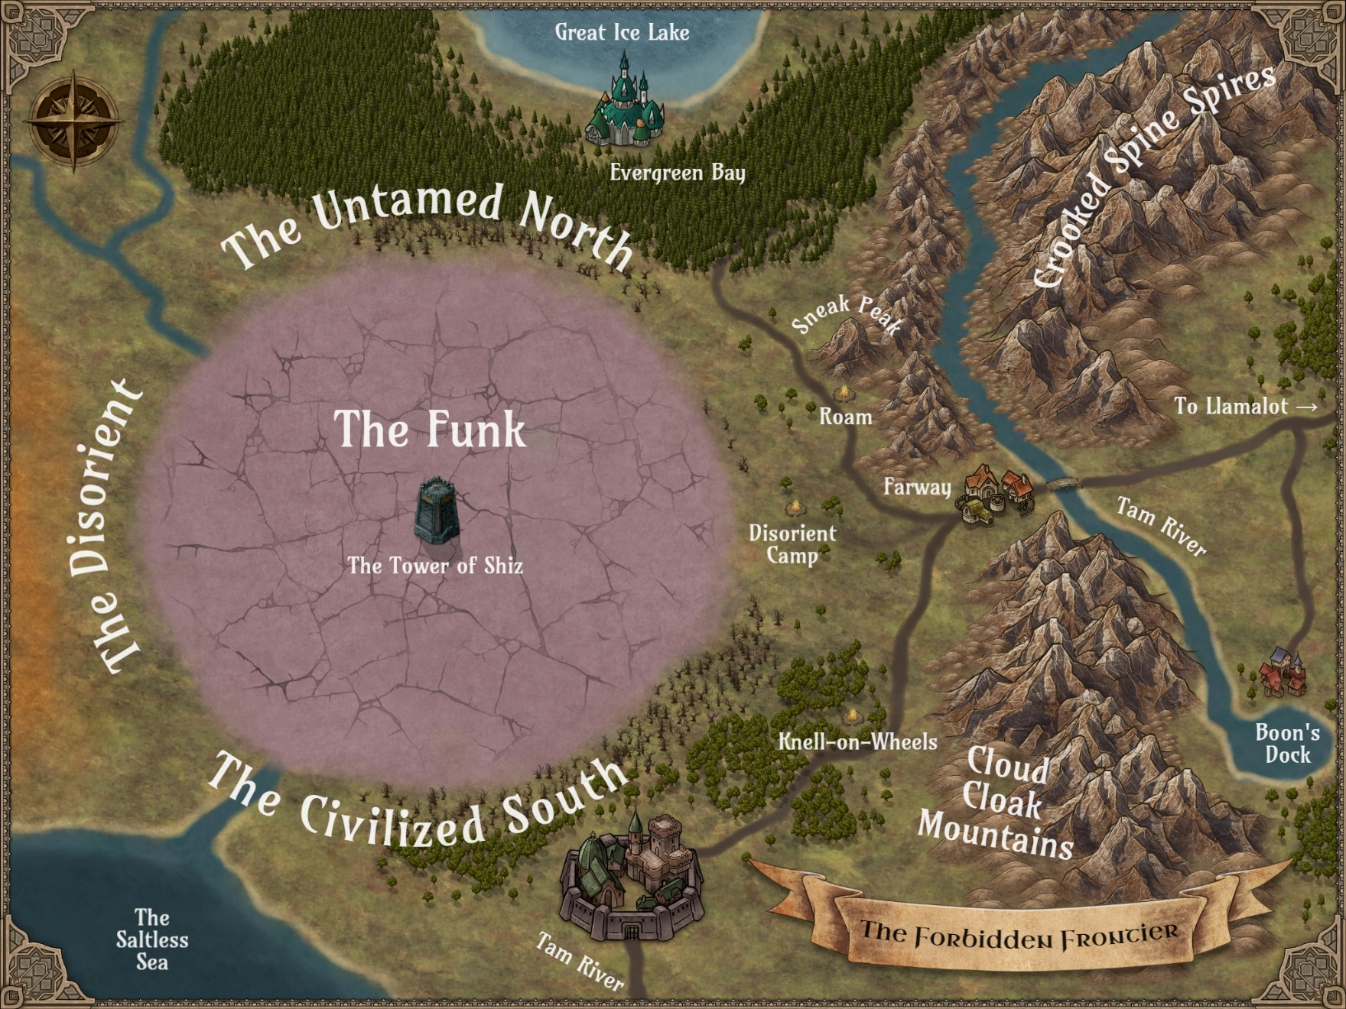

Local Maps

L1 – Farway
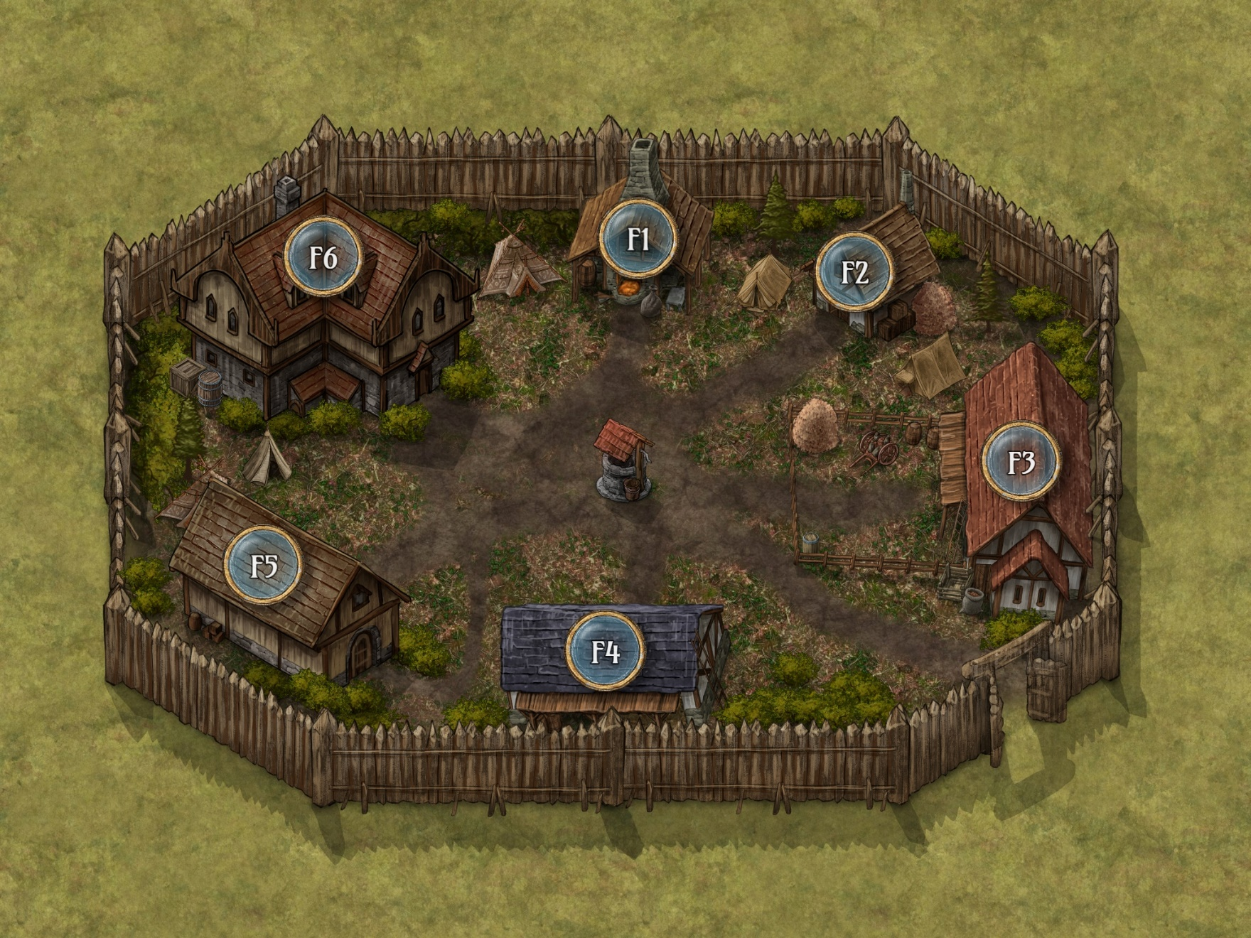

L2 – Knell-on-Wheels
[insert map]

L3 – Roam
[insert map]

L4 – Disorient Camp
[insert map]

Battle Maps

B1 – The Road to Farway
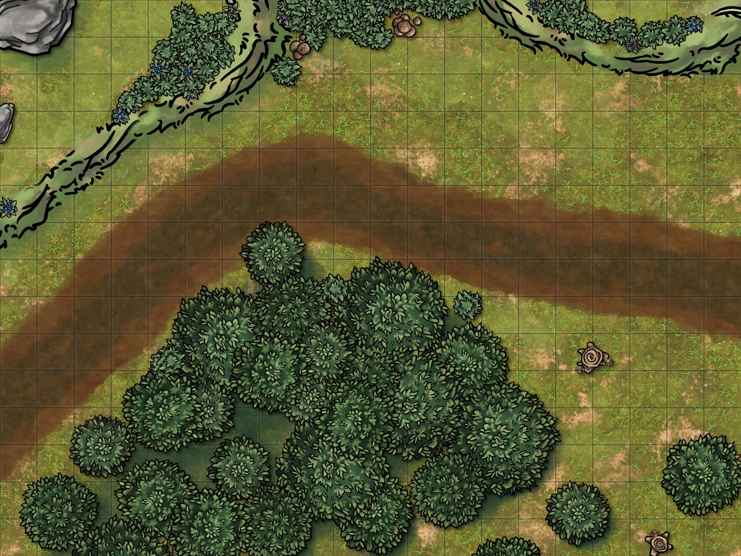

B2 – The Winking Cyclops
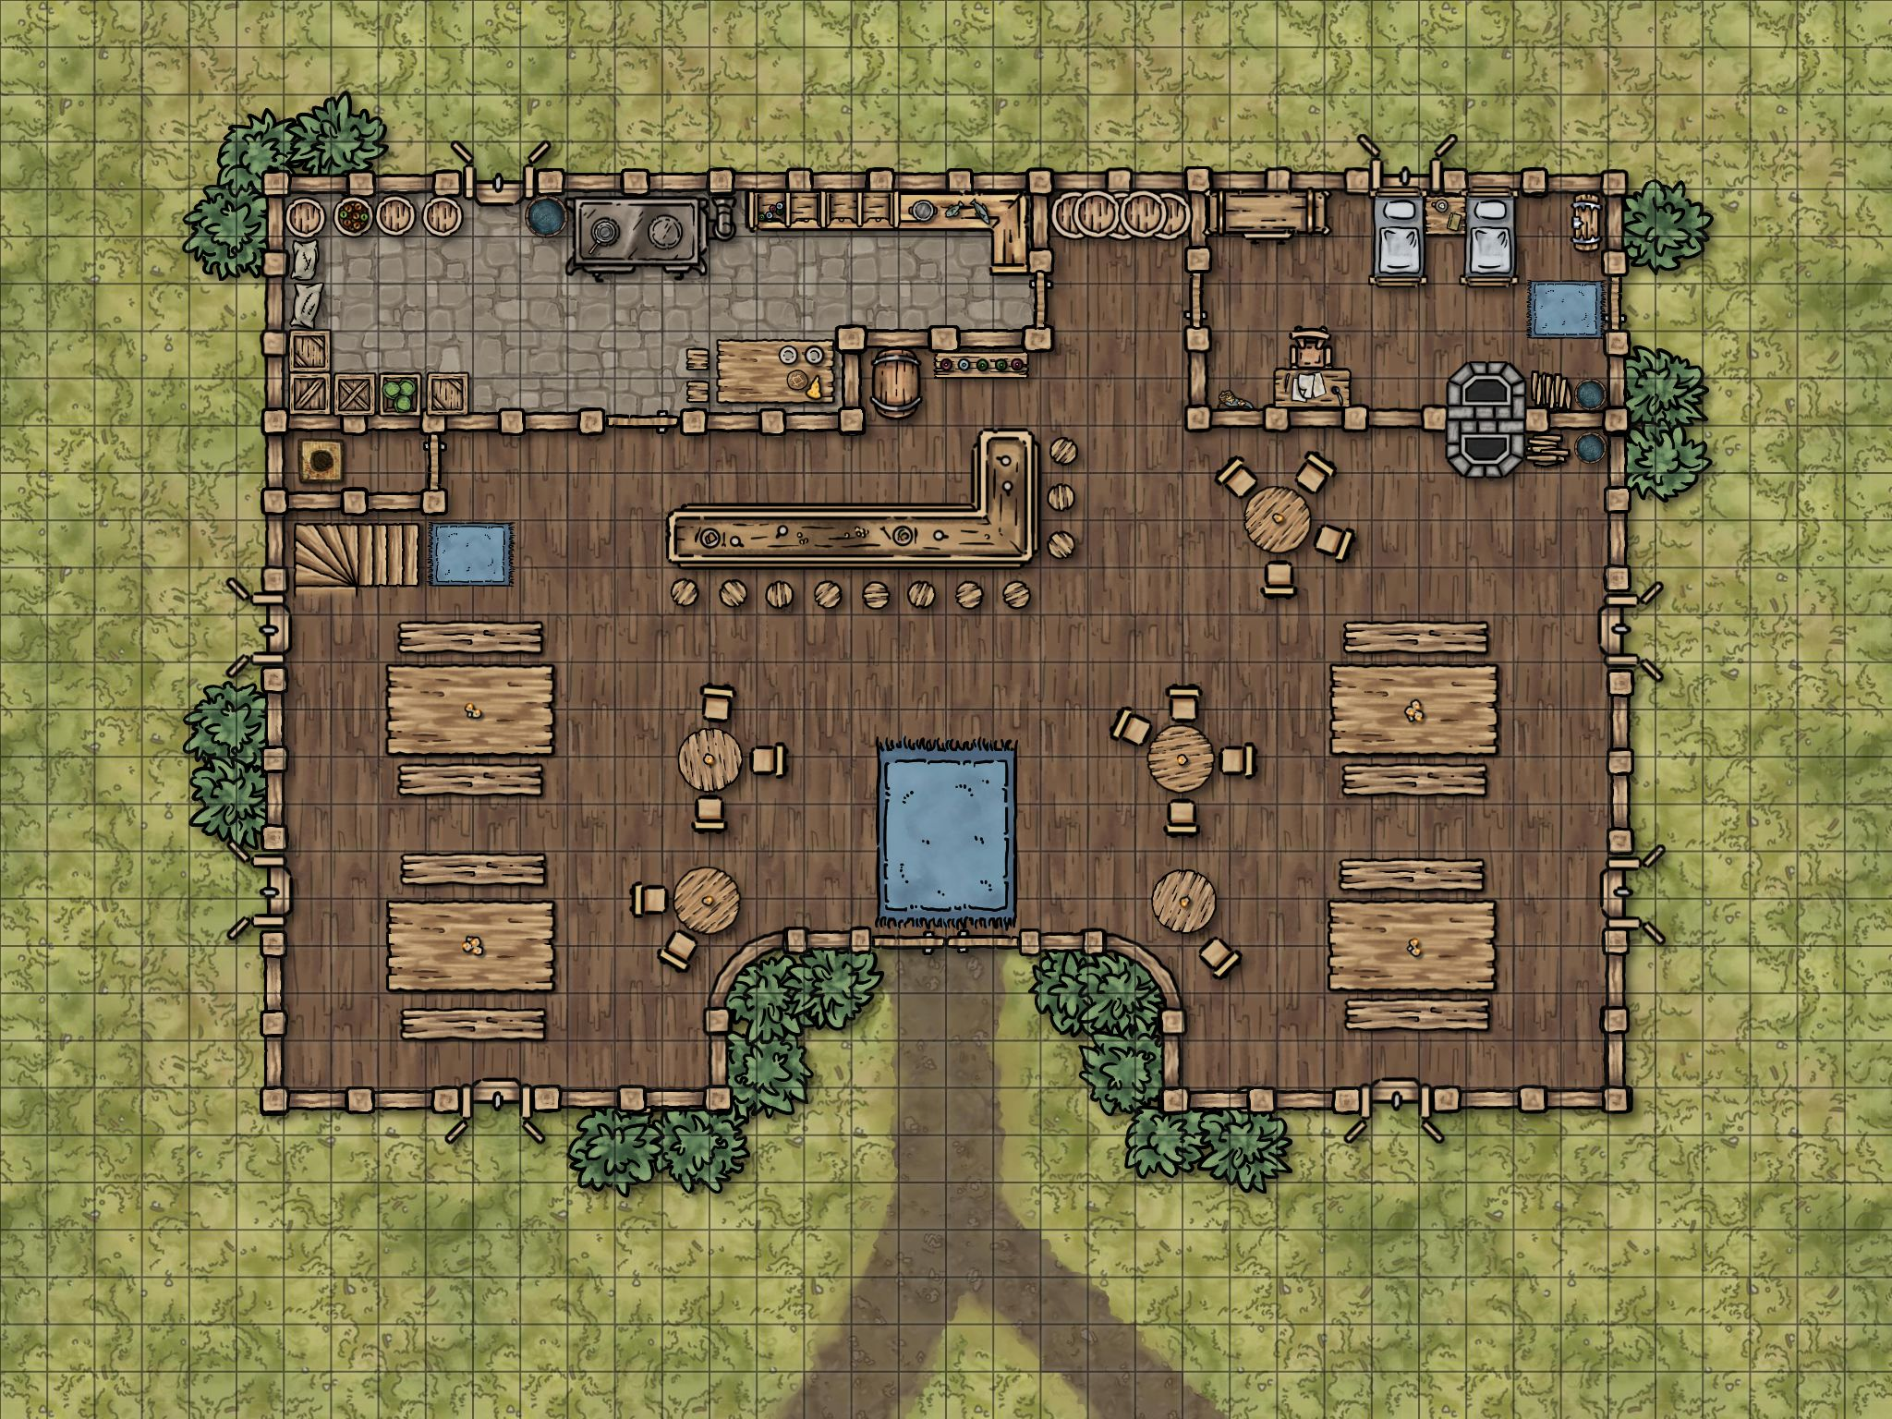

B3 – The Road from Farway
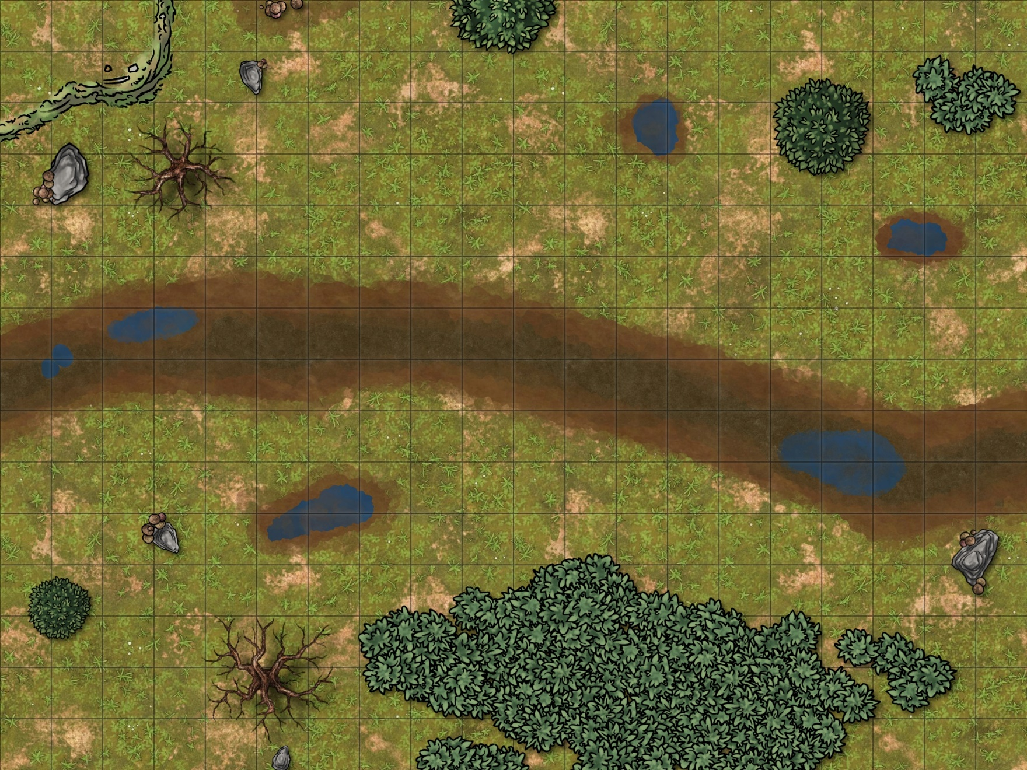

B4 – Entering the Funk
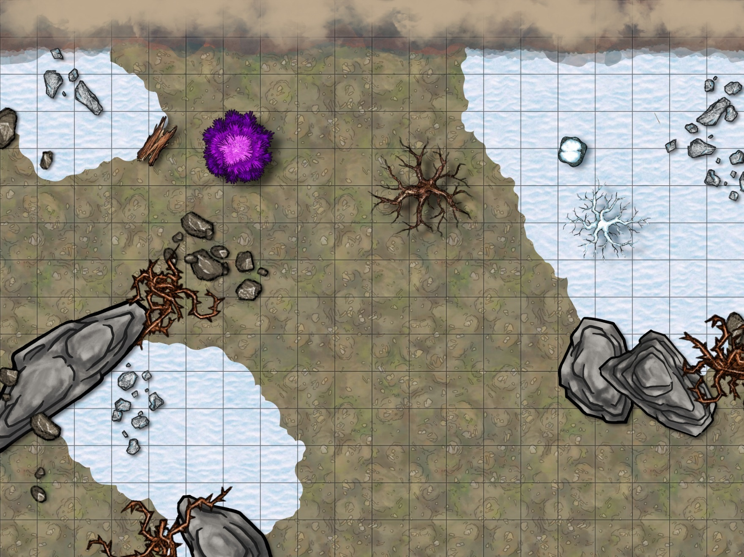

B5 – Tower of Shiz, First Floor
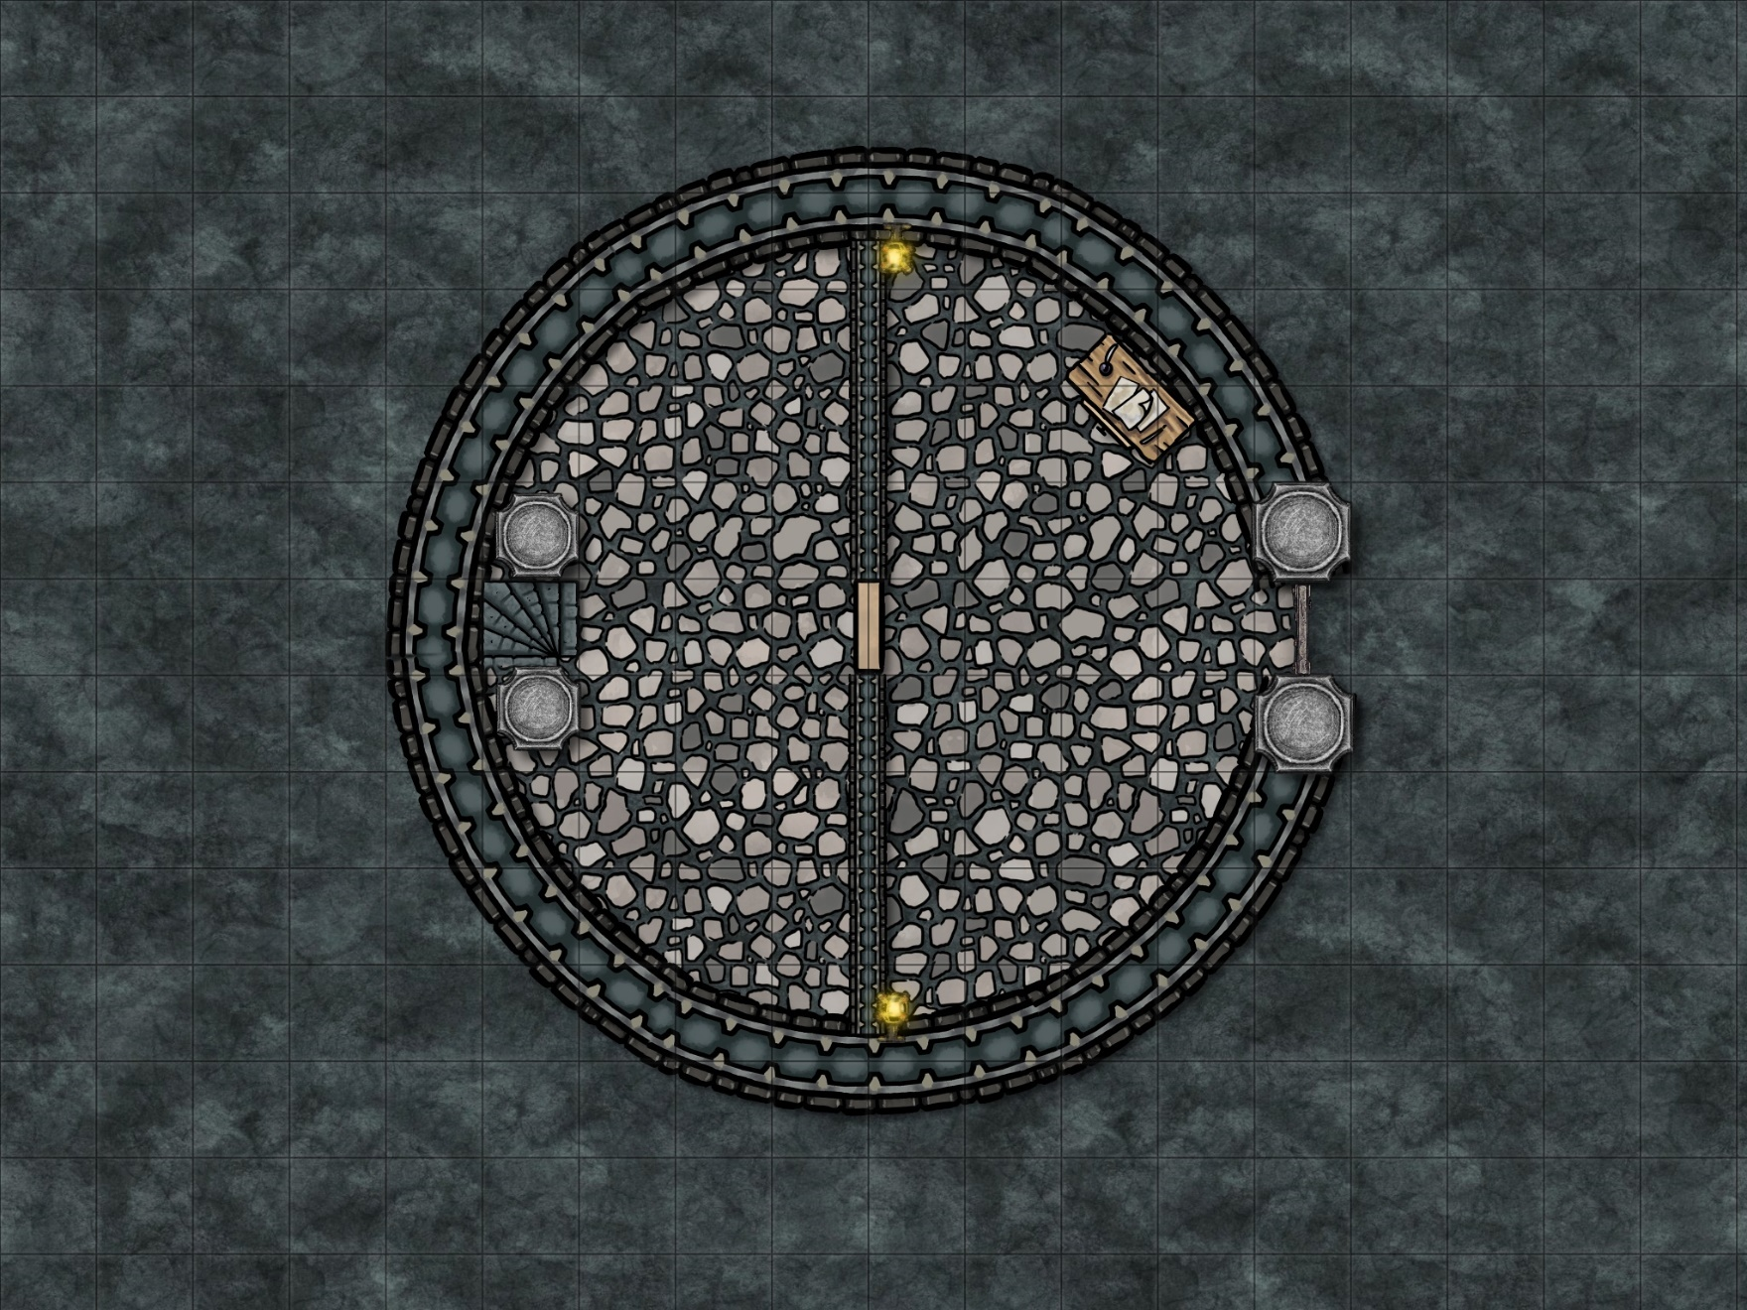

B6 – Tower of Shiz, Second Floor
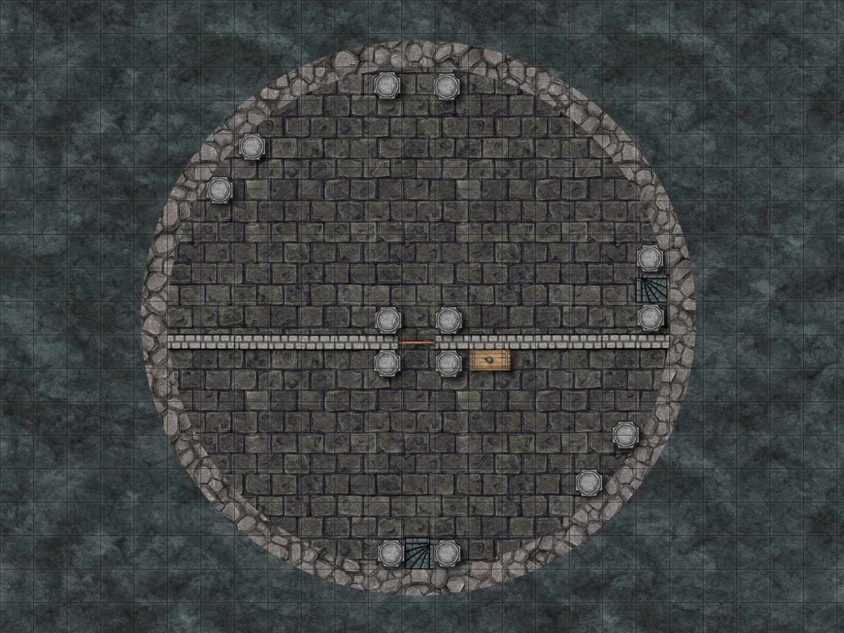

B7 – Tower of Shiz, Third Floor
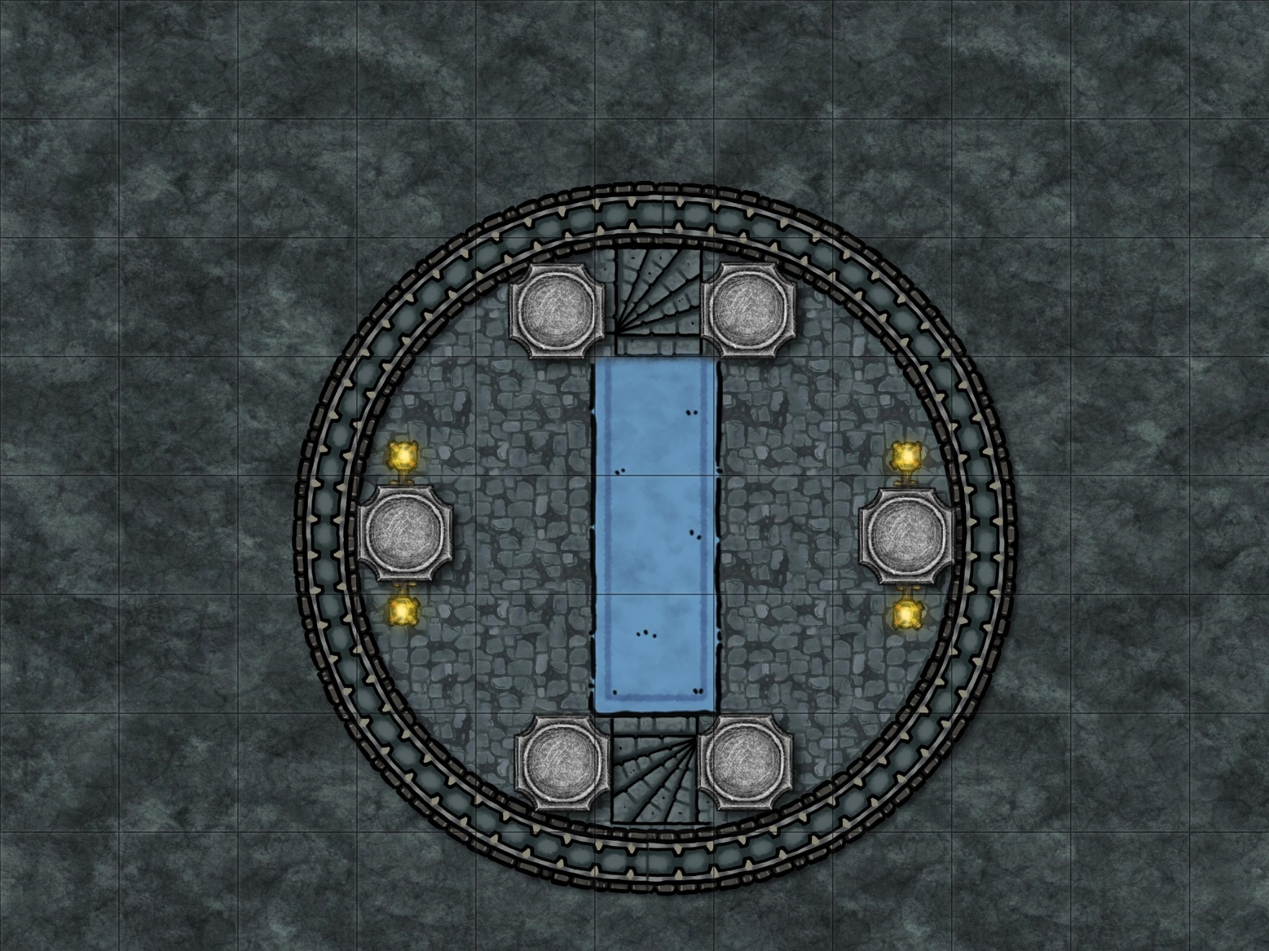

B8 – Tower of Shiz, Summit
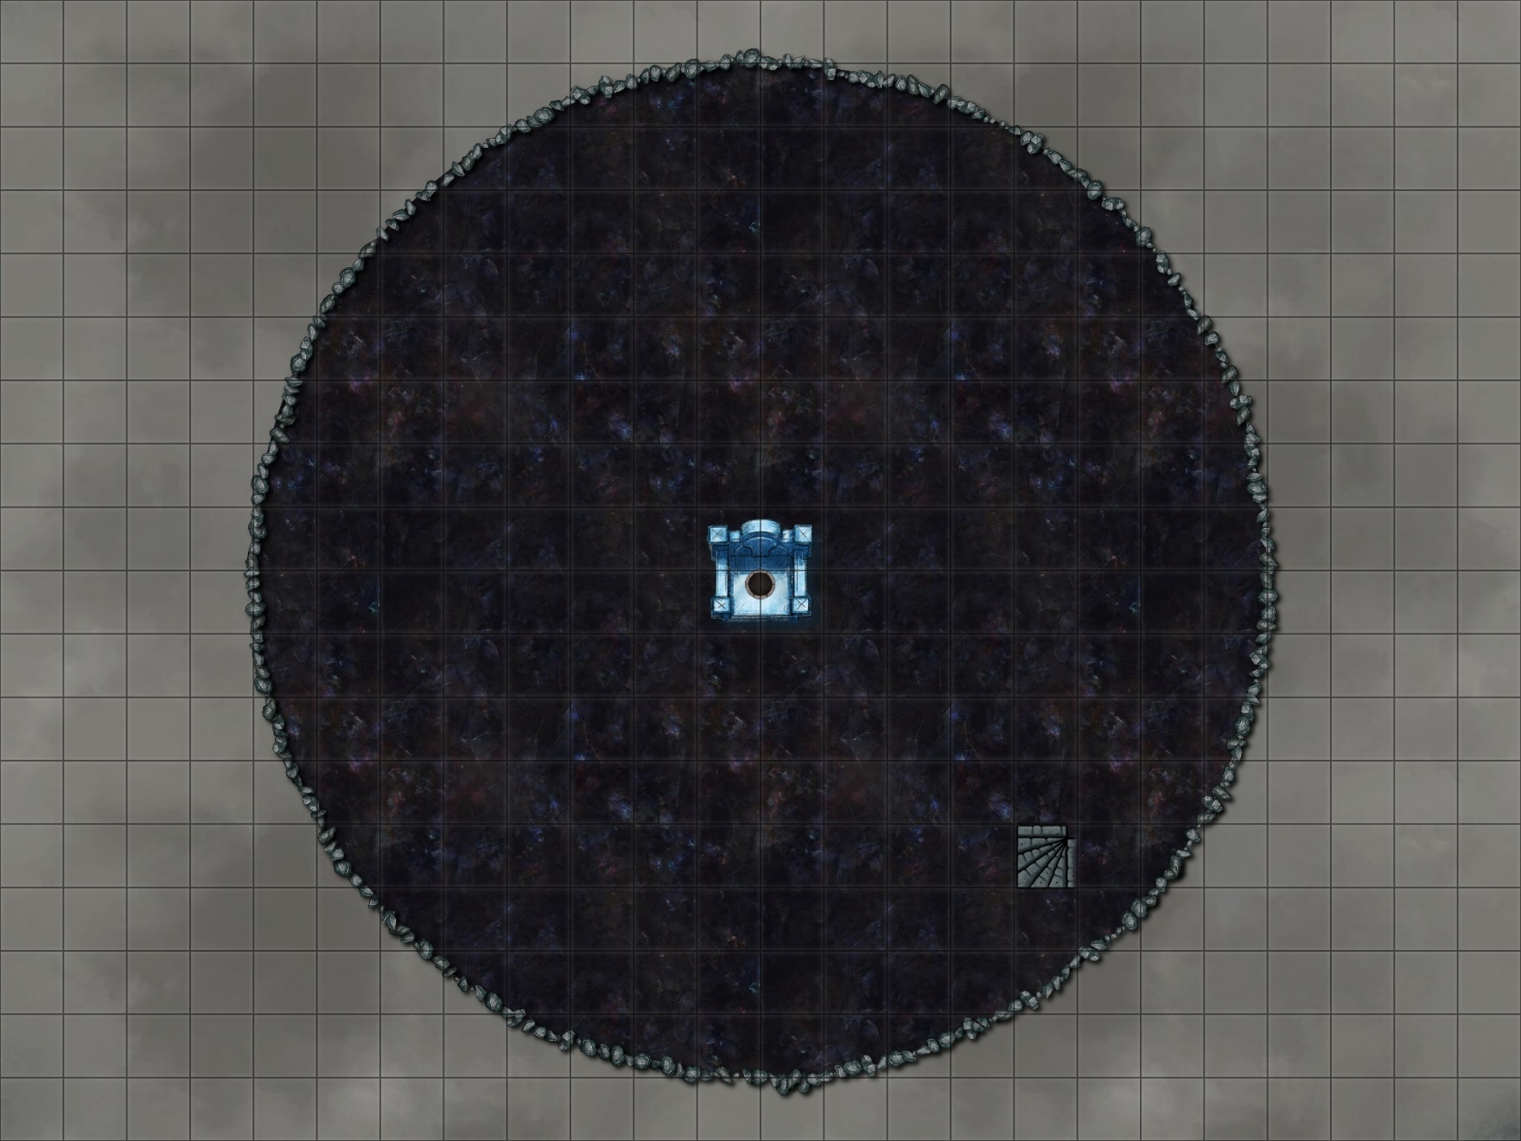
---------------------------------------------------------------------------------------------------------------------

---------------------------------------------------------------------------------------------------------------------

Appendix F
Handouts
While the GM generally must keep most information close to the vest, the occasional visual aid can help paint a clearer picture and break up long stretches spent in the theater of the mind. Share these handouts with the player if/when the adventure text tells you to.

---------------------------------------------------------------------------------------------------------------------

Player Handouts
Disorient Puzzle Box

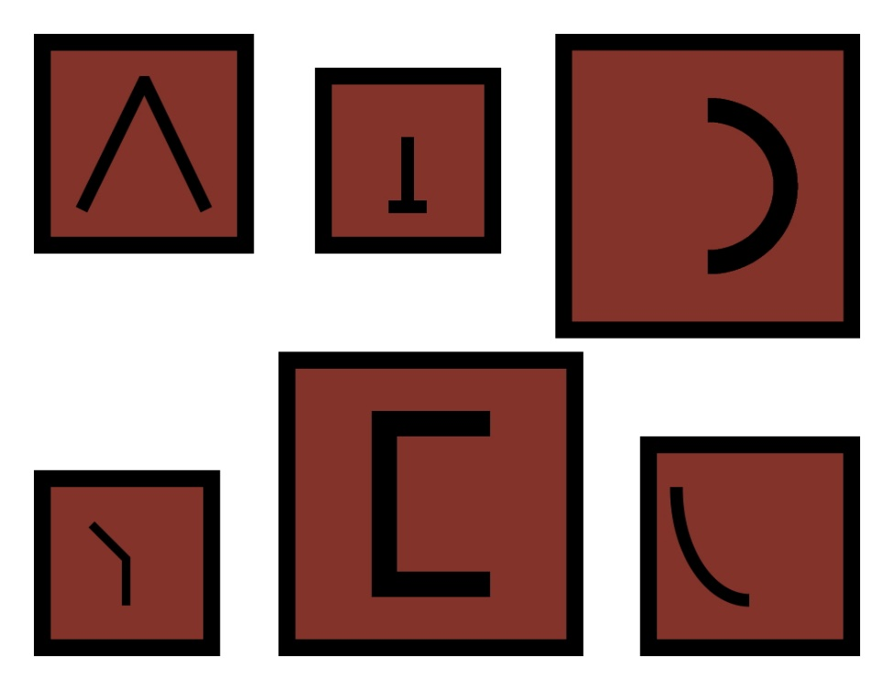
---------------------------------------------------------------------------------------------------------------------
Map of the Forbidden Frontier
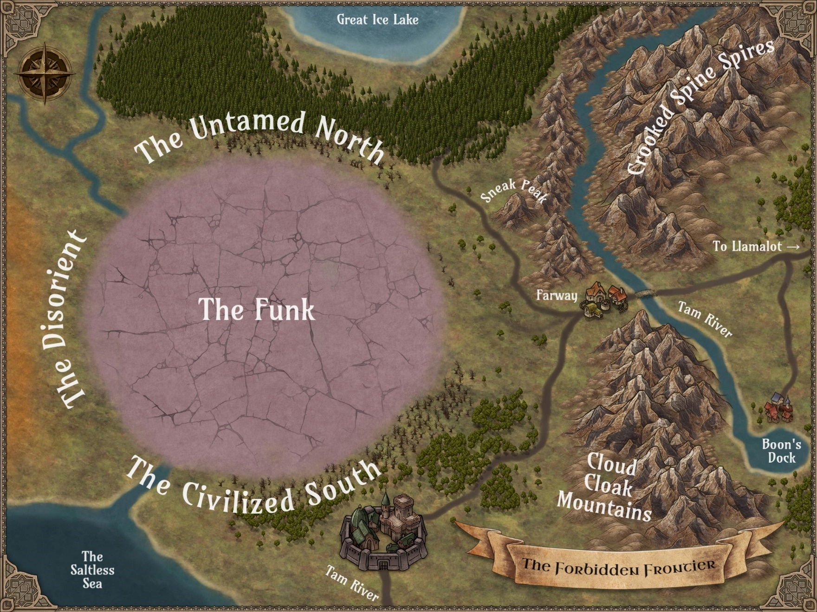

Map of Farway
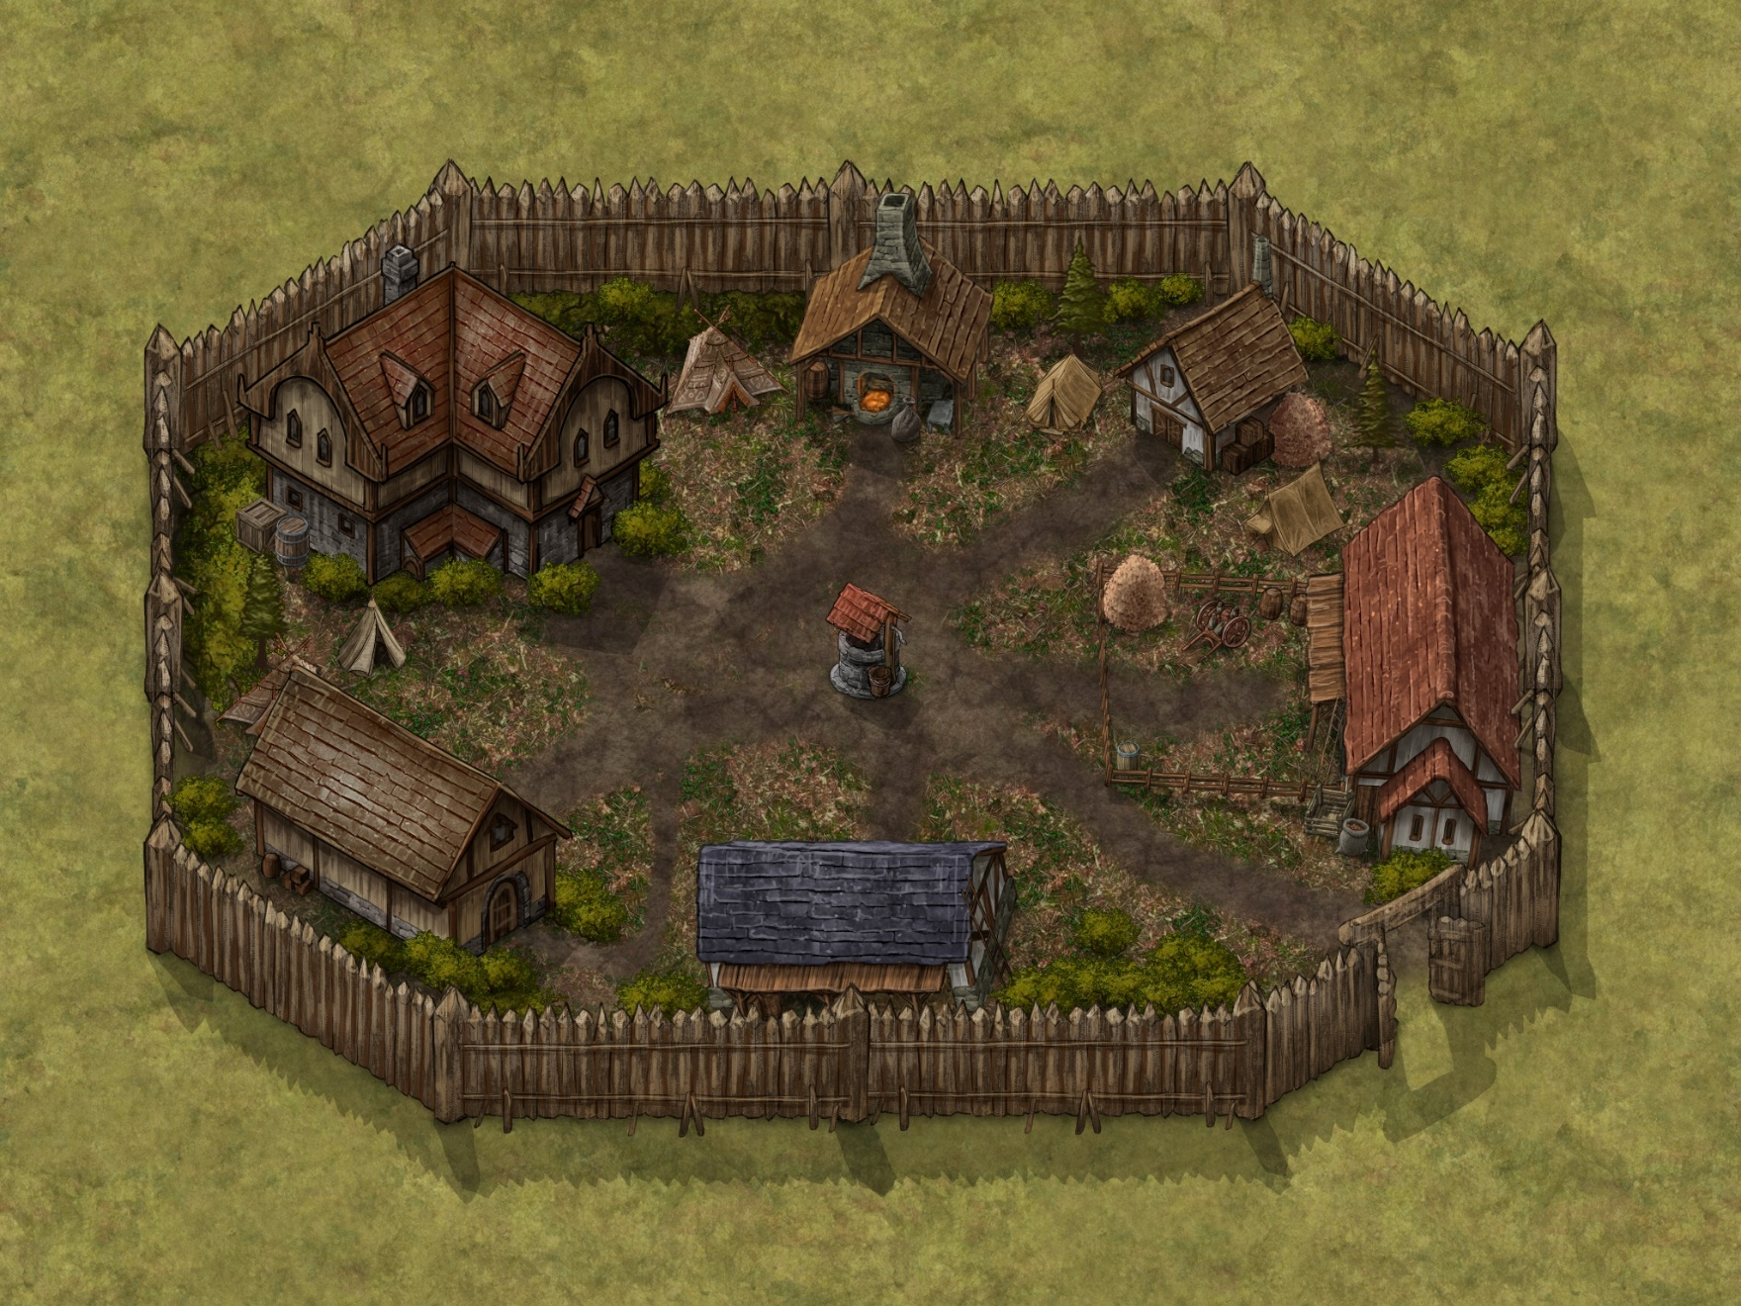

---------------------------------------------------------------------------------------------------------------------
Images of NPCs
Commode-O Dragon (Tohubohu)
[insert image]

---------------------------------------------------------------------------------------------------------------------

Devisor
[insert image]

---------------------------------------------------------------------------------------------------------------------

Faunamancer
[insert image]

---------------------------------------------------------------------------------------------------------------------

Feral Elf
[insert image]

---------------------------------------------------------------------------------------------------------------------

Gildbert G. Goldbottom
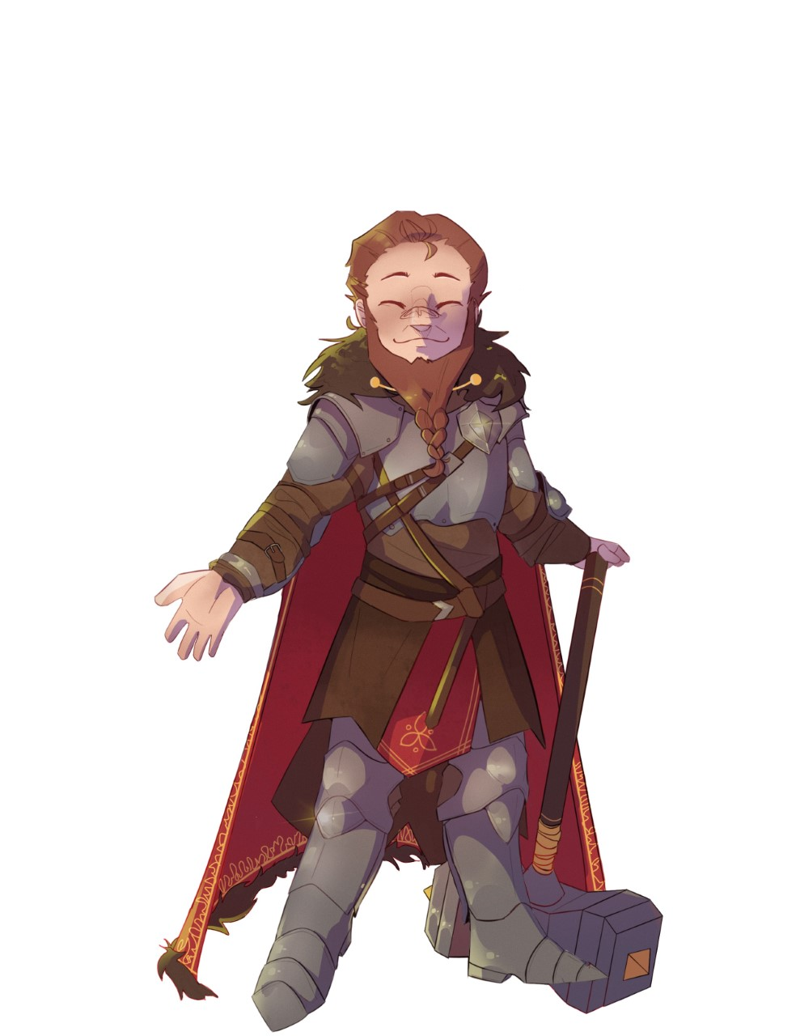
---------------------------------------------------------------------------------------------------------------------

N’ajin
[insert image]

---------------------------------------------------------------------------------------------------------------------

Nightbride
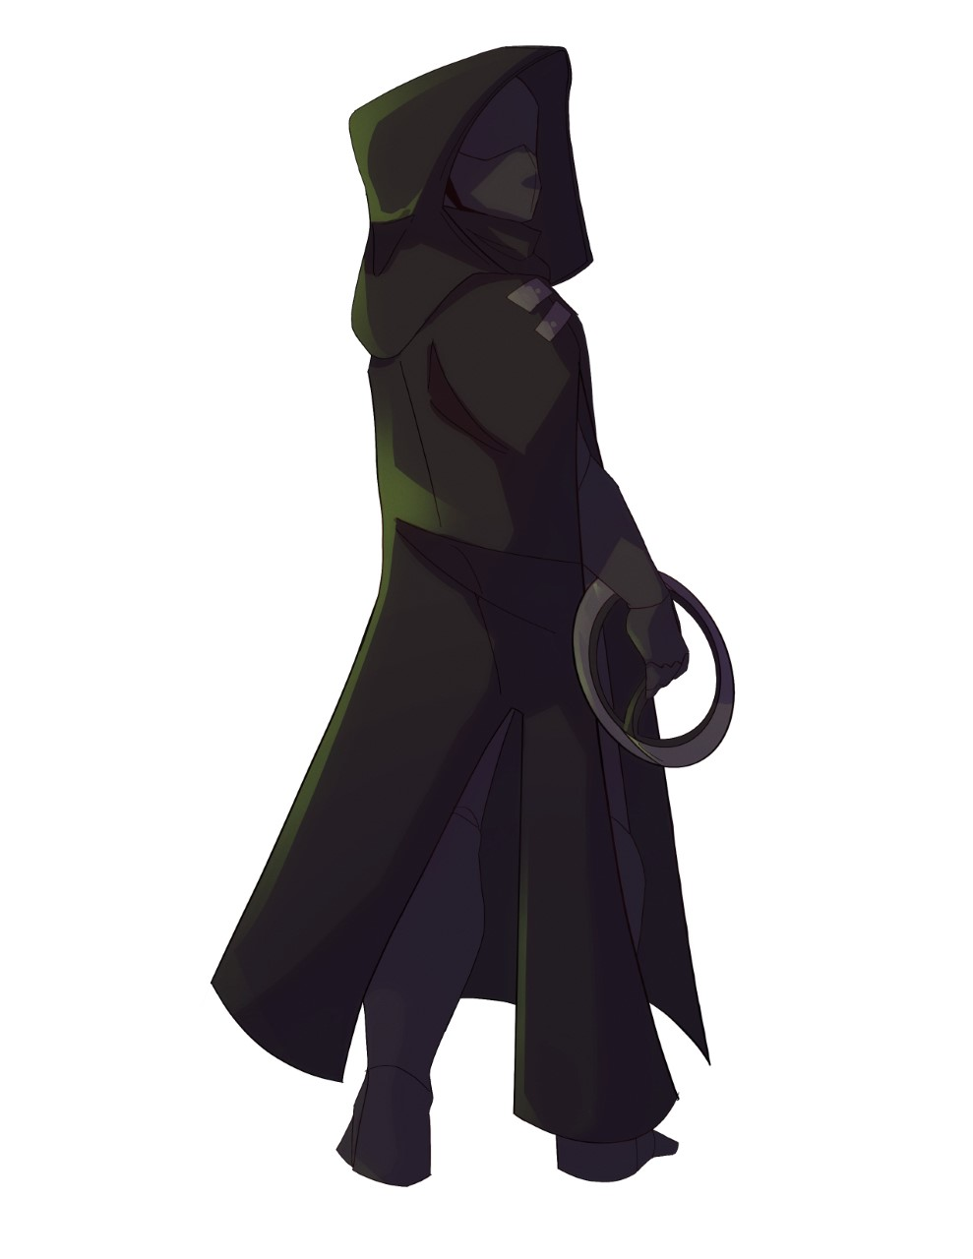
---------------------------------------------------------------------------------------------------------------------

Noh-Wei
[insert image]

---------------------------------------------------------------------------------------------------------------------

River Eagle
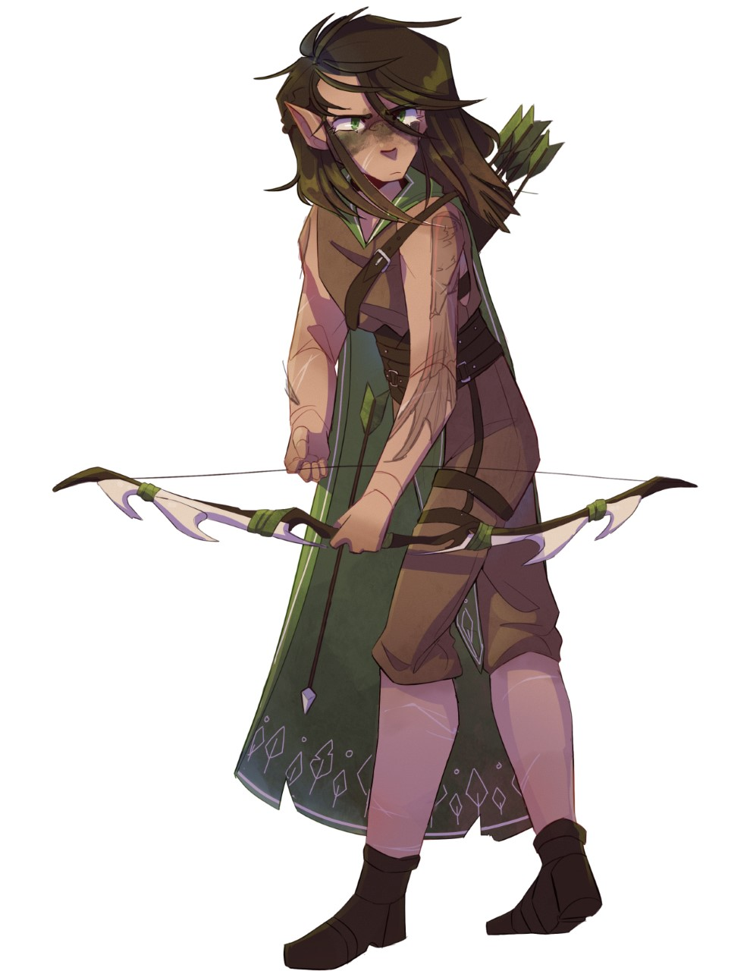
---------------------------------------------------------------------------------------------------------------------

Ruffian
[insert image]

---------------------------------------------------------------------------------------------------------------------

T.H.O.M.A.S. the Tank
[insert image]

---------------------------------------------------------------------------------------------------------------------
---------------------------------------------------------------------------------------------------------------------

---------------------------------------------------------------------------------------------------------------------
---------------------------------------------------------------------------------------------------------------------

Afterword
Despite being ensnared by the fantasy genre and RPG video games in the days before tweens were called tweens, my first foray into tabletop gaming was a failure. Alas, my cousin and I couldn’t puzzle out how to play “the world’s first fantasy roleplaying game.”
Since I had no GM to guide me through a campaign, I instead embraced the fiction set in these shared worlds, consuming more than 100 Dragonlance novels, piles of Forgotten Realms books, a smattering of Ravenloft tales, and a few game compendiums to further lose myself in the lore. All the while, I lurked on the fringes of tabletop-gaming culture, attending Gen Con sporadically and somehow securing an invitation to a pre-convention gathering in Lake Geneva, Wisconsin, where I met Margaret Weis, Don Perrin, Jeff Grubb, and other TSR writers and game designers.
Biding my time until fate saw fit to intervene, I also created my own fantasy setting, later writing and publishing a trilogy of sword-and-sorcery novels called The Renegade Chronicles as well as a standalone prequel, Magic’s Daughter. Years later, I presented my love letter to RPGs in the form of a YA portal fantasy titled The Lost Tale of Sir Larpsalot.
Little did I know I was also planting the seeds for this very book.
By the time The Lost Tale of Sir Larpsalot was published, I’d been blessed with two years of gaming under my belt. Yes, the gods had smiled upon me, sending a GM my way during the recent resurgence of TTRPGs. And while I swore I’d never become a GM myself (due to a plethora of other creative pursuits), I subsequently led a few adventures, including a few homebrew quests.
So when it came time to decide on my next project, I thought back to those two tweens attempting to puzzle out the ins and outs of tabletop gaming. Could I create a “beginner campaign” that was simple and succinct enough for first timers yet quirky enough for longtime gamers to enjoy?
To borrow a line from Sir Larpsalot: “Verily and forsooth!”
The Curse of Er’Mah’Gerd is my homage to the fantasists who inspired me to write in the first place and my gift to fans—and future fans—of tabletop gaming. May you never split the party.

David Michael Williams
June 2022

---------------------------------------------------------------------------------------------------------------------

---------------------------------------------------------------------------------------------------------------------

Acknowledgments
This crazy adventure would not have been possible without the help from many people, who graciously gave of their time and talent to make The Curse of Er’Mah’Gerd better than I ever could have alone.
Artists
Cover
- Mary Christopherson: mary.design
Illustrations
- Carley Knoll: instagram.com/thegen_eral
- Gwendolyn Williams
Editors
- William Fischer: niznocspeaks.wordpress.com
- Bill Fischer
- Dusty Krikau
Play Testers
GMs
- Taima Kern
- Paul Krikau
- Alex Kurowski
- Alexia Lamont
- John McFadden
- Sam Nelson
Players
- Jordan Bradford
- Dusty Krikau
- Eleanor Krikau
- Miles Krikau
- Lance Lamont
- Caleb McFadden
- Connor McFadden
- Christopher Whitmore
- Andrew Williams
- Archer Williams
- Gwendolyn Williams
- Robyn Williams
- Stephanie Williams
- (Play tester 14)
- (Play tester 15)
- (Play tester 16)
- (Play tester 17)
- (Play tester 18)
- (Play tester 19)
- (Play tester 20)
And More
- Wizards of the Coast: company.wizards.com
- DriveThruRPG: drivethrurpg.com
- Inkarnate: inkarnate.com
- Twenty Sides to Every Story: twitch.tv/twentysidestoeverystory

---------------------------------------------------------------------------------------------------------------------

---------------------------------------------------------------------------------------------------------------------

[insert novel cover]
Wizards & Wannabes
As the first day of high school creeps closer, five friends agree to one last larp before splitting the party and ending their geeky game forever.
But the real adventure is just beginning…
Mistaking the teens’ costumed characters for actual warriors, a sorceress summons Sir Larpsalot, Elvish Presley, Brutus the Bullheaded, Master Prospero, and Tom Foolery to her world to complete an impossible quest. To succeed, they must become the heroes they only ever pretended to be.
And if they can’t find a way to win, it’s GAME OVER for real!

The Lost Tale of Sir Larpsalot is available in paperback and e-book at Amazon.com.

---------------------------------------------------------------------------------------------------------------------
---------------------------------------------------------------------------------------------------------------------

---------------------------------------------------------------------------------------------------------------------
---------------------------------------------------------------------------------------------------------------------

NO GOOD DEED GOES UNPUNISHED
When Good Company ventured into the Funk a year ago to retrieve the fabled Staff of Er’Mah’Gerd, the heroes hoped to bring prosperity to a land long fraught with peril.
But even as the ancient curse seems to fade, three factions fight for control over the region. The feral elves of the Untamed North suffer no trespassers in the former no man’s land, while the industrious dwarves of the Civilized South seek to expand their borders. Meanwhile, the masked humans of the Disorient keep their movements—and motivations—a mystery for now.
With a threefold war brewing, the heroes of Good Company must return to the frontier town of Farway to mediate what might prove to be the shortest peace talks in history. Worst of all, a lingering threat in the Funk could spell the end for all of Mezzo-Earth.
THE CURSE OF ER’MAH’GERD is a light-hearted, self-contained adventure for both newcomers and seasoned players familiar with the world’s first fantasy roleplaying game.

ONEMILLIONWORDS [5E Compatible]
one-million-words.com

Suggested Retail Price: TBD
[insert barcode]

